

Commercial Lines

Workflows & Procedures

*For*

Acrisure Southeast Partners Insurance Services, LLC



v03/27/2025

How to Use this Document

|  |
| --- |
| This document contains valuable information relevant to the usage of EPIC, including **Epic Basics**, day-to-day **Workflows**, and **Job Aids. DO NOT PRINT THIS DOCUMENT.**  For optimal usage:   * Click the **View** menu at the top in the Microsoft Word toolbar * Checkmark **Navigation Pane**      * The left pane will open and show a listing of topics      * Click on the topic to jump to that section/page. * Hyperlinks within the document will lead to specific pages or Job Aids.      * Some hyperlinks will connect to a webpage outside of the document. |

# Epic Browser

## Logging in

|  |
| --- |
| 1. Open a web browser.    1. Chrome    2. Edge 2. Enter URL:    1. **Production/Live**: <https://acris03.appliedepic.com/#/>    2. **Test/Training**: <https://ve061t1web.appliedepic.com/#/> |

## Add the URL as a bookmark in the Chrome or Edge Browser

|  |  |  |
| --- | --- | --- |
| 1. In the browser URL address field, enter <https://acris03.appliedepic.com/#/>; press the keyboard enter key. 2. Add to Bookmarks/Favorites as follows:  |  |  | | --- | --- | | **CHROME**    Click the star icon  Enter a name for the bookmark; click Done | **EDGE**    Click the star icon  Enter name and add to Favorites Bar; click Done | |

Browser Tabs

|  |
| --- |
| Browser tabs will open at the top when accounts are located and selected    Use browser tools like Tab Grouping and Zoom, if desired.  To prevent connection issues, close out of a client by clicking the X above the Logout button, NOT the x in the browser tab |

## Connection Suite & New Functionality Popups

|  |
| --- |
| The Connection Suite is required to ensure full functionality and connection within Epic Browser. Acrisure IT manages all updates in the background for the Connection Suite Plugin. **Ignore these popups.** If you are receiving an error, follow the instructions to hard shutdown to ensure there’s a clean connection to all services run on your computer. If you are experiencing functionality issues after shutting down, submit a ticket to [support@acrisure.com](mailto:support@acrisure.com).  ***Reminder: A hard shut down of your computer should be done at the end of each workday.*** |

## Logging out of Epic

|  |
| --- |
| **\*\*IMPORTANT\*\***  When **closing out of Epic,** be sure to click the **LOGOUT** button at the top right in the blue Options Bar. Do not X out or Epic will not close properly and may cause issues when signing in again.  **NO** |

**Shutting Down Computer**

|  |  |  |  |  |  |  |
| --- | --- | --- | --- | --- | --- | --- |
| **\*\*IMPORTANT\*\***  Log out of Epic and SHUT DOWN your computer **at the end of each workday.**   |  |  | | --- | --- | | 1. Shut down the computer by clicking the Start Menu in the bottom left-hand corner of your desktop |  | | 1. Click Power |  | | 1. Click Shut Down |  |   **NO** |

# EPIC BASICS



## Epic Icons

|  |  |  |  |
| --- | --- | --- | --- |
|  | Add New |  | Change column width |
|  | Edit |  | To define a search |
|  | Print list view |  | Executes search. These are cumulative. To begin a new search, click “Clear Filter” |
|  | Sortable column – ascending/descending |  | The logout button will close all open windows. If any screen requires validation (the process isn’t complete), the screen with display prior to closing |
|  | Change the order of items | **RIGHT CLICK** | Right clicking on a selected policy, activity or contact will often generate the same menu as ACTIONS. |
|  | Collapses and opens sections of screen or moves full list from one screen to another |  | Click on the Paperclip to attach documents saved in Epic (Email) |
|  | Required Field – must complete |  | Click on the File to attach files saved on a local or network drive (Email) |
|  | Desired Field – agency would like field completed |  | Contacts in EPIC (from Email) |
|  | Customize columns displayed in the list view |  | Contacts in Outlook (from Email) |

## Keyboard Shortcuts

|  |
| --- |
|  |

## Home Base

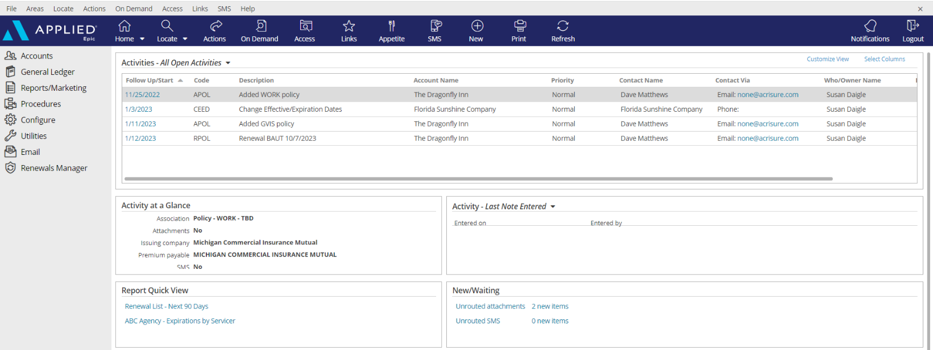

|  |
| --- |
| 1. **Open Activities** (suspense, follow up, to-do list)    * Use “Select Columns” to add columns to your view.    * The position of the columns can also be changed by clicking and dragging the column headers to the desired location.    * Sort columns in ascending or descending order by clicking on the column header 2. **Activity at a Glance** – displays information about the highlighted activity 3. **Activity Tasks** OR **Last Note Entered** – if a task within an activity is assigned to you, the task will appear here only if the activity above, associated with the task, is highlighted. The view can be changed from “Activity – Tasks” to “Last Note Entered” by clicking the dropdown arrow and selecting the appropriate option. 4. **Report Quick View** – Created reports can be sent to Report Quick View for easy access. Just click the link and the report will open. Data displayed is in real time and will be refreshed as of the date it is opened 5. **New/Waiting** – If your agency has opted to use Front End Scanning, scanned mail can be accessed by clicking the “Unrouted Attachments” link. The number of items in your “inbox” will also display. 6. **Navigation Panel** – Items listed here will direct you to distinct parts of Epic or the client’s account while on the locate screen or within the client account. Items listed change depending on which screen is being utilized. This is known as the “View” panel. 7. **Blue Options Bar** – Each icon contains action options, which change depending on which screen is being opened. Think of this as the “Do” bar. 8. **Log Out button** – Clicking this button will close all the open screens/windows and log out of Epic. 9. **Locate** – Click the dropdown arrow to see list of last 20 accounts accessed |

## Activities & Tasks

|  |
| --- |
| **Activities in Epic perform three essential functions:**   * Add a record to the client file for the action performed * Allow a follow up or Open Activity as a reminder to do something at a current or future date * Permanently document the file with the use of Notes within Activities   **Tasks in Epic can supplement an activity:**   * Can be used as a to-do list related to that activity or to share work with another user * Task Owners and start dates can be independent from the activity   ***NOTE: Activities or Notes in an Activity cannot be moved to another account or deleted. While the activity description is editable, the notes area cannot be altered and is date/time stamped.*** |

### Manage Activities from Home Base

|  |  |
| --- | --- |
| **Select Columns** | A close up of a sign  Description automatically generatedCheck or uncheck the columns desired to reflect within the Home Base View |
| **Customize View** | A screenshot of a computer  Description automatically generatedAllows the addition of other Employee activities to reflect within your own open  activities list (if given permission) |
| **Right Click to Manage** | * **Close Activity** – *follow up action is completed* * **Add Note** – *add notes related to the process which is still pending* * **Add Task** – *assign a portion of the activity process to someone else to work on* * **Change Follow-up Date/Time** – *if the deadline for completing the activity can be moved* * **Change Who/Owner** – *reassign the activity for someone else to take care of, which will move to their Home Base* * **View All Notes** – *Read all notes related to a specific activity process*   A screenshot of a computer  Description automatically generated   * **Take Ownership** – *If the activity is assigned to another person or a work group, it can be reassigned to yourself*   ***Note: multi-select activities (CTRL + Click) to apply the above actions to multiple activities at one time.*** |

**Manage Tasks from Home Base**

|  |  |
| --- | --- |
| **Customize View** | A screenshot of a computer  Description automatically generatedAllows the addition of other Employee tasks to reflect within your own open  activities list (if given permission) |
| **Right Click to Edit** | * **Description** * **Owner** *–* *reassign the activity for someone else to take care of, which will move to their Home Base* * **Status** *– mark as cancelled, completed, in-progress or not applicable as needed* * **Start/Due date**s – *amend if the deadline for completing the task must be moved* * **Add Note** - *add notes related to the process which is still pending*A screenshot of a computer program    Description automatically generated |

## Client Accounts

### Account Sources – REQUIRED FIELD

|  |  |  |  |  |  |  |  |  |  |  |  |  |  |  |  |  |  |  |  |  |  |  |  |  |  |  |  |  |  |  |
| --- | --- | --- | --- | --- | --- | --- | --- | --- | --- | --- | --- | --- | --- | --- | --- | --- | --- | --- | --- | --- | --- | --- | --- | --- | --- | --- | --- | --- | --- | --- |
| |  | | --- | | 0. Cross Sell-Platform | | 1. AM/AE Solicited | | 1. Producer Solicited | | 2. Referral - Acrisure Cyber Services | | 2. Referral – Acrisure Global Network | | 2. Referral - Acrisure Title Partner | | 2. Referral - Association | | 2. Referral - Broker - Acrisure | | 2. Referral - Broker - Non-Acrisure | | 2. Referral - Client | | 2. Referral - Employee | | 2. Referral - Financial Partner/WM | | 2. Referral - GA | | 2. Referral - Loan Officer | | 2. Referral - Mariner Wealth | | 2. Referral - Other | | 2. Referral - Payroll Firm | | 2. Referral - Realtor | | 2. Referral - TPA | | 3. Marketing - Acrisure.com | | 3. Marketing - Internet Search | | 3. Marketing - Other | | 3. Marketing - Social Media | | 3. Marketing - Telemarketing | | 3. Marketing - Tradeshow | | 4. Other/Unknown | | 5. Win Back | | 6. Call In/Walk In | | Z. Update Needed | | **Account Source is a Required Field.**  **Be sure to select the appropriate one for tracking and reporting purposes.**  If the policy source is unknown,  select “**Update Needed**” to update at a later time. |

Servicing Roles

|  |  |  |  |  |  |  |  |
| --- | --- | --- | --- | --- | --- | --- | --- |
| **External Service Team** | |  | | --- | | Acrisure Service Center | | Carrier Service Center | | GA - Emerson Reid | | GA - Martin Insurance Services * | | GA - PGM * | | GA - Suvaun * |   **When an account and/or policy is managed by an external service team (the Acrisure Service Center, a Carrier Service Center, or a General Agent on the EB side), select the appropriate one from the drop-down list.**  **Note:**  **An Acrisure-owned GA will be indicated by an asterisk.** |
| Marketing |
| P&C Producer 1 (Primary Producer) |
| P&C Producer 2 |
| P&C Servicer 1 (Primary Servicer) |
| P&C Servicer 2 |
| P&C Claims |
| Other Custom |
| Surety Producer (Primary Producer) |
| Surety Servicer (Primary Servicer) |
| EB Producer 1 (Primary Producer) |
| EB Producer 2 |
| EB Servicer 1 (Primary Servicer) |
| EB Servicer 2 |
| Other Custom (EB) |
| Non-Insurance Product Sales |
| Relationship Manager |

### Locate Account

|  |
| --- |
| * Click the **Locate** button to **search** for existing clients   **Locate Options:**   * + **Account/Business Name** – *contains full or partial account name*   + **Claims: Additional Party** – by involvement type, name, or phone number   + **Insurer Claim#** - must be exact & complete   + **Internal Claim#** - must be exact & complete   + **Date of Loss** – *range*   + **Last name, first name** – *begins with* and will search account detail name field and individual contacts   + **Lookup Code** – *begins with*   + **Phone Number** – must be exact & complete   + **Policy #** - *contains*   + **Prior Account ID** – *begins with* (from your prior system)   + **Relationship** – relationship type and then account name   + **Submission ID** – *begins with* (in marketing)   + **Vehicle Registration Number** * Click the **Locate** button to **add new** client accounts. * Click the **drop-down arrow** on the Locate button to access the last 20 accounts accessed (including client accounts, employee accounts, company accounts, etc.) |

### Close Out of an Account Record

|  |
| --- |
| Locating and selecting an account will create a new tab in the browser. **Close the account record by clicking the X above the Logout button** NOT by clicking the x within the tab at the top. |

## Contacts

### Contacts Overview

|  |  |
| --- | --- |
| **Individual Contact** | This is an additional individual contact (person) on the account. By choosing an individual contact additional fields are available, such as date of birth, SSN, marital status, driver’s license number, etc. |
| **Primary Contact** | This is an **individual contact** and should be selected as the primary contact for the account. To make a contact **Primary,** click **ACTIONS > Change Primary Contact**. The Primary Contact is displayed in the Rolodex Card on the bottom left corner in the client’s account. |
| **Main Business Contact** | This is the **Primary Named Insured** on a Business account. This contact is added when a prospect or insured is added. Any Business Contact can be changed to a Main Business Contact by **ACTIONS > Change Main Business Contact**. A main business contact should have a NAICS number **(required field)**, website and main business phone number, any additional Identification Numbers added such as FEIN may be added on the **Identification Numbers Tab**. A policy may only have 1 Main Business Contact |
| **Category** | Contacts are categorized based on their relationship to the Account: Contact Only—Policy Only—Both Contact & Policy |
| **Description** | Add **Description** **(required field)** to best represent the position or role of the contact (i.e., owner, manager, etc.) Select the appropriate description(s) for each Contact. This information is used for tracking and reporting. |
| **Contact**  **Classifications** | **Be sure to select** the appropriate contact classification. DM=Decision Maker; PC=Primary Contact   |  |  | | --- | --- | | __User - Benefits Technology | _EB Compliance | | __User - CSR24/Portal | _EB Compliance Newsletter | | __User - HR Portal | _EB Eligibility Contact | | __User - Indio | _EB HRLS Compliance Summit | | __User - Insite Portal | _EB Plan Admin | | __User - Succeed | _EB VIP | | __User - Zywave | _HR Leader | | __User - Zywave LMS | _Personal (DM) | | _Certificates | _Personal (PC) | | _Commercial (DM) | _Risk Management (PC) | | _Commercial (PC) | _Safety (PC) | | _Cyber (DM) | _Surety (DM) | | _Cyber (PC) | _Surety (PC) | | _EB (DM) | _Work Comp (DM) | | _EB (PC) | _Work Comp (PC) | | 401K Plan Administrator | Acrisure Webinars | |

## Add Additional Contacts

|  |
| --- |
| **Types of Contacts – EPIC Data Standards**   * + - 1. **Main Business Contact (MBC)**   **Key Fields**   * **FEIN** * **NAICS** * **Business Type**  1. **Primary Contact** (Individual Contact) 2. **Additional Contact** (DBA, Named Insureds, Mailing or Billing Address) |

### Add Individual Contact

|  |
| --- |
| 1. From the client’s account, click **Contacts** in the left Navigation Panel 2. Click the **Add** Badge Follow outline button      1. Select the **Individual** radio button 2. Enter First Name, Last Name 3. **Category:** Indicate whether contact only, policy only, or both contact & policy 4. **Description:** Select the appropriate description for this contact 5. Enter the **address**. If the account address is the same as the contact address, check the box for Use Account Address. Enter **phone number** (indicate if mobile) and email address ***NOTE: Email is a required field***. If the contact does not have an email address, enter [none@acrisure.com](mailto:none@none.com)      1. Click **Detail** to add preferences and business information such as FEIN, Business type **(required field)** etc.   Click **Save Contact**. |

#### Add Business Contact or DBA

|  |
| --- |
| 1. From the client’s account, click **Contacts** in the left Navigation Panel 2. Click the **Add** Badge Follow outline button      1. Select the **Business** radio button 2. Enter Business name 3. **Category:** Indicate whether contact only, policy only, or both contact & policy 4. **Description:** Select the appropriate description for this contact   **\*If a DBA is added as a Contact update Description to 1-DBA**   1. Enter the address. If the account address is the same as the contact address, check the box for Use Account Address 2. Enter phone number (indicate if mobile) and email address.   ***NOTE:*** If the contact does not have an email address, enter [none@acrisure.com](mailto:none@none.com)   1. Click **Detail** 2. **Edit** Contact 3. Search for Industry and enter **NAICS** 6-digit number **(Required)**;click **Save Contact Summary** 4. Update Preferences and Business tabs: = Business details, Identification numbers = FEIN, SSN, etc and Company revenue, payroll, payroll cycle, etc. |

#### Updating Main Business Contact (MBC)

|  |
| --- |
| 1. Double click on MBC 2. Verify your **NAICS** code is listed under the Contact Summary   A close-up of a white screen  Description automatically generated   1. Select the **Business** tabs 2. Add the **FEIN** number under Identification Numbers and select the **Business Type** under Business Details   A screenshot of a computer  Description automatically generated |

#### Add Additional Addresses (Mailing or Billing)

|  |
| --- |
| 1. From the client’s account, click **Contacts** in the left Navigation Panel 2. Click the **Add** Badge Follow outline button   A screenshot of a computer  Description automatically generated   1. Select the **Business** radio button 2. Enter **Main Business** name 3. Category: Indicate whether contact only, policy only, or both contact & policy 4. **Description**: An L – description can be selected to indicate the type of address.   A screenshot of a computer  Description automatically generated   1. Enter the **Address –** Attn: or C/O should be added to Address Line 2 as needed 2. **Address Description** indicate the type of address 3. Enter phone number (indicate if mobile) and email address 4. Click **Detail** 5. **Edit** Contact      1. Enter required **NAICS**; click **Save Contact Summary** 2. Update Preferences and Business tabs: Business details, Identification numbers = FEIN, SSN, etc. and Company revenue, payroll, payroll cycle, etc. |

#### Inactivate a Contact

|  |
| --- |
| 1. From the client’s account, click **Contacts** in the left Navigation Panel 2. Make sure you have Inactivated ANY Indio or CSR24 Portal Login 3. Double click on the **Contact** you wish to Inactivate. 4. To the Right, select **EDIT**      1. Scroll to the bottom and under **Description** choose **1 – INACTIVE CONTACT**      1. Select **Save Contact Summary** 2. Little x out of the contact entry 3. Under the Description Column the Contact is listed as INACTIVE CONTACT |

## Sticky Notes

|  |
| --- |
| 1. Add a sticky note by clicking the **NEW** button in the blue Options Bar within the Client Account      1. Enter note 2. Collapse the note by clicking the double up arrows 3. Manage the Sticky Note by clicking the three vertical dots      1. Delete the Sticky Note by clicking the X 2. Add a New Sticky Note by clicking the + |

## Email

### Microsoft Outlook Integration with Epic

#### Set Outlook Email Integration Default

|  |
| --- |
| ***Setting Outlook as the Email Integration Option will allow the launch of Outlook from Epic. Emails sent from Epic will automatically attach to the client’s account and will also add a Sent Item in Outlook.***  ***This integration applies to emailing from Attachments or from any of the blue email links within a client’s account. This does NOT apply to the Distribution Manager.***   1. From the Home Base, click **Configure** from the left Navigation Panel 2. Click **User Options** and select **Email** 3. Select the Outlook radio button      1. Click **Finish.** |

### Configuring Attach to Epic Plug-In in Outlook

|  |
| --- |
| 1. Open Microsoft Outlook 2. Find **Attach to Epic** in the ribbon and click the down arrow next to the word **Applied**      1. Select Browser 2. Enter the Applied Epic Browser URL 3. Choose a Default Browser      1. X out of this window |

### Email from Distribution Manager

#### Set up Distribution Manager Email Account

|  |
| --- |
| 1. From the **Home Base**, click **Configure** from the left Navigation Panel 2. Click **User Options** and select **Distribution Email Accounts** 3. If more than one account is listed, **delete all except Primary Email Account** 4. Highlight Email Account and click the **Edit** pencil 5. Enter the Distribution Email Details as follows    * Associated Agency =  * **1SE Acrisure Southeast Partners Insurance Services, LLC** * **NJV – NHG Specialty LLC** * **TUG – Acrisure Southeast Specialty Insurance Agency, LLC**   + Display Name = enter your full name   + Reply address = enter your email address  1. Click **Finish**   ***NOTE: For those whose legal entity name is being retained (Public Entity, Financial Services, etc.) it is important NOT to use the Acrisure email address; use your legal entity’s email address.*** |

#### Set up Distribution Email Signature

|  |
| --- |
| 1. From **Outlook**, Copy your email signature (Right Click/Copy or CTRL+C) 2. Go back to EPIC 3. From the **Home Base**, click **Configure** from the left Navigation Panel 4. Click **User Options** and select **Distribution Email Accounts** 5. With your DMS email account highlighted, click the edit pencil 6. Click the **Email Signature** tab 7. Click the **Add** Badge Follow outline button 8. Enter a **Description** for your signature and check the **Default** box      1. In the white space below the format buttons, paste the email signature which was copied in Step 3 above (Right Click/Paste or CTRL+V) |

#### *If Acrisure Logo does not paste appropriately follow the steps below*

|  |
| --- |
| 1. Right click your Acrisure logo from your email signature inside of outlook and click Save as picture.      1. Go back into Epic, Click to Highlight box where logo should appear. 2. Select Insert/Edit Image Button 3. Search for Logo saved to your computer      1. Once Logo is selected click Open, then Click blue Ok button. 2. Resize Acrisure logo as needed. 3. Click **Finish** 4. The email signature will be listed    Click Finish. |

#### Send Email from Distribution Manager

|  |
| --- |
| As part of the normal workflow, when the ACORD form is ready to print/send, utilize the **Distribution Manager** to send documents.   1. From the **Distribution** Tab, set delivery option to **Email** 2. The **From** field defaults to your email address, however the sender can be changed 3. Add **Signature** (should default) 4. Add more than one recipient, cc, or bcc 5. Enter body of the email with full HTML functionality (change font size/color, add logos, pictures, change alignment, etc. 6. If the documents need to be sent to multiple contact recipients, use the **Apply To** link to apply the email to all recipients 7. Click **Finish** to send |

## Faxing

### From Distribution Manager

|  |
| --- |
| As part of the normal workflow, when the ACORD form is ready to print/send, utilize **Distribution Manager** to send documents.   1. From the **Distribution** Tab, set delivery option to **Email** 2. Select a “**From**” email address 3. In the “**To**” field, type [the fax number (including the 1)]**@efaxds.com** 4. Enter **Subject** line (required) 5. Enter message, if needed      1. Click **Finish** to send |

## Attachments

### Adding Attachments and Documents by Dragging & Dropping into Epic

|  |
| --- |
| **Drag & Drop from Outlook, network folder, desktop, etc.**   * **Attach to**: Any final policy documents (new policy, renewal policy, endorsement dec pages, etc.) and any emails, or other “busy work” documents should be attached to the corresponding **Activity**   + **Mark as an Important Policy Document** if it is a Final Policy Document * Use this feature to quickly find important documents such as policy dec pages, audits, endorsements, or other important documents.   ***NOTE: the Access button can also be used to filter attachments. Example: Highlight policy, Access/Attachments then only the attachments associated with the highlighted policy will be seen.***  **Select the appropriate access level for security**  **Check the Client Accessible box to make an attachment available in the client portal** **(CSR24**)  **Remove description and update using Platform** **Naming Convention**  **Select appropriate folder to utilized client portal (CSR24)** |

### Attach using Add Attachment Button located in Attachment area:

|  |
| --- |
| 1. Click the **Add** Badge Follow outline button    1. Select **Existing File** (from outside of Epic (i.e., local or network drive))    2. Select **Document** to access the Form Letter library    3. Select **eForm** to add a form filler ACORD form from the eForms library |

**Add Attachments and Documents using Attach to Epic Plug–In**

|  |
| --- |
| **Attaching New Email Using Attach to Epic Plug-In**   1. Click **NEW Email** Button in Outlook 2. Checkbox **Attach to Epic** Box 3. Add Client Email Address in the To Field, Type Title in Subject Line and Type out body of email. When finished with email and all relevant documents are attached, click **SEND**. 4. **Attach To** tab will open in Browser 5. Click Magnifying Glass to the right of the Code Field to Locate Client. Click **Finish** Once Account is found. 6. Under Attach To – Identify and select the appropriate dropdown (Policy or Activity) for where the Email and/or documents should be attached to.      1. Once all required fields are completed, Click **Finish** and email will be routed into Applied.   **Attaching Existing Email Using Attach to Epic Plug-In**   1. Right Click on existing email in Outlook and select Attach to Epic 2. Attach to Tab will open in Browser 3. Click Magnifying Glass to the right of the Code Field to Locate Client. Click **Finish** Once Account is found. 4. Uncheck the **“Delete original after attaching”** box   ***NOTE: If this box does not get un-checked, your email will be deleted from your outlook.***     1. Under Attach To – Identify and select the appropriate dropdown (Policy or Activity) for where the Email and/or documents should be attached to. 2. Once all required fields are completed, Click **Finish** and email will be routed into Applied. |

***AI Email Summarization***

|  |
| --- |
| A screenshot of a computer  Description automatically generatedLet Epic’s AI Email Summarization tool add activity notes while simultaneously attaching your email.   1. Drag your document to & release on an activity *(either open to full details or in list view)*    1. Select **Summarize** to summarize a thread    2. OR check the box to include **Latest Message Only** and then select **Summarize** 2. The summarized notes will auto-populate and should be reviewed to confirm the results are valid and as expected *(you may add, delete or amend the notes as needed)* 3. Complete your attachment **Description,** select appropriate folder *(if not defaulted)* 4. **Finish**   **A screenshot of a computer  Description automatically generated** |

### Attachment Access Levels

|  |  |  |  |  |  |  |  |  |  |  |  |  |
| --- | --- | --- | --- | --- | --- | --- | --- | --- | --- | --- | --- | --- |
| Access levels allow restriction of access to attachments by granting security rights to certain groups. The default Access Level = Public.   |  |  | | --- | --- | | **Access Level** | **Description** | | 1 | HIPAA | | 2 | Accounting | | 3 | Financial Services | | 4 | Client Financials | | 5 | HR Consulting | |

### Attachment Actions

|  |  |
| --- | --- |
| Click **ACTIONS** | * **Convert to PDF** – *Converts any document to PDF format in two clicks; can also combine multiple documents into one PDF document* * **Distribute Attachments** – *Uses Distribution Manager to email documents to client contacts* * **Edit Attachment Detail** – *Edit description, association, access levels, and folder* * **Move Attachment** – *Move attachment to another account, folder, etc.* * Policy Checking (Do Not Use) * **Reactivate Attachment** – *Used to remove an attachment from the Inactive area* * **Send via CSIO eDelivery –** NOT APPLICABLE * **Send to eSignature** – *Launches DocuSign* * **Send Via Email** – *Emails attachment through Outlook* |

**\*\*PLEASE FOLLOW THE ATTACHMENT NAMING CONVENTION PROTOCOL** **JOB AID****.**

### Finding and Viewing Attachments/Documents

|  |
| --- |
| * **Important Policy Documents:** In the attachments list view, click the link “Show Only Important Policy Documents” to view all documents being previously marked as “Important”   To revert to all documents, click “Show All Documents.” This link serves as a filtering tool.     * **Filters:** Choose a filter: Ex. Attached within last 6 months.     Filtering by multiple Types of Business is also an option and can be set as the filter default |

### Folder Structure

|  |  |  |  |  |  |  |  |  |  |  |  |  |  |  |  |  |  |  |  |  |  |  |  |  |  |  |  |  |  |  |  |  |  |  |  |  |  |  |  |  |  |  |  |  |  |  |  |  |  |  |  |  |  |  |  |  |  |  |  |  |  |  |  |  |  |  |  |  |  |  |  |  |  |  |  |  |  |  |  |  |  |  |  |  |  |  |  |  |  |  |  |  |  |  |  |  |  |  |  |  |  |  |  |  |  |  |  |  |  |  |  |  |  |  |  |  |  |  |  |  |  |
| --- | --- | --- | --- | --- | --- | --- | --- | --- | --- | --- | --- | --- | --- | --- | --- | --- | --- | --- | --- | --- | --- | --- | --- | --- | --- | --- | --- | --- | --- | --- | --- | --- | --- | --- | --- | --- | --- | --- | --- | --- | --- | --- | --- | --- | --- | --- | --- | --- | --- | --- | --- | --- | --- | --- | --- | --- | --- | --- | --- | --- | --- | --- | --- | --- | --- | --- | --- | --- | --- | --- | --- | --- | --- | --- | --- | --- | --- | --- | --- | --- | --- | --- | --- | --- | --- | --- | --- | --- | --- | --- | --- | --- | --- | --- | --- | --- | --- | --- | --- | --- | --- | --- | --- | --- | --- | --- | --- | --- | --- | --- | --- | --- | --- | --- | --- | --- | --- | --- | --- | --- | --- |
| |  |  |  | | --- | --- | --- | | Bonds | Agreements & Contracts | Buy/Sell | | Bond Form |  | | Bondability Letters |  | | Carrier Invoice |  | | Correspondence | Bond Approval | | Bond Request | | Financial Statements | Interim Financials | | Personal Financial Statements | | Tax Returns | | Year End Financials | | General Agreement of Indemnity |  | | Rates |  | | Reports/Summaries | Work in Progress | | Supplemental Underwriting | Affiliate Information | | Background | | Bank Data | | Surety Letter of Authority | | Trade Reports | | Tinubu Bond Details |  | | Property & Casualty | Applications |  | | Appraisals |  | | Audits |  | | Auto IDs |  | | Bind Requests |  | | Binders |  | | Cancellations |  | | Cancellations/Reinstatements |  | | Certificates |  | | Change Requests |  | | Claims | Claim Correspondence | | Claim Invoices | | Claim Payments | | Estimates | | Loss Notice | | Loss Runs | | Photos | | Contracts and Agreements | Contracts | | Premium Finance Agreement | | Correspondence |  | | Endorsements |  | | Equine | Equine Mortality | | Evidence of Insurance |  | | Financial Statements |  | | Inspection Reports |  | | Loss Runs |  | | Marketing | Correspondence | | Quotes | | Submission | | Declinations | | MVR’s |  | | Policies |  | | Policy Checking |  | | Proposal |  | | Renewal | Non-Renewal | |  | | Risk Management |  | | Schedules |  | | Work Comp | Dividends | | Work Comp Forms | | Work Comp Mod Sheets | | Risk Management | Analytical Reports |  | | Claims Review |  | | Contract Review |  | | Correspondence |  | | Loss Controls Reports |  | | Mod Analysis |  | | Policies and Procedures |  | | Site Survey |  | | Sales |  |  | |

**Folder View**

|  |
| --- |
| * Use folders to organize client documents (Optional) * Folder structure is pre-determined by Acrisure * To see documents in folders, click Attachments view and select Folder View from the drop-down list * Select the folder (i.e., Correspondence, Invoices, Policies, etc.) * Click the expander in the left panel to see sub folders |

### Form Letter Templates

|  |
| --- |
| To select a form letter:   1. Click the Attachments area in the Client account 2. Click the **Add** Badge Follow outline button 3. Select Document – click Continue      1. Select a **Template Folder** (i.e., Commercial) 2. Select the form letter from the dropdown list      1. Under the Contact tab, check the recipient of the letter 2. Click the Policy/Claim tab and select a policy or claim to reference in the letter      1. Click **Continue** 2. Change attachment description if needed 3. Click **Finish** 4. Epic data will merge with Microsoft Word and letter will open 5. Update letter as needed. When finished, click the **X** at the top right to close the Word document 6. Click **YES** to save document as an attachment 7. The Attachment will be saved in WORD format; however, if sending the letter via email or to eSignature, be sure to Convert to PDF first, as follows:    1. Right Click on the WORD attachment    2. Select “Convert to PDF”    3. Click **Finish** 8. From the attachments area, find the PDF version of the form letter, right click and either “Send to eSignature” for DocuSign, or “Send Via Email” to send from Outlook. 9. If “Send Via Email” an attachment screen will pop up. The description can be changed for the email attachment if needed. |

### Access Filter

|  |
| --- |
| The Access button will filter items for a specific policy, activity, transaction, within the **Client’s Account**  **Example:**   1. From the policy screen, select a **policy** 2. Click the **Access** button 3. Select an option:    * **Activities** = displays all the activities associated with the selected policy    * **Attachments** = displays all the attachments associated with the selected policy    * **Claims** = displays all the claims associated with the selected policy    * **Opportunities** = displays all the sales opportunities associated with the selected policy    * **Services** = displays all the services associated with the selected policy    * **Proofs** = displays all the Proofs associated with the selected policy    * **Transactions** = displays all the transactions associated with the selected policy    * **Auditing** = displays all the documents a client has access to via the CSR24 Portal    * **Notifications** = displays notifications related to the selected policy   ***Note: Use the Access button to filter attachments, Example: Highlight policy, Access/Attachments, and only the attachments associated with the policy will appear.*** |

## Activities

**Access Levels**

|  |  |  |  |  |  |  |
| --- | --- | --- | --- | --- | --- | --- |
| |  | | --- | | **Description** | | Accounting | | Financials | | HIPAA | | Management | |  | |

### Activity Workgroups

|  |  |  |  |  |  |  |  |  |  |  |  |  |  |  |  |  |  |  |  |  |  |  |  |  |  |  |  |  |  |  |  |  |  |  |  |  |  |  |
| --- | --- | --- | --- | --- | --- | --- | --- | --- | --- | --- | --- | --- | --- | --- | --- | --- | --- | --- | --- | --- | --- | --- | --- | --- | --- | --- | --- | --- | --- | --- | --- | --- | --- | --- | --- | --- | --- | --- |
| |  |  | | --- | --- | | **Code** | **Description** | | @APPAY | Applied Pay Default Work Group | | @EXT | External Default Group | | @LEADS | Leads Inbox Default Work Group | | ACCT | Accounting | | APAY | Accounting - Payables | | ARVW | Accounting Review | | CERT | Certificates | | CIDT | ACRISURE Centralized Interface Download Team | | CJRP | 3rd Party Workgroup – Jupiter/Resource Pro | | CML3 | 3rd Party CL Workgroup – Miami Lakes/Resource Pro | | CPRM | 3rd Party Workgroup – Miami / Resource Pro | | CPRT | 3rd Party Workgroup – Tampa/Resource Pro | | CPTL | 3rd Party Workgroup – Leesburg/Patra | | CPTN | 3rd Party Workgroup – Naples/Patra | | DBSC | Direct Bill Service Center | | INVO | Invoicing | | PSER | PL Workgroup - Leesburg | |  |  | |

### System Generated Activity Codes

|  |  |  |
| --- | --- | --- |
| **Code** | **Description** | **Event** |
| **@APY** | Applied Pay payment received from &ContactName& | Payment from Client |
| **ACLM** | # Added claim for DOL &DateLoss& | Add Claim |
| **ADD1** | # Add Insured &AcctName& | Add Account |
| **ADD2** | # Add Prospect &AcctName& | Add Account |
| **ADDC** | # Address Applied to Other Items | Address Applied to Other Items |
| **ADJR** | # Adjust Receipt | Adjust Receipt |
| **ADSC** | # Add Service | Add Service |
| **AMMK** | # Added master marketing submission for &AcctName& | New Marketing Submission |
| **AOP** | # Add Opportunity | Add Opportunity |
| **APOL** | # Added &PolType& policy effective &PolEffDate& | Add Policy |
| **AUID** | # Issued auto ID card | Issue Auto ID Card |
| **BIND** | # Issued binder &PolDesc& &PolEffDate &Policy#& | Issue Binder |
| **BND1** | # Bind Policy via Master Marketing | Move Marketed Lines to Current Policies |
| **BORP** | # BOR P&C - Agent Received Date: | Add Policy |
| **CCTI** | # Change Client Type To Insured | Change Client Type |
| **CCTP** | # Change Client Type to Prospect | Change Client Type |
| **CEED** | # Change Effective/Expiration Dates | Change Effective/Expiration Dates |
| **CERT** | # Issued Certificate ( &OintNm& ) | Issue Certificate |
| **CHGA** | # Audit &ServSumEffDate& &ServSumDesc& | Endorse/Revise-Existing Lines |
| **CHGE** | # Change &ServSumEffDate& &ServSumDesc& | Endorse/Revise-Existing Lines |
| **CHGI** | # Internal Correction &ServSumEffDate& &ServSumDesc& | Endorse/Revise-Existing Lines |
| **CHGL** | # &ServSumEffDate& &ServSumDesc& | Endorse/Revise-Add Line Midterm |
| **CLBT** | # Close Binder Transaction | Close Binder Transaction |
| **CPOL** | # Canceled - Lost Policy Eff: &ServSumEffDate& &ServSumDesc& | Cancel Policy/Line |
| **CREW** | # Canceled - Rewritten Policy Eff: &ServSumEffDate& &ServSumDesc& | Cancel Policy/Line |
| **CS24** | # Client Portal Account Created &ContactName& | Client Portal Account Created |
| **DSUS** | # Processed downloaded policy suspense item | Process Downloaded Policy Suspense Item |
| **ESIG** | # Send to eSignature | Send to eSignature |
| **EVID** | # Issued Evidence of Insurance &PolDesc& &PolEffDate& | Issue Evidence of Insurance |
| **I-CS** | # Indio Carrier Submission Added | Indio Carrier Submission Added |
| **LOS1** | # Lost Opportunity: &AcctName& | Close Opportunity |
| **MQS** | # Mark Quote Sold - &PolDesc& | Mark Quote Sold |
| **PMT1** | # Receipt for Payment | Generate Receipt for Payment |
| **PMT2** | # Receipt for Payment - SWEEP | Generate Receipt for Payment |
| **Code** | **Description** | **Event** |
| **PROP** | # Proposal Generated | Proposal |
| **RCER** | # Renewed COI | Renew Certificate of Insurance |
| **REIN** | # Reinstated policy/line | Reinstate Policy/Line |
| **RESC** | # Renew Service | Renew Service |
| **REVI** | # Renewed EOP | Renew Evidence of Insurance |
| **RPOL** | # Renewal &PolType& &PolEffDate& | Renew Policy |
| **SCAS** | # Submitted to Carrier &PPEName& for quote on &PolDesc& | Submit to Carriers |
| **SMR** | # SMS Routed | SMS Routed |
| **SMS** | # SMS Sent | SMS Sent |
| **WON1** | # Won P&C Opportunity: &AcctName& | Close Opportunity |
| **WON2** | # Won EB Opportunity: &AcctName& | Close Opportunity |
| **WON3** | # Won Surety Opportunity: &AcctName& | Close Opportunity |
| **WON4** | # Won RMS Opportunity: &AcctName& | Close Opportunity |
| **WON5** | # Won Flood Consulting Opportunity | Close Opportunity |
| **WON6** | # Won Flood Insurance Opportunity | Close Opportunity |
| **WON7** | # Won Referral Opportunity | Close Opportunity |
| **WON8** | # Won IND Opportunity: &AcctName& | Close Opportunity |
| **WON9** | # Won FIN Opportunity: &AcctName& | Close Opportunity |

### Manual Activity Codes (F9)

#### For Accounting Workflow Activities – See [SharePoint](https://acrisure.sharepoint.com/:w:/s/ACR-ABSAccountingTeam/ESAdZgcBwPdJt0_n5-hNILkBueeqZpQWrGK6rg54rr9l7g?e=4LVSdM&clickparams=eyJBcHBOYW1lIjoiVGVhbXMtRGVza3RvcCIsIkFwcFZlcnNpb24iOiI0OS8yMzExMzAyODcyNCJ9) for Platform Activity Guide

#### Commercial Lines Workflow Manual Activities

|  |  |  |
| --- | --- | --- |
| **Code** | **Description** | **When to Create Activity** |
| **CARV** | Account Review | Created when an Account Review is initiated |
| **CAU1** | Audit &PolType& effective &PolEffDate& | Created when Audit is received and further information is needed prior to endorsing policy. |
| **CAU2** | Audit - Monthly/Quarterly Reporting Due | Created when Audit for Monthly/Quarterly Reporting is Due. |
| **CBCH** | CL - Benchmarking |  |
| **CBFO** | CL – BOR Follow Up | Created when a Future BOR is requested. |
| **CBIQ** | CL - Billing Inquiry | Created when a Billing Inquiry is received |
| **CBND** | CL - Bind Request to Carrier | Created when a Bind Request is to be sent to the carrier. |
| **CCBC** | CL – Criminal Background Check | Created when the carrier requests a criminal background check to document in the system. |
| **CCN1** | CL - Carrier Notice of Cancellation | Created when a carrier notice of cancellation (NOC) is received. |
| **CCN2** | CL - Notice of Cancellation for Non-Payment | Created when a notice of cancellation (NOC) for non-payment is received. |
| **CCOI** | COI Request | Created when a certificate is requested and needs further documentation. |
| **CCRF** | CL - Refer Claim to Claims Team | Created when a Claim is referred to our Internal Claims Team |
| **CCRV** | Claim Review/Inquiry | Created when a Claim Review is needed for the account. |
| **CCTR** | Contract Review | Created when a Contract Review is needed for the account. |
| **CDIV** | Dividend | Created when a Dividend is received. |
| **GDRV** | Driver Request | Created when a driver request is received |
| **CEOP** | EOP Request | Created when an Evidence of Property is requested and needs further documentation. |
| **CEXP** | Experience Reporting | Created for experience reporting |
| **CLCR** | Loss Control Recommendation | Created when a Loss Control is recommended for the client. |
| **CLRR** | CL - Renewal Review &PolExpDate& &PolType& | Created when reviewing an upcoming renewal policy to be sure the incumbent is still the best fit. |
| **CMVR** | MVR Request | Created when MVR has been requested or received. |
| **CNCO** | New CL Client Onboarding | Created when we are Onboarding a New Client to our Agency |
| **Code** | **Description** | **When to Create Activity** |
| **CPCK** | CL - Policy Checking | Created for Checking Policy Shell information for accuracy after adding, renewing, or endorsing a policy. |
| **CPIN** | Property Inspection | Created when a Property Inspection is received or notified by the carrier inspection has been scheduled. |
| **CPRN** | Commercial Pre-Renewal Review | Created for documenting the Pre-Renewal Notice |
| **CQUE** | CL - Coverage Inquiry | Created when a Coverage inquiry is received from the client or an additional interest. |
| **CREG** | Regulatory Notice |  |
| **CRMK** | Remarket Request |  |
| **CRSK** | CL - Account At Risk | Created for review of an Account at Risk. |
| **CRUN** | Loss Runs | Created when loss runs are needed or requested. |
| **CSLF** | CL – Surplus Lines Tax Documents | Created for Surplus Lines tax documents |
| **CSTW** | CL - Stewardship Report | Created when a Stewardship Report is needed |
| **CUND** | Underwriting | Created when underwriting has contacted the agency regarding a policy outside of an action activity. |
| **CWA1** | Auto Increase in Reserves |  |
| **CWAU** | Auto Reduction in Reserves |  |
| **CWG1** | GL Increase in Reserves |  |
| **CWGL** | GL Reduction in Reserves |  |
| **CWO1** | Other Increase in Reserves |  |
| **CWOT** | Other Reduction in Reserves |  |
| **CWP1** | Property Increase in Reserves |  |
| **CWPR** | Property Reduction in Reserves |  |
| **CWRD** | Claim Win Reversed Declination |  |
| **CWW1** | Work Comp Increase in Reserves |  |
| **CWWC** | Work Comp Reduction in Reserves |  |
| **GACR** | Acrisure Real Estate Services Referral | Created by an Account Executive or Account Manager to track when a Real Estate Referral is Received |
| **GACS** | Acrisure Cyber Services Referral | Created by an Account Executive or Account Manager to track when a Cyber Services Referral is Received |
| **GAPT** | Appointment with &AcctName& | Created when an Appointment is made with a Client |
| **GCAL** | Call from &AcctName& | Created when a general call or email is received. |
| **GCRQ** | Certificate Request |  |
| **GNRN** | Policy Not Renewed | Created to attach the notice or communication of a client policy not being renewed. |
| **Code** | **Description** | **When to Create Activity** |
| **GCSA** | Cross Sell Agreement |  |
| **GXFL** | Ex-date follow-up for &AcctName& | Created to reach out to the client in the future to win back their business. |
| **QCYB** | Quote - Cyber | Created for documentation for quoting cyber only. |
| **QNEW** | Quote - New Business | Created for documentation during the new business quoting process. |
| **QREW** | Quote – Renewal / Rewrite | Created for documentation during the rewrite quoting process for midterm or at renewal. |
| **Risk Management** | | |
| **Code** | **Description** | **When to Create Activity** |
| **IPCS** | Insurance Contract COI Support |  |
| **IREV** | Insurance Contract Review |  |
| **LDOT** | Safety DOT Compliance Audit |  |
| **LITV** | Safety Insurance to Value |  |
| **LJSA** | Safety Job Site Audit |  |
| **LOSH** | Safety OSHA |  |
| **LSDI** | Safety Department Improvement Plan |  |
| **LSFA** | Safety Facility Audit |  |
| **LSPP** | Safety Policies and Procedures |  |
| **LTRN** | Safety Training |  |
| **Code** | **Description** | **When to Create Activity** |
| **SARV** | Account Review (Surety) | Created for an Account Review is initiated for surety. |
| **SBID** | Bid Bond |  |
| **SCOR** | Bond Correspondence |  |
| **SFBD** | Final Bond File |  |
| **SFI** | Financial Information - Bonds |  |
| **SLRR** | Surety – Renewal Review &PolExpDate& &PolDesc& | Created for Surety Renewal Review |

## Policy Basics

### Policy Sources – REQUIRED FIELD

|  |  |
| --- | --- |
| 0. Cross Sell-Platform | **Account Source is a Required Field.  Be sure to select the appropriate  Source for tracking and reporting purposes.**  If the policy source is unknown, select “**Update Needed**” for update at a later time. |
| 1. AM/AE Solicited |
| 1. Producer Solicited |
| 2. Referral - Acrisure Cyber Services |
| 2. Referral - Acrisure Title Partner |
| 2. Referral - Association |
| 2. Referral - Broker - Acrisure |
| 2. Referral - Broker - Non-Acrisure |
| 2. Referral - Carrier |
| 2. Referral - Client |
| 2. Referral - Employee |
| 2. Referral – FBC Mortgage |
| 2. Referral - Financial Partner/WM |
| 2. Referral - GA |
| 2. Referral - Loan Officer |
| 2. Referral - Mariner Wealth |
| 2. Referral - Other |
| 2. Referral - Payroll Firm |
| 2. Referral - Realtor |
| 2. Referral - TPA |
| 3. Marketing - Acrisure.com |
| 3. Marketing - Internet Search |
| 3. Marketing - Other |
| 3. Marketing - Social Media |
| 3. Marketing - Telemarketing |
| 5. Win Back |
| 6. Call In/Walk In |
| Z. Update Needed |

### Policy Types

|  |  |  |
| --- | --- | --- |
| **Code** | **Description** | **Application Detail** |
| **ALIA** | Agriculture Liability | Agri-Business Liability |
| **APK1** | Agriculture Package-AG | < None > |
| **APK2** | Agriculture Package-CL | < None > |
| **APP** | Agriculture Personal Property | Agri-Business Schedule and Unscheduled Personal Property |
| **APRO** | Agriculture Property | Agri-Business Property Section |
| **BCM1** | Bond Commercial (NR) | Surety Report Detail |
| **BCM2** | Bond Commercial (Recurring) | Surety Report Detail |
| **BCON** | BOND Contract (NR) | Bond – Custom Form |
| **BCOU** | BOND Court | Surety Report Detail |
| **BCWA** | Bond Contract Warranty (NR) | Surety Report Detail |
| **BFDC** | Fiduciary Bond | Surety Report Detail |
| **BFI1** | BOND Fidelity / ERISA - Surety | Surety Report Detail |
| **BFI2** | BOND Fidelity / ERISA - CL | Bond – Custom Form |
| **BLIC** | BOND License & Permit | Surety Report Detail |
| **BMAI** | BOND Maintenance | Surety Report Detail |
| **BMSC** | BOND Miscellaneous | Bond – Custom Form |
| **BNOT** | BOND Notary | Surety Report Detail |
| **BPER** | BOND Performance Payment | Surety Report Detail |
| **BPOF** | BOND Public Official | Surety Report Detail |
| **BROL** | BOND Release of Lien | Surety Report Detail |
| **BSUB** | BOND Subdivision | Surety Report Detail |
| **CACH** | Commercial Accident & Health | CF AD&D / Travel Accident |
| **CADD** | Commercial AD&D | CF AD&D / Travel Accident |
| **C-AF** | Captive Assessment Fee | < None > |
| **CANI** | Animal Mortality | CF Animal Mortality |
| **CARA** | COM Roadside Assistance | Business Auto Detail |
| **CAU1** | Business Auto | Business Auto Detail |
| **CAU2** | Business Auto - Excess | Business Auto Detail |
| **CAU3** | Commercial Recreational Vehicle | Business Auto Detail |
| **CAV0** | Aircraft | CF Aviation |
| **CAV1** | Aviation Droves/UAV | < None > |
| **CAV2** | Aviation General Liability | CF Aviation |
| **CBAI** | Bailee | Property Detail |
| **CBM** | Boiler & Machinery | Boiler & Machinery Detail |
| **CBOP** | Business Owners Policy | Business Owners Detail |
| **CBR** | Builders Risk | Installation/Builders Risk Detail |
| **CBR2** | Builder’s Risk – Reporting Form | Installation/Builders Risk Detail |
| **CCL1** | Cyber Liability | CF Cyber Privacy & Data Breach Insurance |
| **CCL3** | Cyber Liability – Excess | Umbrella Detail |
| **CCOW** | Control of Well | < None > |
| **CCRM** | Crime | Crime Detail |
| **Code** | **Description** | **Application Detail** |
| **CCRP** | Crop & Hail | < None > |
| **CDIC** | Difference In Conditions | Property Detail |
| **CDO1** | Directors & Officers | CF Directors & Officers |
| **CDO2** | Directors & Officers - Excess | CF Directors & Officers |
| **CE01** | Errors & Omissions | CF Errors and Omissions |
| **CE02** | Errors & Omissions - Accountants | CF Errors and Omissions |
| **CE03** | Errors & Omissions - Architects & Engineers | CF Errors and Omissions |
| **CE04** | Errors & Omissions - Bankers | CF Errors and Omissions |
| **CE05** | Errors & Omissions - Contractors | CF Errors and Omissions |
| **CE06** | Errors & Omissions - Lawyers | CF Errors and Omissions |
| **CE07** | Errors & Omissions - Med Mal | CF Errors and Omissions |
| **CE09** | Errors & Omissions - Public Officials | CF Errors and Omissions |
| **CE10** | Errors & Omissions - Pension Trustee | CF Errors and Omissions |
| **CE11** | Errors & Omissions - Excess | CF Errors and Omissions |
| **CE12** | Errors & Omissions – Aviation | CF Errors and Omissions |
| **CE13** | Errors & Omissions – Clinical Trials | CF Errors and Omissions |
| **CE14** | Errors & Omissions – Education Legal Liability | CF Errors and Omissions |
| **CE15** | Errors & Omissions – Transportation Brokers | CF Errors and Omissions |
| **CE16** | Errors & Omissions – Property Managers | CF Errors and Omissions |
| **CEBL** | Employee Benefits Liability | < None > |
| **CEDP** | Electronic Data Processing | Electronic Data Processing Detail |
| **CEF1** | Equipment Floater | Equipment Floater Detail |
| **CEF2** | Commercial Fine Arts | Equipment Floater Detail |
| **CEF3** | Jewelers Block | Equipment Floater Detail |
| **CEML** | Employed Lawyers | < None > |
| **CEP1** | Employment Practices Liability | CF Employment Practices Liability |
| **CEP3** | Employment Practices Liability – Excess | CF Employment Practices Liability |
| **CEQ** | Commercial Earthquake | Property Detail |
| **CEQ1** | Equine – Prospective Foal | CF Animal Mortality |
| **CEQ2** | Equine – Full Mortality | CF Animal Mortality |
| **CEQ3** | Equine – Limited Perils | CF Animal Mortality |
| **CEQU** | Equine | CF Animal Mortality |
| **CERP** | Extended Reporting Period | General Liability Detail - Simplified |
| **CFGL** | Foreign General Liability | General Liability Detail - Simplified |
| **CFL** | Fiduciary Liability | CF Fiduciary Liability |
| **CFL0** | Fiduciary Liability – Excess | CF Fiduciary Liability |
| **CFL1** | Commercial Flood (NFIP) | Flood Insurance Preferred Risk Policy Application |
| **CFL2** | Commercial Flood (Private) | Flood Insurance Preferred Risk Policy Application |
| **CFL3** | Commercial Flood - Excess | Flood Insurance Preferred Risk Policy Application |
| **CGD** | Garage & Dealers | Garage and Dealers Detail |
| **CGL1** | General Liability | General Liability Detail - Simplified |
| **CGL2** | General Liability – Excess | Umbrella Detail |
| **Code** | **Description** | **Application Detail** |
| **CGL3** | General Liability – Project Specific | General Liability Detail - Simplified |
| **CGL4** | General Liability - OCIP / Wrap | General Liability Detail - Simplified |
| **CGL5** | Owners Contractor Protective | General Liability Detail - Simplified |
| **CGL6** | Contractors Controlled Insurance Program | General Liability Detail - Simplified |
| **CGS** | Glass & Sign | Glass and Sign Detail |
| **CGSD** | Group State Mandated Disability (CL) | CF Group State Mandated Disability |
| **CHUL** | Hull & Machinery | General Liability Detail - Simplified |
| **CID** | Commercial Identity Theft | < None > |
| **CKR** | Kidnap & Ransom | CF Kidnap & Ransom – Custom Form |
| **CLD** | Legal Defense | < None > |
| **CLL** | Liquor Liability | CF Liquor Liability 2 |
| **CMOL** | Marina Operators Liability | CF Marina Operators Liability – Custom Form |
| **CMTC** | Motor Truck Cargo | Motor Truck Cargo |
| **CNL** | Nuclear Liability | General Liability Detail - Simplified |
| **COA** | Occupational Accident | CF Occupational Accident – Custom Form |
| **COMC** | Ocean Cargo | CF Ocean Marine Cargo – Custom Form |
| **CP04** | Pollution – Contractors | < None > |
| **CP1** | Property | Property Detail |
| **CP2** | Property - Excess | Property Detail |
| **CPI** | Protection & Indemnity | General Liability Detail - Simplified |
| **CPK1** | Commercial Package | < None > |
| **CPK2** | Executive Package | < None > |
| **CPK3** | Foreign Package | < None > |
| **CPK4** | Commercial Farm Package | < None > |
| **CPK5** | Public Entity Package | < None > |
| **CPK6** | Energy Package | < None > |
| **CPK7** | Dealer Package | < None > |
| **CPK8** | Marine Package | < None > |
| **CPLI** | Products Liability | General Liability Detail - Simplified |
| **CPLL** | Public Law Liability | General Liability Detail - Simplified |
| **CPO1** | Pollution | CF Pollution – Custom Form |
| **CPO2** | Underground Storage Tank | < None > |
| **CPO3** | Above Ground Storage Tank | < None > |
| **CPO4** | Pollution – Contractors | < None > |
| **CPRE** | Product Recall | < None > |
| **CRP** | Railroad Protective | General Liability Detail - Simplified |
| **CRW** | Reps & Warranties | < None > |
| **CSA** | Student Accident | < None > |
| **CSAM** | Sexual Abuse and Molestation Liability | General Liability Detail - Simplified |
| **CSD** | Subcontractor Default | Subcontractor Default Protection – Custom Form |
| **CSE1** | Special Event | General Liability Detail - Simplified |
| **CSE2** | Hole-In-One | General Liability Detail - Simplified |
| **Code** | **Description** | **Application Detail** |
| **CST** | Stock Throughput | < None > |
| **CTA** | Travel Accident | CF AD&D / Travel Accident |
| **CTC** | Trade Credit | < None > |
| **CTD** | Tenant Discrimination | < None > |
| **CTER** | Terrorism | Property Detail |
| **CTR1** | Truckers | Truckers/Motor Carriers Detail |
| **CTR3** | Truckers Auto Liability | Truckers/Motor Carriers Detail |
| **CTR4** | Truckers Contingent Auto Liability | Truckers/Motor Carriers Detail |
| **CTR5** | Truckers Contingent Cargo Liability | Motor Truck Cargo |
| **CTR6** | Truckers Physical Damage | Truckers/Motor Carriers Detail |
| **CTR7** | Truckers Package | < None > |
| **CTR8** | Truckers Broker Liability | < None > |
| **CTR9** | Truckers Passenger Accident | < None > |
| **CTRA** | Transportation | Transportation Detail |
| **CTRB** | Bobtail | Truckers/Motor Carriers Detail |
| **CUMB** | Commercial Umbrella | Umbrella Detail |
| **CVO2** | Volunteer Accident | General Liability Detail - Simplified |
| **CVOL** | Volunteers Participants Liability | General Liability Detail - Simplified |
| **CVP** | Valuable Papers / Accounts Receivables | Accounts Receivable/Valuable Papers Detail |
| **CWAT** | Commercial Watercraft | Watercraft Detail |
| **CWC1** | Workers Compensation | Workers Compensation |
| **CWC2** | Workers Comp Assigned Risk | Workers Compensation |
| **CWC3** | Workers Compensation - Excess | Workers Compensation |
| **CWE1** | Employers Liability | Workers Compensation |
| **CWE2** | Employers Liability – Marine | Workers Compensation |
| **CWE3** | Employers Liability – Maritime | Workers Compensation |
| **CWI1** | Commercial Wind / Hail | Property Detail |
| **CWI2** | Commercial Wind - Excess | Property Detail |
| **CWI3** | Commercial Wind Deductible Buy Back | Property Detail |
| **CWI4** | Commercial Wind – Assigned Risk | Property Detail |
| **CWLL** | Warehouse Legal Liability | < None > |
| **CWV** | Workplace Violence | < None > |
| **CXLI** | Excess Liability | Umbrella Detail |
| **PPKP** | PER Personal Farm Package |  |
|  | | |
| **Code** | **Description** | **Application Detail** |
| **R401** | 401K Referral | < None > |
| **RACS** | Acrisure Cyber Services | < None > |
| **RODP** | On Demand Pay Referral | < None > |
| **RPA2** | Payroll Referral | < None > |
| **RPE0** | PEO | < None > |
| **RPE1** | PEO Benefits Package | < None > |
| **RPED** | PEO Dental | ACR Group Dental Plan Detail |
| **REPM** | PEO Medical | < None > |
| **RPEU** | PEO Voluntary | < None > |
| **RPEV** | PEO Vision | < None > |
| **RPEW** | PEO Workers Compensation | < None > |
| **RPRP** | Portable Retirement Plan Referral | < None > |
| **RSLO** | SMB Loan Referral | < None > |
| **RSUB** | Subscription/Membership | < None > |
| **RTIT** | Acrisure Title Referral | < None > |

### Policy Statuses

|  |  |  |
| --- | --- | --- |
| **Code** | **Description** | **When Used** |
| **NBR** | New - BOR | New policy acquired via BOR |
| **NEW** | New | Net-new policy |
| **NX1** | New – Cross Sell – Under 10K | New policy cross sold within the Platform if Total Annual Account revenue is under $10,000 |
| **NX2** | New – Cross Sell – Over 10K | Renewal of a cross sold policy if Total Annual Account revenue is under $10,000 |
| **REN** | Renewal | Renewed policy with same carrier |
| **REW** | Renewal – Rewrite (First renewal w/new carrier) | Policy rewritten with another carrier on renewal |
| **RX1** | Renewal – Cross Sell – Under 10K | Renewal of a cross sold policy if Total Annual Account revenue is under $10,000 |
| **RX2** | Renewal – Cross Sell – Over 10K | New policy cross sold within the Platform if Total Annual Account revenue exceeds $10,000 |
| **CNW** | Cancelled (New) | Cancelled policy when original policy status was NEW |
| **CRN** | Cancelled (Renewal) | Cancelled policy when original policy status was REN |
| **CRW** | Cancelled – Rewritten (Flat or Mid-Term Rewrite) | Cancelled from original carrier and rewritten with another carrier |
| **X-N** | Not Renewed (New) | Policy went to term but did not renew – original status = NEW |
| **X-R** | Not Renewed (Renewal) | Policy went to term but did not renew – original status = REN |
| **ZER** | Created In Error | Use when deprecating policy for conversion cleanup, etc. |
| **ZIN** | Info Only | Use for Info Only policies which are not active with any carrier |

Issuing Company / Premium Payable

|  |
| --- |
| **EPIC Data Standards**  **ICO**   * The Epic ICO field should match the policy DEC page. * If the final company has not yet been determined, you may use the QUOTE1 ICO as a placeholder, but you must update when you bind coverage along with the policy #. * If the issuing company you are looking for is not available in Epic, you can submit a request to Regional Enterprise Applications (REA).   **PPE**   * The PPE must match the carrier/broker invoice or commission statement * The PPE field is critical because if the wrong PPE is selected it could lead to the wrong carrier getting paid resulting in cancellation, delayed commission posting could impact producers, and carrier/reporting analytics could be incorrect. * The accounting team may enter a $PUR activity for you to update the PPE if it is not entered properly which will indicate to you a policy update is needed. |

#### Determining your Issuing Company (ICO) and Premium Payable Entity (PPE)

|  |
| --- |
| * **ICO:** The Issuing Company is the writing company that is displayed on the policy DEC page. * **PPE:** The Premium Payable Entity should be the carrier or broker that is paying direct bill commission or invoicing for premium. * **Example:**   + ICO = Travelers Property Casualty Company of America   + PPE = THE TRAVELERS COMPANIES INC   A close-up of a document  Description automatically generated  A screenshot of a computer  Description automatically generated |

#### Select the Correct Issuing Company (ICO)

|  |
| --- |
| **When setting up a policy, it is critical to select the correct writing/issuing company. This selection will pre-fill the correct Billing Company (PPE).** |

#### Select the Correct Broker Payable Contract

|  |
| --- |
| * **If the PPE is a Broker**, change the Premium Payable CA to BR and select the Broker from the dropdown list * Select the correct Payable Contract by clicking the dropdown arrow * **This step is critical to align accurate Accounting functions** |

### Service Summary Rows and Stages

|  |
| --- |
| Service Summary Rows **(SSR)** provide a chronological order of services provided to the account. Each service/action taken to a policy will be reflected in the service summary row in the order of most recent.  When viewing a policy in Epic it is essential to view the most recent Service Summary Row.  From the policy view screen in a client account click to highlight the policy. Once doing so the most recent Service Summary Row will highlight. To view a different service summary row, click to highlight.  **For example**: Service Summary #2 *will* display the policy details for the endorsement effective on the date noted on the Service Summary row. While Service Summary Row #1 *will not* reflect the added vehicle since Service Summary row #1 is the details of the policy when the policy term began.    ***NOTE: When viewing a multi-line package, click to highlight one of the lines under the policy header to view the Service Summary Row. The screenshot below indicates if CPK1 is selected, there are no SSR’s displayed.***    ***Single click on a line of business then the most recent Service Summary Row will default.***  ***See below.***    Having multiple Service Summary Rows to view, allows us to be able to see the policy details at any given date during the term. We can use these details to compare the changes made between one Service Summary Row and another. To compare Service Summary rows, go to Blue Options bar and click **ON Demand>Service Summary Comparison**  The list below explains what the various stages represent. ***It is imperative to be sure the correct status of the policy is representative of the current stage of the policy details.***   * **In Process** – Policy details are not complete, and the application is open for edits * **Submitted** – It has been sent to the carrier for action and the application or endorsement is now locked down * **Issued** - Policy or endorsement has been issued by the carrier or confirmation of coverage received from carrier * **Not Issued** – Use only if policy or endorsement has not been issued by the carrier and it was previously in submitted stage * **Cancelled** – Cancellation has been confirmed by the carrier * **Migrated** – One time use for conversion and simulates the stage of submitted |

### Change Policy Dates

|  |
| --- |
| 1. Select **Policy** 2. Click **Actions > Change Effective/Expiration Dates** 3. Enter new dates (Note: Service Summary Row Dates may need to be updated as well)      1. Activity **CEED** - Change to Closed if no follow-up needed |

### Copy Policy

|  |
| --- |
| Use this workflow when a copy of an entire policy needs to be moved to another account.   1. Highlight the policy needing to be copied 2. Click **Actions > Copy Policy** 3. Choose To Another Account or To Current Account 4. Enter Lookup Code of the Other Account (if copying to another account) 5. Fill in structure and policy detail 6. Click **Detail** 7. Policy has now been copied. Enter additional detail as needed. |

### Print Application

|  |
| --- |
| 1. With the policy selected, click **Actions** **> Review Application** 2. Click the **Distribution** Tab    1. Select Print as the distribution method    2. Click the Download & Print button      * 1. Download will be added to your **Downloads Folder** on your computer. This will allow the documents to be printed locally or to be printed from the PDF file.       ***NOTE: Do not use the PRINT button within the Options Bar – This function downloads and prints a watermarked “House Copy”*** |

### ACORD Application Prefills

|  |
| --- |
| Prefilled ACORD applications can be configured for your convenience (email [support@acrisure.com](mailto:support@acrisure.com))   * Use prefills to enter common information or agency standard limits/coverages * The prefill can then be added when the policy is created by clicking the dropdown list and selecting the prefill      * Prefills can also be added while in the application (navigation panel is open to the policy form), then clicking Actions / Select Prefill. Service Summary Stage must be In Process. |

**One Time Policies**

|  |
| --- |
| One Time Policies such as Per Project Builders Risk, Notary Bonds, Special Events, Etc. Adding the ADC to the policy will make sure the policy is removed from Renewal/Expiration Reports from Epic and AcriVision. *Only to be used if the policy will not have an option to extend or renew*.   * Add One Time Policy * Under **Servicing/Billing > Line** and the **Categories/History** tab add the **One Time Policy** Agency Defined Category   A screenshot of a computer  Description automatically generated |

### Multi-Year Policies

|  |
| --- |
| * For multi-year terms such as a 3-year policy term, the effective and expiration dates should reflect the full. three years. The estimated premium should also reflect the full 3-year premium amount. Commission agreements can be set up as a multi-year commission agreement.     *Example: Jane Smith has a three-year Crime policy. The full premium is being collected at the policy inception. If the client is being billed for the full three-year premium, the policy would be entered with an effective/expiration date of January 1, 2024, to January 1, 2027.*  Please reach out to your REA [Amy Merrill Rice](mailto:amerrill@acrisure.com) for assistance with the Multi-Term Commission Schedule. |

Continuous Policies (policies which do not expire)

|  |
| --- |
| * **Commercial Policies**:   + If an Agency Bill or Direct Bill policy and expiration date is known, enter as reflected on policy or binding documents.   + If a true continuous policy (i.e., E&O, Tail Coverage, etc.) where expiration date is not known and policy changes are not expected, enter the expiration date as 9999.   + If policy changes are expected, enter policy as an annual term and renew from year to year until coverage ends. * **Client Contracts/Fee Policy Types:**   + If a service contract/fee policy type and expiration date is known, enter expiration date as reflected on service contract.   + If a service contract/fee policy type and expiration date is not known, enter expiration date as a one-year term and renew annually until contract is cancelled.   + This process would be continued until the carrier is no longer collecting annual premiums or is cancelled. |

# Southeast Platform Epic Structure

|  |  |  |  |
| --- | --- | --- | --- |
| **AGENCIES** | | | |
| **1SE** | **Acrisure Southeast Partners Insurance Services, LLC** | | |
| NJV | NHG Specialty LLC | | |
| TUG | Acrisure Southeast Specialty Insurance Agency, LLC | | |
| **BRANCHES** | | | |
| **1SE** | **SE – Beyond FL** | **\*\*The following agencies will continue to use their branch code and name.** | |
| **2SE** | **SE – Central Florida** |
| **3SE** | **SE – South Florida** |
| **5SE** | **SE - Ohio** |
|  | | | |
| AAP | Adcock-Adock Property & Casualty | JC1 | Jeff Clark Insurance Agency |
| ALN | All Lines Insurance Agency | JMB | JM Berenguer & Associates |
| AMA | AmeriAgency | NAV | Navinsure |
| ATS | Atlantic Shield | NJV | NHG Specialty LLC |
| AVS | AV Insurance Services | OCI | Old Colony Insurance |
| BPF | Bradley & Parker of Florida | RH1 | R.H. Benson & Company |
| CGI | CGI Benefits | RKA | RK Asset Management |
| DCI | Daniels Insurance | SAH | Spears & Houston Insurance |
| DJJ | DJJ Insurance | SMI | Smith Insurance & Bonds |
| FSA | Elemental and FSA Risk | SVI | Service Insurance Agency |
| GSA | Gerald Scroggs Insurance Agency | TLC | The LINQ Companies |
| HHI | Humston Holt Insurance Agency | TUG | The Upton Group |
| JB1 | Johnson Brady Insurance Agency | VAR | Varcas Insurance |

|  |  |
| --- | --- |
| **1SE SE - Beyond FL** | |
| ***Agencies*** | |
| ACHS | JLP Interests |
| ACHS Lynn Sanders | MC Blair Insurance |
| Benefit Coordinators Inc | Morris Consulting Solutions Book |
| Brett A Virgin | Nicholson Insurance Agency |
| Don Bullard | Palmer-Hampton Agency |
| Emmett Hall Book | PCB Insurance |
| Fiser Insurance Agency | Peachtree Benefit Group |
| Fullerton | PentaRisk Holdings (ATL) |
| GCH Insurance Group | Premier Insurance Consultants of Augusta |
| Head Capital Advisors | Selina Simpson Book |
| Hicks Insurance Agency | Shubert & Associates |
| Insurance Marketing Group | Smith Manus Surety |

|  |  |
| --- | --- |
| **2SE SE - Central FL** | |
| ***Agencies*** | |
| Alltrust Ins | Insurance Seguros of America |
| Bissell & Associates Insurance | Jeffrey A. Persky Book of Business |
| Carl Roberge Book | John Adcock Insurance Agency |
| Citrus Insurance Group | JTR Insurance Strategies |
| COBIA | Keyser Insurance Group (FL) |
| CorePRO Non-Core Book of Business | Labor for Hire Book of Business |
| Crevello Financial Services | Lassiter Ware Insurance |
| Fletcher & Company | Lucy Singer – RRL |
| ForeRunner Insurance Group | RRL Agency |
| Gambrell & Sturges | The Holmes Organisation of FL |
| Gary Robles Book | Thomas Insurance Services |
| Glenn E Martin Insurance | Thompson Bostrom & Assoc |
| Gulfshore Insurance | V&R Insurance |
| Helman & Associates | Versured Personal Lines Book of Business |
| Insurance Resources and Risk Management | Wallace Welch & Willingham |

|  |  |
| --- | --- |
| **3SE SE - South FL** | |
| ***Agencies*** | |
| Bryan Hoyo Book | Lucy Singer BOOK - Insource |
| FloodZone | Nielson Group Holdings |
| Frank H. Furman | One Source of Florida Insurance Services |
| Furman Insurance | South Atlantic |
| Global Assurance | Southgate Insurance Agency |
| InSource |  |

|  |  |
| --- | --- |
| **5SE SE - Ohio** | |
| ***Agencies*** | |
| Bob Love Book - RRL |  |

|  |  |  |
| --- | --- | --- |
| **DEPARTMENTS** | | |
| **ACT** | Accounting |  |
| **BND** | Bonds | All Policy Types = BO |
| **CLL** | Commercial - Large | $50k Rev + |
| **CLM** | Commercial - Middle | $5001-50K Rev |
| **CLS** | Commercial - Small | <$5000 Rev |
| **REF** | Non-Insurance Referrals | Non-Insurance Products - PEO, ACS, Title Referrals |
| **SRV** | Services | Revenue (Service Codes) generated from Loss Control, P&C Claims, Consulting HR & Consulting P&C, Compliance Services and other HR/EB services, etc. |
| **PROFIT CENTERS** | | |
| **AGR** | COM - Agriculture |  |
| **BND** | Bonds |  |
| **COM** | COM - General | Core Business – Use when no other profit center applies |
| **CPG** | COM - Construction |  |
| **EBR** | Equine - Brokered |  |
| **ENB** | Equine - Non-Brokered |  |
| **FDD** | COM - Food Delivery |  |
| **NON** | Non Profits |  |
| **REF** | Non-Insurance Referrals | Non-insurance related revenue (ACS referrals, PEO brokering, Payroll Services referrals, etc) |
| **REG** | COM - Real Estate |  |
| **RMG** | Risk Management Services |  |
| **SUR** | Surtegrity Program |  |
| **TRA** | COM - Transportation |  |
| **TRB** | Tribal |  |
| **XSC** | Acrisure Service Center (HO Use Only) |  |

Agency Address & Phone Number

|  |  |  |  |  |
| --- | --- | --- | --- | --- |
| **Agency Name** | **Address (Main)** | **Address (Mailing)** | **Address (Other)** | **Main Phone Number** |
| Acrisure Southeast Partners Insurance Services, LLC | 1317 Citizens Blvd.  Leesburg, FL 34748 | Acrisure Southeast Trust  PO BOX 738516  Dallas, TX 7573-8516 | J.P. Morgan – Lockbox Processing – TX1-0029  Acrisure Southeast Trust & 738516  14800 Frye Road  Fort Worth, TX 76155 | 800-845-8437 |
| NHG Specialty LLC | 15050 NW 79th Court Suite 200  Miami Lakes, FL 33016 | 15050 NW 79th Court Suite 200  Miami Lakes, FL 33016 |  |  |
| Acrisure Southeast Specialty Insurance Agency, LLC | 356 Gunter Ave  Guntersville, AL 35976 | 356 Gunter Ave  Guntersville, AL 35976 |  | 800-251-7407 |

**WORKFLOWS**



## New Business Workflow

|  |  |  |
| --- | --- | --- |
| **Best Practice – Add Prospect in Epic as soon as Prospect is received**   * Before adding New Business, make sure to search client through Locate to make sure the company has not already been added. Be sure to search Insureds, Prospects, Active and Inactive. **NO DUPLICATE ACCOUNTS** | | |
| **Key Fields -EPIC Data Standards** | | |
| * **Account Type** * **Account Name** * **Account Address** | * **Account Source** * **Account Servicing Roles** * **Number of Employees** |  |

Add New Client (Prospect or Insured)

|  |
| --- |
| 1. Click **Locate** 2. Click the **Add** Badge Follow outline button 3. **Add Account**    1. Select the **Business** radio button    2. Type of Business = **Commercial** (Multiple types of business can be selected)   A close up of a computer screen  Description automatically generated   1. **Account Information**    1. **Account Name –** Enter legal name of the business entity    2. **Client Type** – Prospect or Insured    3. **Account Source** – Select from the dropdown list **(Required Field)**    4. **Structure** – Select Agency & Branch from dropdown lists      1. **Business Contact Information**    1. **Address** – enter valid **primary physical** address (will be verified and auto filled when selected)    2. A popup will appear if there are possible address duplicates found    3. Enter address description **(Required Field)** (i.e., Business)   A screenshot of a computer  Description automatically generated   1. **Business Phone**    1. Enter Type (i.e., Business, Mobile, Residence, etc.)    2. Enter Number (must include all 10 digits)    3. Permission – select from dropdown    4. **SMS** = check to enable this number for SMS Text Messaging    5. Click **Yes** to enable conversational SMS for this number   A screenshot of a computer  Description automatically generated   * 1. A screenshot of a computer       Description automatically generatedClick **+Phone** to add additional phone numbers  1. **Email/Website**    1. A screenshot of a computer        Description automatically generatedEnter Account Email & Website 2. **Identification Numbers**    1. Search for Industry and enter **NAICS** 6-digit number **(Required)** and SIC, if desired 3. **Primary Contact Information**    1. Enter **primary contact** name and date of birth (the person most often spoken with on behalf of this client)    2. Enter **primary contact phone** and enable SMS if the contact agrees to send and receive text messages from the Agency    3. Click **+Phone** to add additional phone numbers   A screenshot of a computer  Description automatically generated   1. Enter **Primary Contact Email** and **contact preferences**   A screenshot of a computer  Description automatically generated   1. **Agency Information**    1. **Agency Defined Categories** – predetermined by the agency; used to tag an account for a specific reporting purpose (i.e., to mark as a VIP account)    2. **Relationships** – add related accounts (i.e., account subsidiaries)   A screenshot of a computer  Description automatically generated   1. Click **Save Account**      1. **Activity**: **ADD2** (add Prospect) or **ADD1** (add Insured)    1. Defaults closed    2. Add **Notes** (how account was acquired, what has been done for this account thus far, etc.)    3. Click **Finish** 2. **Account Details**    1. Click the **Servicing** tab and enter all applicable staff names within the **Servicing Roles**   **Data Standards** – Other teams, including the Accounting Team and Invoicing Teams, reference the **‘Servicing’** tab. It is vital that this screen be updated with accurate information.     * 1. A screenshot of a computer       Description automatically generatedClick the **Employee Benefits** tab to enter **Number of Employees.** This information will populate in the Auris Cross-Sell report to promote account growth. |

New Business Quoting/Marketing Workflow

|  |
| --- |
| * Use [Auris/Tarmika](https://auris.acrisure.com/app/placement)or separate rating system for rating **OR** * Use online carrier portal/website for rating **OR** * Use Marketing Module Lite or Marketing Module Full for Carrier Submissions * Proposals – Small/Middle can utilize Carrier Proposals; Large utilize Epic Proposals. |

Create Activity when Using Auris/Tarmika or Online Carrier Quoting

|  |
| --- |
| Create**QNEW** for each carrier quoted to document file and save attachments; update Activity with quoted PPE and Quoted Premium in the Amount field  **Add manual activity (F9)**   1. Go to Full Screen Add 2. Enter activity code: **QNEW** (Quote - New Business) 3. Enter **PPE** and **Quoted Premium** 4. Add Note(s) with additional information, underwriting, client discussions, etc.   **Update Activity When Quote Selected**   1. For **binding carrier,** close the **QNEW** for the carrier as **successful** add final notes. 2. For **non-binding carriers,** close each **QNEW** as **unsuccessful** and select reason; add notes.  * When bound on Auris/Tarmika or Carrier Website, Add New Policy in EPIC |

Policy & Line

|  |  |  |  |  |  |  |  |  |
| --- | --- | --- | --- | --- | --- | --- | --- | --- |
| |  |  | | --- | --- | | **Policy Key Fields – EPIC Data Standards** | | | * + - * **Policy Type**       * **Policy Number** * **Effective & Expiration Dates** | * **Policy Source** * **Department** * **Policy Estimated Premium** (LEAVE BLANK) | | **Line Key Fields – EPIC Data Standards** | | | * **Line Type** * **Line Status** (see Policy Status) * **Bill Mode** * **Profit Center** * **ICO & PPE** * **Line Commission** * **Line Estimated Premium** | * **Line Estimated Commission** * **Line Billing – Financed** * **Line Billing – Send Invoice To** * **Line P&C Producer** * **Line P&C Servicer** * **Producer/Broker Payable (PR/BR)** |  * **New Business Policies must be entered in Epic no later than the day it is bound with the carrier. A Prospective Policy must be entered in Epic to request a Binder Bill.** * **Policies should NOT be used for fee-based service contracts including fees in lieu of commission.** |

Add New Policy

|  |  |  |  |  |  |  |  |  |  |
| --- | --- | --- | --- | --- | --- | --- | --- | --- | --- |
| 1. Click **Policies** from the left Navigation Panel 2. Click the **Add** Badge Follow outline button - select **Contracted** policy 3. Enter Policy Details:    1. **Select Policy Type** from dropdown list (click the Description header to sort by description)    2. **Policy Line** – description will default    3. **Description** – Update Description if needed (Location, exclude wind, etc)    4. **Policy number** – enter Policy Number or TBD if unknown    5. **Effective/Expiration date**: update as needed    6. **Source:** choose from the dropdown **(Required Field)**    7. **Agency =**  * **1SE Acrisure Southeast Partners Insurance Services, LLC** * **NJV – NHG Specialty LLC** * **TUG – Acrisure Southeast Specialty Insurance Agency, LLC**   1. **Branch =** Select from the following branches **unless** the entity you work for is in earnout or must use its legal business name. (If you are unsure of your branch review Southeast Platform Branch Structure) * **1SE** – Beyond FL * **2SE** – Central Florida * **3SE** – South Florida * **5SE** – Ohio   1. **Department:** Select the department based on the **account** **revenue** size  |  |  |  | | --- | --- | --- | | **CLS** | Commercial Small | Under $5,000 in revenue | | **CLM** | Commercial Middle | $5001 - $50K in revenue | | **CLL** | Commercial Large | $50,001+ in revenue |  * 1. **Status** = Select **NEW**   2. **Issuing Location** – verify   3. **Bill type**: Select Agency or Direct Bill   4. Select **Profit Center** = Select **COM** **unless** the policy fits into a specific **practice group**  (Note: Options shown in the dropdown are based on Department selected)   5. **Issuing Company** – Select from dropdown list (Click description header to sort by Name)   6. **Premium Payable Entity** - Select from dropdown list (Click description header to sort by Name)      * 1. If PPE is a Broker, change **CA** to **BR** and enter broker name from dropdown list     **NOTE: Be sure to select the appropriate PPE Contract if BR is selected)**     * 1. Follow Multi-Carrier Schedule if needed on the policy  1. **Line Commission**: 2. If Carrier Commission **is** Known: Enter carrier policy commission percentage. This can be found on the quote or carrier/broker invoice. 3. If Carrier Commission **is NOT** Known: Mark Checkbox **‘Use Commission Agreement’**  * Commission Agreement will Prefill * Verify Selected Agreement – **Policy – ‘Acrisure Estimated Rate’**  1. **Line estimated premium:** Estimate Annual Premium only (no taxes or fees). Enter premium quoted. **Package policies – Estimated Premium MUST be split between each line if known.** 2. Hit the blue **Calculate** next to Commission and Epic will calculate the commission.      1. Click **Detail** 2. Select **APOL** activity    1. Verify Who/Owner    2. Follow-up/Start Date    3. Add Notes    4. Click **Finish** 3. **IMPORTANT:** Epic will automatically transfer you to **Pr/Br** tab; if it does not, click **Servicing/Billing > Line** from left Navigation Panel.    1. **Pr/Br** tab **(REQUIRED):** Click the **Add** Badge Follow outlinebutton. If a **Producer** is getting paid commission on a policy, select the **Producer** and click **‘Use Commission Agreement’**. By clicking the box Commission Agreement will automatically fill in **%** of commission.   **DO NOT AMEND COMMISSION % UNLESS APPROVED BY LEADERSHIP**   * + - * + **If ‘Use Commission Agreement’ box is not checked an ADC – Agency Defined Category of ‘Commission Agreement Exception’ must be added.**      * 1. Each policy requires at least one **PPAY** (Note: PPAYs are Employees; BPAYs are outside Brokers). **If there is **no** Producer involved select House.   2. Verify **Production Credit** is 100% unless splitting with other Producers. (Note: This is not commission related but gives the Producer credit for booking the business written. **BPAYs** never receive Production Credit). **If House Code – Production Credit will be 100%.**   3. Refer to the **Pr/Br Commissions Guide**   4. Click **Servicing** tab: Verify Servicing Roles for Producer and Servicer.   5. **Billing** tab:  1. Check the **Financed** box if your policy was premium financed and add the finance contract number to the **Loan #** field 2. Click on the looking glass to select an alternative billing contact &/or address from your existing contacts 3. If you are billing a Broker net commission, use the dropdown under **Send Invoice To** and amend to broker and use the looking glass to amend the **Account** to the applicable broker 4. Use the dropdown to select the preferred **Delivery Method** 5. **For Non-Download Carriers only:** Update policy detail with coverage on the left panel prior to moving to step 10.   **If you are Importing/Exporting** follow Import/Export Risks Job Aid before proceeding to step 11 as policy stage must be left in process.   1. Click the **X** on the left Navigation Panel to close out of the policy detail 2. Click Yes, Perform Action > **Update Stage to Submitted**; click **Finish**.   ** If an ACORD form needs to be sent to the carrier, Click Yes, Perform Action > **Submit Application** to generate the ACORD for distribution) click **Finish**.  **If Named Insureds, Locations, Vehicles, Drivers, Scheduled Equipment are needed to be Imported follow Import/Export Risks Job Aid. Policy Status **MUST** be ‘In Process’ stage to Import/Export.  **\*\*If policy is a Builders Risk policy it is recommended to mark Policy as ‘Do Not Download’ this will prevent download issues. Double click policy > Servicing/Billing > Policy and check box.** |

#### Policy Received From Carrier

|  |
| --- |
| * Downloaded policies will automatically update policy stage to **Issued** * Non-Downloaded policies will need to be marked as **Issued** by **Actions > Issue/Not Issue Policy** prior to Policy Checking   **Downloaded Policies:**   * **ZNEW** activity will generate and is set to close automatically * Review **Daily Download Report** to view downloads received and the **Download Audit Report** to update policy/client record with missing information.   **Policy Check for Downloaded and Non-Downloaded Policies:**   1. **Policy Check for Accuracy –** Add additional notes in **APOL** or **BND1** activity or if additional activity is needed, manually create **CPCK** Activity (F9 or NEW > Activity); reassign to Third-Party Vendor or Processor. 2. Verify notes in **APOL** or **BND1** activity and verify policy from carrier to ensure it was completed as requested.  * If Policy is **NOT** accurate, leave activity open for follow up; send to carrier or account servicer for correction. * If Policy is **Correct**, add notes in activity and close the **APOL** or **BND1** activity  1. If **(CPCK)** activity is open for Third-Party Vendor/Processor – verify notes and close activity. 2. Attach policy documents to the **APOL** or **BND1** activity in Epic (if not already attached as eDoc download)   **Non-Downloaded Policies:**   1. Double click on policy 2. Click **Servicing/Billing** > **Line**; update **Line Estimated Premium** per line 3. Verify the policy stage has been **Issued**, if not click **Actions > Issue/Not Issue Policy** 4. Verify effective date of policy and other details, Issue Policy 5. If activity was not closed in Policy Checking; Click **Close Open Activities** tab: Add note if needed; Update the **APOL** or **BND1** activity status as Closed Successful; click **Finish**   Add Client to CSR24 Client Portal (if applicable)  Issue EPIC Auto ID Cards  Issue Evidence of Property Insurance  Issue Certificate of Liability Insurance  For Agency Billing Questions & Accounting Activities see [SharePoint](https://acrisure.sharepoint.com/:w:/s/ACR-ABSAccountingTeam/ESAdZgcBwPdJt0_n5-hNILkBueeqZpQWrGK6rg54rr9l7g?e=4LVSdM&clickparams=eyJBcHBOYW1lIjoiVGVhbXMtRGVza3RvcCIsIkFwcFZlcnNpb24iOiI0OS8yMzExMzAyODcyNCJ9) for Platform Activity Guide |

### Add BOR Policy

|  |
| --- |
| **Best Practices**   * If Broker of Record Policy is confirmed in advance, enter manual activity **CBFO** to add notes and attach documents. Follow Add BOR Policy workflow below 60 days prior to effective date. * If Broker of Record Policy is being serviced or accepted from the carrier immediately; follow the Add BOR Policy workflow below. |
|  |
| 1. Follow Add Account Workflow for new clients or if existing client locate Client Account. 2. Click **Policies** from the left Navigation Panel 3. Click the **Add** Badge Follow outline button - Select whether the policy is Prospective or Contracted 4. Select **Policy Type** from dropdown list 5. Change Policy Description as needed 6. Enter policy number if known 7. Verify the following:    1. **Effective and Expiration dates** (defaults to system date and one year term)    2. **Source:** choose from the dropdown **(required field)**    3. **Structure**: Agency, Branch, Department (Set defaults under Config/User Options)    4. **Lines of Business**:    5. Policy Line    6. Status = **BOR**    7. Select Profit Center    8. Issuing Company    9. Premium Payable Company If PPE is a Broker, change **CA** to **BR** and enter broker name from dropdown list    10. Add Carrier Commission percentage or check box to use agreement    11. Click **Detail**    12. Select **BORP** activity    13. Add detailed notes, leave open to follow up on receipt of policy; click **Finish**. 8. Complete:    1. **PR/BR Tab:** Enter PR/BR name from dropdown list if area is not defaulted.   Refer to the **Pr/Br Commissions Guide**   * 1. **Servicing Tab:** Enter Policy Producer and Policy Servicer   2. **Billing Tab:** Verify Invoice information and delivery method   3. **Line Tab:** Enter Estimated Premium and Estimated Commission if known  1. Follow Steps for Policy Received from Carrier 2. After Policy Checking is Complete, close out **BORP** activity with detailed notes and add final documents to the **BORP** activity. |

## Renewal Policy Workflow

|  |
| --- |
| **Best Practices**   * Review upcoming renewal list **30, 60, 90 days** in advance depending on industry (or use Renewal Manager) * Add Manual Activity **CLRR** – **CL Renewal Review** for any policy Renewal Reviews or Pre-Renewal * If utilizing Renewals Manager > Select upcoming Renewal > Right Click > Add Activity or F9 * Receive & review new term policy from carrier – policy check against details from expiring term |

Downloaded Renewal

|  |
| --- |
| * Downloaded policies will automatically renew the new term as Issued and **update status to REN** * **ZREN** automatic closed activity (created by download) * Review daily download report – **update policy/client record with any missing information** * If Separate Policy Check Activity is needed for accuracy – Add Open **CPCK** Activity to Third-Party Vendor or Account Manager * **eDoc** attached (depending on carrier) |

|  |
| --- |
| Non-Downloaded Renewal (with same carrier)  * 1. Receive renewal from carrier   2. Select **Policy** in Epic   3. Click **Actions > Renew**  1. Review policy details (policy number, effective/expiration dates, etc.) 2. Policy Status will automatically update to **REN - Renewal** 3. Click **Detail** 4. Select **RPOL**Activity - add notes, update follow up and status of activity. 5. Click **Finish** 6. From left Navigation Panel - update policy detail ACORD form (if needed based on renewing term)  * If Policy has been Issued - Close Policy Detail > Update **Stage to Issued** * If Policy has been submitted for Binding – Close Policy Detail > Update **Stage to Submitted**  1. Attach carrier dec pages to the **RPOL** Activity 2. Policy Check for Accuracy – **RPOL** Activity or Create Manual **CPCK** Activity; activity can be reassigned to Policy Checker. 3. If Renewal is complete and no follow up is needed close **RPOL** activity 4. If Renewal is not complete and follow up is needed leave **RPOL** activity open 5. Send copy to client with form letter if not sent by carrier 6. Issue Proofs – ID Cards, Evidence of Property, and/or Certificate of Liability Insurance   For Agency Billing Questions & Accounting Activities see [SharePoint](https://acrisure.sharepoint.com/:w:/s/ACR-ABSAccountingTeam/ESAdZgcBwPdJt0_n5-hNILkBueeqZpQWrGK6rg54rr9l7g?e=4LVSdM&clickparams=eyJBcHBOYW1lIjoiVGVhbXMtRGVza3RvcCIsIkFwcFZlcnNpb24iOiI0OS8yMzExMzAyODcyNCJ9) for Platform Activity Guide |

#### Policy Received From Carrier

|  |
| --- |
| **Policy Check for Downloaded and Non-Downloaded Policies:**   1. **Policy Check for Accuracy –** Add additional notes in **RPOL** or **BND1** activity or if additional activity is needed, manually create **CPCK** Activity (F9 or NEW > Activity); reassign activity to Third-Party Vendor or Processor. 2. Verify notes in **RPOL** or **BND1** activity and verify policy from carrier to ensure it was completed as requested.  * If Policy is **NOT** accurate, leave activity open for follow up; send to carrier or account servicer for correction. * If Policy is **Correct**, add notes in activity and close the **RPOL** or **BND1** activity  1. If **(CPCK)** activity is open for Third-Party Vendor/Processor – verify notes and close activity. 2. Download will update the service summary row and **Issue** the Policy 3. Attach renewal policy to the **RPOL** or **BND1** activity in Epic (if not already attached as eDoc download)   **Non-Downloaded Policies:**   1. Double click on policy 2. Click **Servicing/Billing** > **Line**; update **Line Estimated Premium** per line 3. From policy, click **Actions > Issue/Not Issue Policy** 4. Verify effective date of policy and other details 5. **Issue**Policy 6. If activity was not closed in Policy Checking; Click **Close Open Activities** tab: Add note if needed; Update the **RPOL** or **BND1** activity status as Closed Successful; click **Finish**   Add Client to CSR24 Client Portal (if applicable)  Issue EPIC Auto ID Cards  Issue Evidence of Property Insurance  Issue Certificate of Liability Insurance  For Agency Billing Questions & Accounting Activities see [SharePoint](https://acrisure.sharepoint.com/:w:/s/ACR-ABSAccountingTeam/ESAdZgcBwPdJt0_n5-hNILkBueeqZpQWrGK6rg54rr9l7g?e=4LVSdM&clickparams=eyJBcHBOYW1lIjoiVGVhbXMtRGVza3RvcCIsIkFwcFZlcnNpb24iOiI0OS8yMzExMzAyODcyNCJ9) for Platform Activity Guide |

## Rewrite Policy Workflow

|  |
| --- |
| **Best Practices**   * When Rewriting a policy, depending on whether the policy **Downloads** or **Non-Downloads** a policy shell must be created. The below steps must be done **within 24 hours** of binding the policy with the carrier. * Review upcoming renewal list **30, 60, 90 days** in advance depending on industry (or use Renewal Manager) * Remarket to carriers via Carrier Portal, [Auris/Tarmika](https://auris.acrisure.com/app/placement), Marketing Module Lite or Marketing Module (Full Version) if ACORD form is needed * **Proposals** – Small/Middle can utilize Carrier Proposals; Large should utilize Epic Proposals. |

Quote/Remarket on Carrier or Broker Website or Quote Software

|  |
| --- |
| **Add manual activity (F9)**  Create**QREW** for **each** carrier quoted to document file and save attachments; update Activity with quoted PPE and Quoted Premium in the Amount field.   1. Go to Full Screen Add 2. Enter activity code: **QREW** (Rewrite Business)        1. Enter PPE and Quoted premium 2. Present quotes to the client   **Update Activity When Quote Selected**   * For **binding carrier,** close the **QREW** for the carrier as successful add final notes. * For **non-binding carriers,** close each **QREW** as unsuccessful and select reason; add notes |

**Remarket Downloaded Policies:**

|  |  |
| --- | --- |
| |  | | --- | | **Policies rewritten from one carrier to a new carrier will use Actions > Copy Policy instead of Actions > Renew and the expiring carrier renewal download will need to be cancelled flat.**  **Copying the policy instead of renewing it will make sure the Rewritten policy is downloaded correctly. Confirming the expiring carrier renewal download is cancelled will remove the policy from Expiration and Potentially Missed Renewal reports.** |   If Remarketed Policy **Downloads:**   1. Select **EXPIRING** policy term 2. Click **Actions > Copy Policy** 3. **Destination** – To current account 4. Verify **Structure** 5. **Policy Detail** 6. Description 7. Policy Number 8. Effective/Expiration Date 9. **Lines of Business** (if more than one line of business, each line needs to be updated) 10. Verify Line(s) of Business 11. Policy Status **REW – Rewrite** 12. Billing – **Agency** or **Direct** 13. Profit Center – Select from dropdown 14. Issuing Company/Premium Payable 15. **Line Commission –** Enter carrier commission percentage if known  * **If Commission is Unknown –** * Check the box to use commission agreement * Select the policy type with **Acrisure Estimated Rate** in the dropdown   **A screenshot of a computer screen  AI-generated content may be incorrect.**   1. Click **Detail** 2. Policy Opens - Click **Servicing/Billing > Line** on left Navigation Panel 3. **Servicing** tab – Verify required Servicing Contacts 4. **Pr/Br Commissions** tab – **Verify Producer and Commission % - click ‘Use Commission Agreement’ box do not amend %.** 5. Click the **X** on the left Navigation Panel to close out of Policy Detail 6. If Policy has been Submitted to the Carrier for binding – Close Policy Detail > **Update Stage to Submitted** 7. Click **Finish** 8. If Activity is needed for following up on policy issuance, utilize **CLRR** activity. 9. When **Expiring** carrier has downloaded the renewal; proceed with one of the following options:  * Confirm for carrier Cancellation Download and update policy status to **CRW – Cancelled – Rewritten** * Follow the Cancellation Workflow to cancel the downloaded renewal flat. Policy status of **CRW – Cancelled – Rewritten** and utilize the **CREW** activity code if needed. |

**Remarket Non-Downloaded Policies:**

|  |
| --- |
| If Remarketed Policy **Does NOT Download:**   1. Select **EXPIRING** policy term 2. Click **Actions > Renew Policy** 3. **Destination** – To current account 4. Verify **Structure** 5. **Policy Detail** 6. Description 7. Policy Number 8. Effective/Expiration Date 9. **Lines of Business** (if more than one line of business, each line needs to be updated) 10. Verify Line(s) of Business 11. Policy Status **REW – Rewrite** 12. Billing – **Agency** or **Direct** 13. Profit Center – Select from dropdown 14. Issuing Company/Premium Payable 15. **Line Commission –** Enter Carrier Commission Percentage – this can be found on the quote or carrier/broker invoice.  * **If Commission is Unknown –** * Check the box to use commission agreement * Select the policy type with **Acrisure Estimated Rate** in the dropdown   **A screenshot of a computer screen  AI-generated content may be incorrect.**   1. Click **Detail** 2. Select **RPOL** Activity – Update Description (if needed), add notes, update follow date for follow up. 3. Policy Opens - Click **Servicing/Billing > Line** on left Navigation Panel 4. **Servicing** tab – Verify required Servicing Contacts 5. **Pr/Br Commissions** tab – **Verify Producer and Commission % - click ‘Use Commission Agreement’ box do not amend %.** 6. Update any **Policy Detail/Application Coverages** on left Navigation Panel for Line(s) of Business. 7. Click the **X** on the left Navigation Panel to close out of Policy Detail 8. If Policy is still In Process for additional data entry; leave stage **‘In Process’** 9. If Policy has been Submitted to the Carrier for binding – Close Policy Detail > Yes, perform action: **Update Stage to Submitted** 10. If Policy has been Issued by the Carrier – Close Policy Detail > Yes, perform action: **Issue/Not Issue Policy** 11. Click **Finish** |

#### Policy Received From Carrier

|  |
| --- |
| **Downloaded Policies:**   * Review **Daily Download Report** to view downloads received and the **Download Audit Report** to update policy/client record with missing information. * Downloaded policies will automatically update policy stage to Issued * **Download** activity will generate and is set to close automatically   **Policy Check for Downloaded and Non-Downloaded Policies:**   1. **Policy Check for Accuracy –** Add additional notes in **CLRR, RPOL** or **BND1** activity or if additional activity is needed, manually create **CPCK** Activity (F9 or NEW > Activity); reassign activity to Third-Party Vendor or Processor. 2. Verify notes in **CLRR, RPOL** or **BND1** activity and verify policy from carrier to ensure it was completed as requested.  * If Policy is **NOT** accurate, leave activity open for follow up; send to carrier or account servicer for correction. * If Policy is **Correct**, add notes in activity and close the **CLRR, RPOL** or **BND1** activity  1. If **(CPCK)** activity is open for Third-Party Vendor/Processor – verify notes and close activity. 2. Download will update the service summary row and **Issue** the policy 3. Attach policy to the **CLRR, RPOL** or **BND1** activity in Epic (if not already attached as **eDoc** download)   **Non-Downloaded Policies:**   1. Double click on policy 2. Click **Servicing/Billing** > **Line**; update **Line Estimated Premium** per line 3. From policy, click **Actions > Issue/Not Issue Policy** 4. Verify effective date of policy and other details 5. Issue 6. If activity was not closed in Policy Checking; Click **Close Open Activities** tab: Add note if needed; Update the **RPOL** or **BND1** activity status as Closed Successful; click **Finish**   Add Client to CSR24 Client Portal (if applicable)  Issue EPIC Auto ID Cards  Issue Evidence of Property Insurance  Issue Certificate of Liability Insurance  For Agency Billing Questions & Accounting Activities see [SharePoint](https://acrisure.sharepoint.com/:w:/s/ACR-ABSAccountingTeam/ESAdZgcBwPdJt0_n5-hNILkBueeqZpQWrGK6rg54rr9l7g?e=4LVSdM&clickparams=eyJBcHBOYW1lIjoiVGVhbXMtRGVza3RvcCIsIkFwcFZlcnNpb24iOiI0OS8yMzExMzAyODcyNCJ9) for Platform Activity Guide |

## Policy Change Workflow

|  |
| --- |
| **Best Practices**   * When Endorsing a policy, the ***ACTIONS > Endorse/Revise Existing Line*** workflow is **required** to create a detailed service summary row and to ensure the endorsement download comes through properly. The below steps must be done **within 24 hours** of binding the endorsement with the carrier. * Policy check (Create **CPCK** manual activity) or reassign existing **CHGE** activity to policy checker or Third-Party Vendor/Workgroup * Update Master Certificate Template if policy change affects limits of coverage (Ex. Increase or decrease umbrella limit) * **If/when there is a Marketing Representative, be sure to communicate any changes to the policy.** |

### Process Change Request (Existing Line)

|  |
| --- |
| 1. Receive policy change request from client; search client and select **Policy** 2. In Epic – click **Actions > Endorse/Revise Existing Line;** enter:    1. Effective date of change    2. Description of change    3. Click **Detail**    4. Select **CHGE a**ctivity    5. Add detailed notes:  who called, what did they ask for, your responses or direction, etc.; click **Finish**   **Downloaded Policies:**   1. Process change on carrier website 2. Click the **X** on the left Navigation Panel to close out of the policy detail 3. Click Yes, Perform Action > **Update Stage to Submitted** 4. Attach bind confirmation, emails with client/carrier, etc. to the **CHGE** activity   **Non-Downloaded Policies Requiring an ACORD Change Request:**   1. Update ACORD detail in Epic to include the change requested. 2. Click the **X** on the left Navigation Panel to close out of the policy detail 3. Select Yes, Perform Action > **Submit Change Request** 4. Click **Finish** 5. Prepare ACORD Form - Submit Change Request > Confirm and Update tab(s)    1. Update Detail tab with Underwriter name (if specific)    2. Confirm Line(s) of Business – if more than one line, both have to be submitted.    3. Confirm Forms/Attachments    4. Add Additional Remarks in **Remarks** tab if applicable.    5. Confirm Organization Contact    6. **Distribution** tab —select Email via the dropdown box and complete the applicable detail.    7. Choose **Download & Print** if a Preview Copy is needed. 6. Click **Finish** 7. ACORD form change has been emailed to underwriter/carrier and automatically attached at policy level.    1. Go to Attachment > Right Click > Edit Attachment Details    2. Click (+) Add to CHGE Activity   A screenshot of a computer  Description automatically generated   1. Leave Activity Open for follow up.   **Non-Downloaded Policies Not Requiring an ACORD Change Request:**   1. Update ACORD detail in Epic to include the change requested. 2. Click **Actions > Update Stage to Submitted.** 3. Click **Finish** 4. Email change to carrier or upload to carrier website. 5. Attach email/change request to the **CHGE** activity. 6. Leave Activity Open for follow up |

Process Internal Correction Change to Epic only

|  |
| --- |
| 1. In Epic – click **Actions > Endorse/Revise Existing Line;** enter:    1. Effective date    2. Description of correction to system only    3. Click **Detail**    4. Select **CHGI** Activity    5. Click **Finish** 2. Update ACORD detail in Epic to include the correction 3. Click the **X** on the left Navigation Panel – Click Yes, Perform Action > **Update Stage to Issued** |

#### Endorsement Received from Carrier

|  |  |
| --- | --- |
| |  | | --- | | **Downloaded Policies:**   * Review daily download list – review download audit report and update missing information * Download will update the service summary row and **Issue** the endorsement   **Policy Check for Downloaded and Non-Downloaded Policies:**   1. **Policy Check for Accuracy –** Add additional notes in **CHGE** activity or if additional activity is needed, manually create **CPCK** Activity (F9 or NEW > Activity); reassign to Third-Party Vendor or Processor. 2. Verify notes in **CHGE** activity and verify policy change from carrier to ensure it was completed as requested.  * If Endorsement is **NOT** accurate, leave activity open for follow up; send to carrier or account servicer for correction. * If Endorsement is **Correct**, add notes in activity and close the **CHGE** activity  1. IF **(CPCK)** activity is open for Third-Party Vendor/Processor – verify notes and close activity. 2. Download will update the service summary row and **Issue** the endorsement 3. Attach policy endorsement to the **CHGE** activity in Epic (if not already attached as eDoc download)   **Non-Downloaded Policies:**   1. Double click on policy 2. Click **Servicing/Billing** > **Line**; update **Line Estimated Premium** to show the Additional or Return Premium. (Example – Current premium is $4,000; a chance was made increases premium by $400. Change Line Estimated Premium to $4,400) 3. From policy, **Actions > Issue/Not Issue Endorsement** 4. Verify effective date of change and other details 5. Issue 6. If activity was not closed in Policy Checking; Click **Close Open Activities** tab: Add note if needed; Update the **CHGE** activity status as Closed Successful; click **Finish**   **Update or Issue Proofs:**  Update Certificate of Insurance  Issue Auto ID Card  Issue Evidence of Property  Issue Certificate of Insurance  For Agency Billing Questions & Accounting Activities see [SharePoint](https://acrisure.sharepoint.com/:w:/s/ACR-ABSAccountingTeam/ESAdZgcBwPdJt0_n5-hNILkBueeqZpQWrGK6rg54rr9l7g?e=4LVSdM&clickparams=eyJBcHBOYW1lIjoiVGVhbXMtRGVza3RvcCIsIkFwcFZlcnNpb24iOiI0OS8yMzExMzAyODcyNCJ9) for Platform Activity Guide | |

### Process Change Request (Add Line Mid-Term)

|  |
| --- |
| **Best Practice**   * When Endorsing a policy, the ***ACTIONS > Endorse/Revise Add Line Mid-Term*** workflow is **required** to generate a detailed service summary row and to ensure the download comes through properly. The below steps must be done **within 24 hours** of binding the endorsement. * This process should only be followed if we are adding an additional Line of Business to a Package policy Mid-Term and the **policy number is the same.** * Policy check (Create **CPCK** manual activity) or reassign existing **CHGL** activity to policy checker or Third-Party Vendor/Workgroup |

|  |
| --- |
| 1. Receive policy change request from client, search client and select **Policy** 2. In Epic – **Actions > Endorse/Revise Add Line Mid-Term;** enter:    1. Effective date of change    2. Description of change    3. Click the **Add** Badge Follow outline button    4. Add Line Code, Status, and Issuing Location    5. Verify Profit Center, ICO/PPE    6. Add Carrier Commission percentage or check box to use agreement    7. Click **Detail**    8. **Activity = CHGL**    9. Add detailed notes:  who called, what did they ask for, your responses and direction, etc.; click **Finish**   **Downloaded Policies:**   1. Process change on carrier website 2. Attach bind confirmation, emails with client/carrier, etc. to the **CHGL** activity 3. Click the **X** on the left Navigation Panel to close out of the policy detail 4. Click Yes, Perform Action > **Update Stage to Submitted**   **Non-Downloaded Policies:**   1. Update ACORD detail in Epic to include the change requested 2. Prepare ACORD Change Request Form (if applicable) and/or email change to carrier    1. Attach email/change request to the **CHGL** activity    2. Leave Activity Open for follow up 3. Click the **X** on the left Navigation Panel – Yes, Perform Action > **Update Stage to Submitted** (if an ACORD form needs to be sent to the carrier, Yes, Perform Action > **Submit Change Request** to generate the ACORD for distribution) click **Finish**. |

#### Endorsement Received from Carrier

|  |
| --- |
| **Downloaded Policies:**   * Review daily download list – review download audit report and update missing information * Download will update the service summary row and **Issue** the endorsement   **Policy Check for Downloaded and Non-Downloaded Policies:**   1. **Policy Check for Accuracy –** Add additional notes in **CHGL** activity or if additional activity is needed, manually create **CPCK** Activity (F9 or NEW > Activity); reassign to Third-Party Vendor or Processor. 2. Verify notes in **CHGL** activity and verify policy change from carrier to ensure it was completed as requested.  * If Endorsement is **NOT** accurate, leave activity open for follow up; send to carrier or account servicer for correction. * If Endorsement is **Correct**, add notes in activity and close the **CHGL** activity  1. If **(CPCK)** activity is open for Third-Party Vendor/Processor – verify notes and close activity. 2. Download will update the service summary row and **Issue** the endorsement 3. Attach policy endorsement to the **CHGL** activity in Epic (if not already attached as eDoc download)   **Non-Downloaded Policies:**   1. Double click on policy 2. Click **Servicing/Billing** > **Line**; update **Line Estimated Premium** to show the Additional or Return Premium. (Example – Current premium is $4,000; the change was made increases premium by $400. Change Line Estimated Premium to $4,400) 3. From policy, **Actions > Issue/Not Issue Endorsement** 4. Verify effective date of change and other details 5. Issue 6. If activity was not closed in Policy Checking; Click **Close Open Activities** tab: Add note if needed; Update the **CHGL** activity status as Closed Successful; click **Finish**   **Issue Proofs:**  Issue Auto ID Card  Issue Evidence of Property  Issue Certificate of Insurance  For Agency Billing Questions & Accounting Activities see [SharePoint](https://acrisure.sharepoint.com/:w:/s/ACR-ABSAccountingTeam/ESAdZgcBwPdJt0_n5-hNILkBueeqZpQWrGK6rg54rr9l7g?e=4LVSdM&clickparams=eyJBcHBOYW1lIjoiVGVhbXMtRGVza3RvcCIsIkFwcFZlcnNpb24iOiI0OS8yMzExMzAyODcyNCJ9) for Platform Activity Guide |

Policy Expiry Date Extended via Policy Change

|  |
| --- |
| * Carrier continued coverage by extending the expiry date; same policy # and term * By extending the expiry date, maintained uninterrupted insurance protection without having to purchase a new policy immediately. This is contingent upon the type of insurance and the carrier. |

|  |
| --- |
| 1. Select **Policy** 2. Click **Actions** > **Change Effective/Expiration Dates** 3. Enter updated Expiration date (Note: Service Summary Row Dates may need to be updated as well)   A screenshot of a computer  Description automatically generated   1. Activity **CEED** - Change to Closed if no follow-up needed Close – Successful; 2. In Epic – **Actions > Endorse/Revise Existing Line;** enter:    1. Effective date of change    2. Description of change (this will flow into the Activity description)    3. Click **Detail**    4. Select **CHGE**    5. Add detailed notes for change    6. Click **Finish**   **Downloaded Policies:**   1. Process change on carrier website or email 2. Click the **X** on the left Navigation Panel to close out of the policy detail 3. Click Yes, Perform Action > **Update Stage to Submitted** 4. Attach bind confirmation, emails with client/carrier, etc. to the **CHGE** activity   **Non-Downloaded Policies Not Requiring an ACORD Change Request:**   1. Update ACORD detail in Epic to include the change requested. 2. Click **Actions > Update Stage to Submitted.** 3. Click **Finish** 4. Email change to carrier or upload to carrier website. 5. Attach email/change request to the **CHGE** activity. 6. Leave Activity Open for follow up   Refer to Endorsement Received Workflow to complete the process |

Policy Change - Audit

|  |
| --- |
| 1. Receive policy audit from carrier; search client and select **Policy** 2. In Epic – click **Actions > Endorse/Revise Existing Line;** enter:    1. Effective date of change    2. Description of change    3. Click **Detail**    4. Select **CHGA a**ctivity (If no follow up is needed, close **CHGA** as Successful)    5. Add detailed notes regarding audit.    6. Click **Finish**   **Downloaded Policies:**   1. Click the **X** on the left Navigation Panel to close out of the policy detail 2. Click Yes, Perform Action > **Update Stage to Submitted** 3. Attach audit confirmation, emails with client/carrier, etc. to the **CHGA** activity   **Non-Downloaded Policies Requiring an ACORD Change Request:**   1. Update ACORD detail in Epic to include the audit change (payroll, etc). 2. Click the **X** on the left Navigation Panel to close out of the policy detail 3. Select Yes, Perform Action > **Issue/Not Issue Endorsement** 4. Click **Finish** |

Cancel Policy Workflow

|  |
| --- |
| **Best Practice**   * Received Cancellation Request from Insured or Cancel Policy to Rewrite * Start the Cancellation Process in EPIC * You will choose either **CPOL** (Lost Business) or **CREW** (Rewrite coverage Mid-Term or Renewal) * Make sure to document your appropriate activity.   When completed, close **CPOL** as **Unsuccessful** and **CREW** as **Successful** |

### Cancel Policy

|  |
| --- |
| 1. Locate Account 2. Select **Policy** 3. Click **Actions > Cancel** 4. Select Policy Release 5. Enter Effective Date of Cancellation 6. Enter a description 7. Click **Detail**    * Activity: **CPOL-** Add notes (who, what, where, when how) or **CREW** if rewriting with a new carrier    * Click **Finish** 8. From the left Navigation Panel, enter Reason/Method, Additional Interest, and Remarks as needed. 9. Click the **X** on the left Navigation Panel to exit policy 10. Generate Lost Policy Release form, click **Print > Cancellation** 11. Select **Attach without Distributing** 12. If utilizing DocuSign > From Attachments, right click on the LPR and select **send to eSignature** 13. If utilizing Indio > Save Cancellation as PDF and upload to Indio |

#### Signed LPR Received:

|  |
| --- |
| 1. Once Signed Cancellation/LPR has been received 2. Add notes to the **CPOL** or **CREW** Activity 3. **Option 1: Submit Cancellation request through Carrier Website**     * Enter cancellation on carrier website    * Select Policy and **Actions** > **Update Stage to Submitted**—Click **Finish**   **Option 2: Submit Cancellation through Epic**   * + Select the signed LPR from Attachments   + Right click and **Send Via Email** to the carrier   + Highlight the policy in question; then click **Actions > Update Stage to Submitted** |

#### Cancellation Confirmation Received from Carrier:

|  |
| --- |
| **Download Policies:**   * Review Download Report and/or open **ZCAN** or **ZNON** Activity * Download will automatically update the: * Service Summary Stage to **Cancelled** * Expiration Date of Policy * Policy Status to **Cancelled (Renewal)** * Policy Status will need to be verified: From the left Navigation Panel click Servicing/Billing > Line and update the **Policy Status** to**:** * **Cancelled – CNW or CRN** (select based on original status) * **Cancelled – Rewritten – CRW** (Cancel/Rewrite) * If **Lost Policy** - * If there **is** a **CPOL** activity – Close as **Unsuccessful** and select reason; add notes and click **Finish**. Close the **downloaded** activity as **Successful** to prevent duplication. * If there is **not** a **CPOL** and only a **ZCAN** / **ZNON** activity – Close as **Unsuccessful** and select reason; add notes and click **Finish**. * If **Rewritten Policy** – Close the **CREW** **ZCAN / ZNON** activity as Successful; add notes and click **Finish**.   **Non-Download Policies:**   1. Select Policy then click **Actions** > **Issue Cancellation** – verify details 2. Policy Status will need to be verified: From the left Navigation Panel click Servicing/Billing > Line and update the **Policy Status to:** 3. **Cancelled – CNW or CRN** (select based on original status) 4. **Cancelled – Rewritten – CRW** (Cancel/Rewrite) 5. Click the **Close Open Activity** tab and close the **CPOL** activity as **Unsuccessful** or **CREW** activity as Successful add notes, click **Finish**. Attach Cancellation Confirmation to **Activity**. |

#### If Account is Lost

|  |
| --- |
| 1. Make sure all in force Policies have been Issued as **Cancelled** 2. Make sure all Open Activities have been Closed 3. Make sure to remove Indio and CSR24 access from your insured. Also update the **Contact Classification** on the individual **Indio and CSR24 Contacts**. 4. Under Account Detail, **Actions** > **Inactivate/Reactivate Client**. From drop down, select a reason. |

### Cancel a Policy Line from a Package Mid-Term

|  |
| --- |
| 1. From the Client’s account, click **Policies** from the left Navigation Panel 2. Select the policy line to be cancelled; click **Actions > Cancel** 3. If the client’s signature is required on a Lost Policy Release form, select Policy Release, otherwise, select Cancellation Request 4. Enter Effective Date of cancellation 5. Enter description as to why cancelling 6. **Uncheck all lines NOT being cancelled** and **check only the line which IS being cancelled** 7. Click **Detail** 8. Select **CPOL Activity** - change Description to reflect only the one line in the package policy being cancelled    1. Activity = Open for follow-up on receipt of cancel confirmation/endorsement from the carrier    2. Add notes as to why cancelling    3. Click **Finish** |

#### Cancellation Confirmation Received from Carrier:

|  |
| --- |
| **Downloaded Policies:**   * Review Download Report and/or open **ZCAN** or **ZNON** Activity * Download will automatically update the: * Service Summary Stage to **Cancelled** * Expiration Date of Policy * Policy Status to **Cancelled (Renewal)** * Policy Status will need to be verified: From the left Navigation Panel click Servicing/Billing > Line and update the **Policy Status** to**:** * **Cancelled – CNW or CRN** (select based on original status) * **Cancelled – Rewritten – CRW** (Cancel/Rewrite) * If **Lost Policy** - * If there **is** a **CPOL** activity – Close as **Unsuccessful** and select reason; add notes and click **Finish**. Close the **downloaded** activity as **Successful** to prevent duplication. * If there is **not** a **CPOL** and only a **ZCAN** / **ZNON** activity – Close as **Unsuccessful** and select reason; add notes and click **Finish**. * If **Rewritten Policy** – Close the **CREW** **ZCAN / ZNON** activity as Successful; add notes and click **Finish**.   **Non-Downloaded Policies:**   1. Select Policy then **Actions** > **Issue Cancellation** – verify details 2. Policy Status will need to be verified: From the left Navigation Panel click Servicing/Billing > Line and update the **Policy Status to:**  * **Cancelled – CNW or CRN** (select based on original status) * **Cancelled – Rewritten – CRW** (Cancel/Rewrite)  1. Click the **Close Open Activity** tab and close the **CPOL** activity as **Unsuccessful** or **CREW** activity as Successful add notes, click **Finish**. Attach Cancellation Confirmation to **Activity**. |
| **Important Notes:**   * **The Cancellation status will only show on the Service Summary Line of the policy to be cancelled. All other lines will show N/A because the change/cancellation did not affect the other package lines.** * **The expiration date will change only for the line of business for which the cancellation was requested. The policy expiration date will not change.** * **ON RENEWAL, remember to uncheck the cancelled line so it will not be included in the package policy renewal term.** |

Notice of Cancellation

|  |
| --- |
| 1. When NOC for Non-Payment is received, go to Policies area in the Client’s account 2. Click **Policies** in the left Navigation Panel 3. Highlight the policy in question from the policy list view 4. Click the **NEW** button in the top blue options bar and select Activity (or press F9) 5. Select the **CCN2** activity      1. Update the Follow-up/Start date to the Date of Cancellation 2. Add Notes 3. Click: **Save & Go to Detail** 4. Drag and Drop the Pending Cancel notice into this activity 5. Update the Attach To description in accordance with your Platform’s Naming Conventions      1. Click **Finish** 2. Follow appropriate steps below based on if client did or did not make payment    1. If client makes payment by the due date, drag & drop the carrier Rescind Notice to the open CCN2 activity on the Home Base. Update the description according to the Platform’s Naming Conventions; Add to folder as needed.       1. Right click on the activity and select Close       2. Mark as **Successful**       3. Add Final note (i.e., Payment received – cancel notice rescinded)       4. Click **Finish**    2. If client does not make payment by the due date, drag & drop the carrier Final Cancel Notice to the open CCN2 activity on the Home Base. Update the description according to the Platform’s naming conventions.  Add to Cancellation folder as needed.       1. Right Click on the activity and select Close       2. Mark as **Unsuccessful**       3. Add Final note (i.e., Payment not received by due date – carrier cancelled)       4. Click **Finish** |

## Policy Not Renewed Workflow

### Mark Policy as Not Renewed

|  |
| --- |
| * With the policy highlighted, press F9 (or click **NEW > Activity**) and select the **GNRN** Activity; add notes as to why the policy not renewed.   **Download Policies:**   * Review **Download Report** and/or open **ZCAN** or **ZNON** Activity * Download will **automatically** update the: * Service Summary Stage to **Cancelled** * Policy Status to **Cancelled (Renewal)** * Verify policy status: From the left Navigation Panel click Servicing/Billing > Line and update the **Policy Status** to represent the following:   If **Lost Policy/Coverage Not Replaced** –   * Update policy status to **Not-Renewed – X-N or X-R** (select based on original status) * If there **is** a **GNRN** or **CPOL** activity – Close as **Unsuccessful** and select reason; add notes and click **Finish**. Close the **downloaded** activity as **Successful** to prevent duplication.   **Non-Download Policies:**   * From the client’s account, click **Policies** from the left Navigation Panel * Double click the policy * Verify policy status: From the left Navigation Panel click Servicing/Billing > Line and update the **Policy Status** to represent the following:   If **Lost Policy/Coverage Not Replaced** –   * Update policy status to **Not-Renewed – X-N or X-R** (select based on original status) * If there **is** a **GNRN** or **CPOL** activity – Close as **Unsuccessful** and select reason; add notes and click **Finish**. |

## Policy Reinstated Workflow

### Reinstate Policy

|  |  |  |  |  |  |  |  |  |  |  |  |  |  |  |  |  |  |
| --- | --- | --- | --- | --- | --- | --- | --- | --- | --- | --- | --- | --- | --- | --- | --- | --- | --- |
| **Download:**   |  | | --- | | **Download will automatically amend your policy/line status to Renewal. If the original policy status was other than Renewal, status will need to be updated appropriately.**  **If a policy status is Cancelled, it will NOT show up on your expiration reports or create system generated renewal activities.** |      * Review **Download Report** and/or open **ZREI** or **ZRNR** activities. * Download will **automatically** update the: * Service Summary Stage to **Reinstated** * Expiration date to the original **Expiration Date** * Policy Status to **REN** - **Renewal** * Policy status will need to be verified: from left navigation panel click **Servicing/Billing > Line** and update the policy status to the appropriate “New” or “Renewal” option:  |  |  |  |  | | --- | --- | --- | --- | | **NBR** | New - BOR | **REN** | Renewal | | **NEW** | New | **REW** | Renewal – Rewrite (First renewal w/new carrier) | | **NX1** | New – Cross Sell – Under 10K | **RX1** | Renewal – Cross Sell – Under 10K | | **NX2** | New – Cross Sell – Over 10K | **RX2** | Renewal – Cross Sell – Over 10K |  * Mark task on **ZREI** or **ZRNR** as completed and close Activity as **Successful**, add notes and click Finish * If closed, reopen the **ZCAN / ZNON**Activity and close as **Successful**; add notes and click Finish. * If there is an original closed **CPOL or CREW** Activity; Reopen Activity, then close as **Successful**; add notes and click Finish.   **Non-Download:**   * From the client’s account, click Policies from the left Navigation panel * Select the **CANCELLED** policy to be reinstated * Click **ACTIONS > Reinstate** * Enter date the policy was reinstated * Add Description * Click **Finish** * Activity = **REIN**: Add detailed notes as to why the policy was reinstated   + Close Activity Successful; click Finish * Verify the Policy Status was updated correctly per the original Policy Status * If there is an original closed **CPOL** Activity; Reopen **CPOL** Activity then Close as Successful |

## Claims Workflow

### Add New Claim

|  |
| --- |
| 1. Locate Account 2. Select **Policy** 3. Click **NEW** Claim    * When receiving **claims download**, enter data in required fields only. Download will populate claims details.    * If **NOT receiving claims download**, enter all detail in all fields manually. 4. Add Date of Loss, Reported by, Claim Description, Date reported, Reported to 5. Add Risk by selecting lookup button (ie Location, Subject, Vehicle, Driver, Hazards etc) and Sub risk 6. Add Claim type 7. Click **Detail** 8. **ACLM** Activity – leave open for follow up.    * Add notes (who, what, where, when, how, why, etc.) - Click **Finish** 9. Click all screens in the Navigation Panel to enter claim details 10. Click the **X** in the left Navigation Panel to close out of claim detail 11. To **Issue a Loss Notice**, highlight the claim; click **Actions > Issue Loss Notice**  * Click the Distribution tab * Select Contact (use lookup button to locate) * Select Via (Print, Email) and enter additional details * Click **Finish**  1. Attach all claims documentation to the **ACLM** Activity |

#### Claim Updates

|  |
| --- |
| 1. Double click the Claim to open the left panel 2. Click the section to be updated (i.e., Claim Payments, Update Reserves, Enter Subrogation or Litigation Detail, etc.) 3. Click the **X** in the left Navigation Panel to close out of the claim detail 4. To add notes to the **ACLM** Activity:    * Click once on the claim from the list view    * Click **Access > Activity – Open Activities**    * Add notes, Click **Finish**   Example -  ***Assignment of claim***  ***Submitted claim to carrier via XXXX***  ***Notified insured that claim was reported to Carrier*** |

#### Close Claim in Epic when Claim closed by Carrier

|  |
| --- |
| 1. Select **Claim** 2. Click **Actions > Close Claim**; add close date, click Finish 3. With the claim highlighted, click **ACCESS > Activity – Open Activities**    * Select the open **ACLM** Activity    * Add notes    * Mark as Closed – Successful    * Click **Finish** |

### Add RECORD ONLY Claim – Filing Claim through Other Party

|  |
| --- |
| 1. Locate Account 2. Locate **Policy** 3. Click **NEW** Claim 4. Add Date of Loss, Reported by, Claim Description, Date reported, Reported to 5. Click **Record only** 6. Add Risk by selecting lookup button (ie Location, Subject, Vehicle, Driver, Hazards etc) and Sub risk 7. Add Claim type 8. Click **Detail** 9. **ACLM** Activity – leave open for follow up.    * Add notes (who, what, where, when, how, why, etc.) - Click **Finish** 10. Click all screens in the left Navigation Panel to enter claim details 11. Click the **X** in the left Navigation Panel to close out of claim detail |

|  |
| --- |
| Claim Details  * **Servicing Section**   + If adding an older claim, confirm current Account Producer and Servicer are selected.   + In Policy Other, enter the name of the Claims Advocate who will be assigned to the claim * **Insured/Contact Section**   Identification Section:   * Insured Location Code – Enter Location Code (if applicable) * Report Purpose Code – Enter Claimant Name * Jurisdiction – Enter State * **Insured / Contact Section:** * Insured Tab – Confirm Correct Insured is selected * Contact Tab – Click on Magnifying glass and select Insured Claim Contact * If contact not listed, add information manually * Authority Contacted – Enter Police Report data on this tab (if applicable) * **Litigation Section (if applicable)** * Add Case #, Court and Date Served * **Additional Parties Section** * Add all parties to claim here and they will pull to other sections of the Loss Notice * Claimant, GC, Subcontractor, Driver, Injured parties, Witnesses, etc. * **Continue to Coverage Section (Line of Business in BOLD beneath Payments/Expenses)**   *\*Note: Only complete this section if it is relevant to reporting the claim. If an incident report or DWC-1 form is available to send to carrier or claim has already been reported, no need to complete the detail in this section.*   * **Loss Section** – Add and/or confirm loss location and description *   *\*Description on ACORD Loss Notice pulls from this section and does not auto update if Claim Summary is updated.*   * **Policy Section** – Verify coverage / deductibles are correct (View Policy Detail) * **Injured** – Complete if any injured parties. * **Property Damaged** – Complete for Owner of Property and note what was damaged. * **Witnesses** – Add any witnesses * **Remarks** – Add any additional information on claims * If to be printed on form with claim notice, check the box ‘Print on Form’  Add Attachment |

## Client Contracts/Services Workflow

|  |  |  |  |  |  |  |  |  |  |  |  |  |  |  |  |  |  |  |  |  |  |  |  |  |  |  |  |  |  |  |  |  |  |  |  |  |  |  |  |  |  |  |  |  |  |  |  |  |  |  |  |  |  |  |  |  |  |  |  |  |  |  |  |  |  |  |  |  |  |  |  |  |  |  |  |  |  |  |  |  |  |
| --- | --- | --- | --- | --- | --- | --- | --- | --- | --- | --- | --- | --- | --- | --- | --- | --- | --- | --- | --- | --- | --- | --- | --- | --- | --- | --- | --- | --- | --- | --- | --- | --- | --- | --- | --- | --- | --- | --- | --- | --- | --- | --- | --- | --- | --- | --- | --- | --- | --- | --- | --- | --- | --- | --- | --- | --- | --- | --- | --- | --- | --- | --- | --- | --- | --- | --- | --- | --- | --- | --- | --- | --- | --- | --- | --- | --- | --- | --- | --- | --- | --- |
| 1. Locate Client Account 2. On the left Navigation Panel, click **Client** **Contracts** 3. Click **Services** 4. Click **Add** Badge Follow outline button 5. Select a **Service Code** from the dropdown menu  |  |  |  | | --- | --- | --- | | **CODE** | **DESCRIPTION** | **DEPARTMENT** | | *FLB | EB Fee in Lieu of Commission | BEL, BEM, BES | | *FLC | CL Fee in Lieu of Commission | CLL, CLM, CLS | | *FLP | PL Fee in Lieu of Commission | PEL, PEM, PES | | CMV1 | C.MVR Fee (One time fee) | CLL, CLM, CLS | | HBCA | Benefits Coverage Analysis (NR) | ARR | | HCSA | B.ACA Filing (annual fee) |  | | HHRA | HR Services - Annual | ARR | | HHRP | HR Services – Project Specific (NR) | ARR | | RCCC | C. Claim Consulting | ARR | | RCDM | Driver Management Fee (ARR) | ARR | | RCLF | Loss Forecasting Services | ARR | | RCMA | CL - Certificate Tracking (annual fee) | CLL, CLM, CLS | | RCMP | CL - Certificate Tracking (one time) | CLL, CLM, CLS | | RCTA | Contract Review - Annual | ARR | | RCTC | COM Technology Solutions (SRV) | ARR | | RCTP | Contract Review – Project (NR) | ARR | | RCWC | Work Comp Consulting (SRV) | ARR | | RFZ1 | Flood Zone Correction (NR) | ARR | | RFZ2 | Flood – Consulting (SRV) (NR) | ARR | | RHBT | Benefit Technology (SRV) | ARR | | RHCC | Compliance Consulting (SRV) | ARR | | RPCA | P&C Insurance Coverage Analysis (NR) | ARR | | RRMA | Risk Management - Annual | ARR | | RRMP | Risk Management – Project (NR) | ARR | | RSSA | Safety Services & Consulting – Annual | ARR | | RSSP | Safety Services & Consulting – Project (NR) | ARR |  1. Enter Contract number, if applicable  ***NOTE: When adding a New Service and including billable fees where there is no policy association, be sure to add #NEW in the Contract Number field*** 2. Enter Description of the Service provided 3. Enter term of service from the dropdown menu, and the inception and expiration dates 4. If Monthly Fee Installment is Consistent – Set up Term of Service as Annual 5. **Be sure to enter the correct Agency/Branch & Department** 6. Click **DETAIL** 7. **ADSC** Activity defaults    * Verify Who/Owner    * Defaults as Closed, but mark as Open if follow up is needed and verify follow-up/start date    * Add Notes 8. Add Type of Fee (Flat or Hourly) 9. Enter contracted fee / contracted hours as needed 10. Click the **Association** tab: Click ADD to associate this service with existing client policy(ies) 11. Click the **Itemizations** tab: Click ADD   - Enter description of service  - Name of person who provided the service  - Account Contact  - Mileage (if applicable)  - Hours of service provided  - Hourly rate  - Calculate total   1. Click the Servicing Tab:  * Enter Policy Producer & Policy Servicer  1. Click the **PR/BR Commissions** Tab:    1. Click **ADD** if someone will be receiving commission on the service fee and enter their percentage of commission and production credit. Refer to the **Pr/Br Commissions Guide** 2. Click Attachments from the Navigation Panel and click the **Add** Badge Follow outline button to add any attachments associated with the service (i.e., Service Contract, etc.) 3. When finished, close the Service from the Navigation Panel 4. Create Manual Activities that corresponds with Client Contract/Service  * Highlight Service>Click F9 to add Manual Activity  1. Create Accounting Activity to get Service Invoiced; see [SharePoint](https://acrisure.sharepoint.com/:w:/s/ACR-ABSAccountingTeam/ESAdZgcBwPdJt0_n5-hNILkBueeqZpQWrGK6rg54rr9l7g?e=4LVSdM&clickparams=eyJBcHBOYW1lIjoiVGVhbXMtRGVza3RvcCIsIkFwcFZlcnNpb24iOiI0OS8yMzExMzAyODcyNCJ9) for Platform Activity Guide |

|  |  |
| --- | --- |
| **Itemizations/Services List** | |
| MVR Fee | Inspection Fee |
| Focus Meeting | Standard First Aid and CPR |
| Site Visit | Ergonomic/Ergo Assessment Office |
| 10 Hour General Industry Seminar | Standard First Aid and CPR Seminar |
| Arc Flash Safety Training | Vehicle Safety |
| Asbestos Review | Train the Trainer Aerial Lift Training |
| Defensive Driving Training | Train the Trainer Forklift Training |
| Engaging Supervisors | Conference Call |
| WPV Site Security Assessment | Mock OSHA Inspection |
| EHS System Audit | Document Review |
| Summary Communication | Safety Committee Meeting |
| Trenching Excavation Training |  |
| **OSHA Related Mandated Training** | |
| GHS Training | Safety Manual |
| Recordkeeping Review | Electrical Safety |
| Fire Safety Training | Bloodborne Pathogen Training |
| Aerial Lift Training | Scaffolding Training |
| Confined Space Training | General Safety Training |
| Forklift Training | Lock-out Tag Out Training |
| Fall Protection Training | Machine Guarding Training |
| Personal Protective Equipment Training | Silica Training |
| Respirator Training | Workplace Violence Training |
| **May Be Required as a Contractor** | |
| 10 Hour OSHA Construction | 30 Hour OSHA Construction |
| 10 Hour OSHA Construction Seminar | 30 Hour OSHA Construction Seminar |
| **Risk Management Related Items** | |
| WC Claim Review MMYY | MyWave Setup and Training |
| YY-YY Ex Mod Projection | Claim Triage |
| Loss Run Analysis Report | Return to Work Program |
| WC Risk Assessment Report | Facilitate Relationship with Occupational Health Provider |

# JOB AIDS



## JA.1 Marketing Module Lite (New or Renewal Business)

**Add Master Marketing Submission**

|  |
| --- |
| 1. Click **Policies** area from the left Navigation Panel of the Client’s account 2. Change policy view from **Current** to **Marketed**      1. Click the **Add** Badge Follow outline button 2. Enter a name for the Submission (Name: 23-24 Master Submission) 3. Enter required information (Department & type of business)      1. Add policies to the submission by clicking the **Add** Badge Follow outline button under Policies to Market 2. **Add New Line**—Create new policy(ies) for marketing 3. Click DETAIL 4. Close the **AMMK** Activity - **Finish** 5. Enter policy detail by clicking each line in the navigation panel and completing each of the screens to fill in detail in the ACORD apps (be sure to add detail to the Commercial AP/ACORD 125 first) 6. Click the **ATTACHMENTS** Tab and drag & drop all attachments to be included in the submission      1. When finished, close Submission from the left Navigation Panel (**X**) |

**Add QNEW (New Business) or QREW (Renewal / Remarket) Activity   
for each carrier**

|  |
| --- |
| 1. From the **Policies Marketed** list view, highlight the Master Submission 2. Click the **NEW** button at the top in the blue bar; select **Activity** (or press F9) 3. Go to Full Screen Add        1. A screenshot of a computer     Description automatically generatedEnter activity code: **QNEW** (New Business) or **QREW** (Renew/Rewrite) 2. A screenshot of a computer screen     Description automatically generatedEnter Carrier/Broker name and Estimated Premium 3. Leave open; click **Save Activity** 4. Repeat Steps for **each** carrier |

**Send Applications to Carriers**

***Save & Submit ACORD Applications***

|  |
| --- |
| 1. Right click on the Master Marketing Submission created above 2. Select **Review Application** 3. Select the “Master Marketing Submission” radio button; click **Continue** 4. Click the **Organization Contact** tab and verify/update the agency address 5. Click the **Distribution** tab 6. Under **Delivery Options** select **“Attach Without Distributing”** 7. Click **Finish** 8. With the submission highlighted, click **ACCESS >** **Attachments**, **right click** on the ACORD, and select **Send Via Email** if emailing to the underwriter 9. If quoting online, add notes to the specific carrier’s Open QNEW or QREW Activity. |

***Attach quote-related documents to QNEW or QREW activity***

|  |
| --- |
| * Be sure to attach all emails, documents, applications, etc. to **the specific carrier QNEW or QREW activity**  1. Drag & drop onto the **QNEW or QREW** activity 2. Select the **Marketing** Folder 3. Click **Finish** on the **Attach to** screen |

**Carrier Responses Received**

|  |
| --- |
| 1. Record carrier responses by adding NOTES in the **QNEW** **or QREW** activity for the appropriate carrier.    1. Right click on the carrier’s **QNEW** **or QREW** activity    2. Select Add Note    3. Enter detailed note    4. If carrier responded with a quote, enter the amount of the quote in the amount field on the activity. Use “Premium Quoted” as the amount qualifier.     Drag & Drop Carrier emails to the carrier’s **QNEW** **or QREW** Activity |

**Carrier Selected for Binding**

|  |
| --- |
| * + 1. When a carrier is selected for **binding**, close the corresponding **QNEW** **or QREW** activity as **Successful** and add notes     2. **All other QNEW or QREW** activities should be **closed as Unsuccessful**, select a reason, and add notes as to why the carrier declined, or why the quote was rejected. |

Move Binding Carrier Submission to Current Policies

|  |
| --- |
| These steps must be followed in order **ONLY FOR THE BINDING CARRIER:**   1. Right click the Master Submission and select **Create Carrier Submission**    1. Premium Payable = select the binding carrier    2. Submission Status = Completed    3. Click **Finish** 2. Right click the Master Submission and select **Update Stage to Entered/Submitted**      * + Click **Finish**   ***The steps above must be done to Generate an Epic Proposal.***   1. Right click the submission and select **Create Carrier Response**    * Description = Quoted / Bound    * Date Received = current date    * Carrier Response = Quote    * Enter Response Line Premium, carrier commission rate and click **Calculate**    * Click **Finish**      * + On the popup, select Yes, Perform Action and select **Move Marketed Lines to Current Policies**     ***Policies Tab****:*   1. Select **Add New Policy** 2. Enter Policy Line, Description, Effective & Expiration Dates 3. Update Stage to: Submitted or In Process if policy detail edits are needed 4. Select Contracted policy     ***Lines Tab:***   1. Select the line(s) needing to be added to the new policy, renewal, or existing policy 2. Select **Add to this policy** - Adds the line to the policy added under the Policies tab  * Keep in mind, the choices made here affect only the highlighted line * Use **Apply to All Lines** if the choices apply to all lines and not just the highlighted line.  1. Under the LINE tab, select Status = NEW; enter Issuing Co (writing co); enter carrier commission rate      1. Click the **SERVICING** tab – verify the employees in each servicing role      1. Click the **PR/BR COMMISSIONS** tab **(REQUIRED):**      * 1. Click the **Add** Badge Follow outlinebutton. If a **Producer** is getting paid commission on a policy, select the **Producer** and click **‘Use Commission Agreement’**. By clicking the box Commission Agreement will automatically fill in **%** of commission.   **DO NOT AMEND COMMISSION % UNLESS APPROVED BY LEADERSHIP**   * + - * + **If ‘Use Commission Agreement’ box is not checked an ADC – Agency Defined Category of ‘Commission Agreement Exception’ must be added.**   Refer to the **Pr/Br Commissions Guide**     * 1. Each policy requires at least one **PPAY** (Note: PPAYs are Employees; BPAYs are outside Brokers). **If there is **no** Producer involved select House.   2. Verify **Production Credit** is 100% unless splitting with other Producers. (Note: This is not commission related but gives the Producer credit for booking the business written. **BPAYs** never receive Production Credit). **If House Code – Production Credit will be 100%.**  1. When finished, click **MOVE**  * Update Submission status to Completed; click **Finish**  1. **BND1** Activity – Bind Policy via Master Marketing    * Leave open for receipt of policy    * Add Notes 2. Change Policy view from **MARKETED** to **CURRENT** |

**Policy Received from Carrier**

|  |
| --- |
| 1. Drag & Drop the policy dec to the appropriate **BND1** activityin the client’s account 2. Downloaded Policy – Updates Stage to Issued automatically. Verify download.    * Click the **Access > Open Activities** and close the open **BND1** activity as Successful and add final note    * Click **Finish** 3. Non-Downloaded Policy - Issue the Policy in Epic:    * Highlight the policy    * Click **Actions** **> Issue/Not Issue Policy** and **Issue**    * Verify Policy #, Effective/Expiration Dates, Estimated Premium and Policy Status (NEW)    * Click the **Close Open Activities** tab and close the open **BND1** activity as Successful and add final note    * Click **Finish**   **Review** **Policy Checking** **for further workflow** |

## JA.2 Marketing Module (Full Version) (New or Renewal Remarket)

### Add Master Marketing Submission

|  |
| --- |
| 1. Click Policy from Client’s account 2. Change policy view from Current to **Marketed** 3. Click the **Add** Badge Follow outline button 4. Enter a name for the Submission (i.e., Master Submission 2017-2018) 5. Enter required information (Department & type of business) 6. Add policies to the submission by clicking the **Add** Badge Follow outline button under Policies to Market 7. **Add New Line**—Create new policy(ies) for marketing 8. **Add Existing Line —** Select from existing policies. Check all policies going out to market. **Include ALL lines of business going out to market whether they are being sent to a particular carrier or not.** 9. Click **Detail** 10. **Activity** = **AMMK -**Defaults Open for 3 days; click **Finish** 11. Enter policy detail by clicking each line in the navigation panel and completing each of the screens 12. When finished, close Submission from the left Navigation Panel (**X**) |

### Create Carrier Submission

|  |
| --- |
| 1. Select the appropriate Master Marketing Submission 2. Click **Actions** > **Create Carrier Submission** 3. Enter the PPE (Premium Payable) Carrier (CA) or Broker (BR) name 4. Update carrier submission description 5. Check each line to submit to the specific carrier 6. Enter the requested premium/commission (if desired) 7. Click the Attachments tab  * Uncheck attachments not needed for this carrier * Click the **Add** Badge Follow outline button to attach additional documents, if needed  1. Click the **Add** Badge Follow outline button to add additional carriers 2. Click **Finish** |

### Submit to Carriers

|  |
| --- |
| 1. Select the appropriate master marketing submission 2. Click **Actions** > **Submit to Carriers** 3. Click **Continue** 4. Create one activity per Carrier Submission 5. Place a checkmark next to each carrier in which a submission should be sent 6. Highlight the first carrier and complete all tabs related to the selected carrier 7. Review attachments and ADD additional attachments if needed 8. Distribution—select Print, Email or Fax and complete the details 9. Highlight the next carrier (if applicable) and complete all tabs as above 10. Preview if desired; Click **Finish** 11. **Activity** = **SCAS** defaults to open for 3 weeks; click Finish |

### Create Carrier Response

|  |
| --- |
| 1. Select the appropriate Master Marketing Submission 2. Click **Actions** > **Create Carrier Response** 3. Enter a Description for the Response (i.e., Quoted $1,000; declined due to claims, etc.) 4. Enter Date Received 5. Click the Dropdown for Carrier Response and select Decline, Not Received, or Quote. 6. If multiple lines were submitted and the carrier response applies to all lines, click “Apply to All Lines” in the gray bar, right 7. Click **Detail** 8. Update policy lines as needed 9. Close policy from the Navigation Panel (X) 10. If quoted, update stage: “Yes, Perform Action” - choose **Update Stage to Entered** if still waiting on other carrier responses; **or Move Marketed Lines to Current** if the client has accepted carrier’s quote. |

### Attach Quote-Related Documents to SCAS Activity

|  |
| --- |
| 1. Be sure to attach all emails, documents, applications, etc. to **the specific carrier SCAS activity** 2. Drag & drop onto the **SCAS** activity 3. Select the **Marketing** Folder 4. Click Finish on the **Attach to** screen |

### Bind/Accept Quote

|  |
| --- |
| 1. When a carrier is selected for binding, leave the carrier **SCAS** activity Open until the policy dec is received from the carrier 2. Close All other **SCAS** activities as Unsuccessful and select reason from the dropdown list 3. Add notes as to why you’re not binding with each specific carrier, if applicable. |

### Move Marketed Lines to Current Policies

|  |
| --- |
| 1. If “Move Marketed Lines to Current” was chosen in STEP 3, continue to the Policies tab (below); otherwise, highlight the submission being moved, and click **Actions > Move Marketed Lines to Current**  * ***Policies Tab*:** * Select Add new Policy if this is a new policy/new business * Select Renew Existing Policy if creating the Marketing Submission from a Renewal * Select Update Existing Policy if adding policy lines to an existing policy. * Enter Policy Line, Description, Effective & Expiration Dates * Update Stage to: Submitted, Issued, or In Process * Select Prospective or Contracted policy * ***Lines Tab*:** * Select the lines to be added to the new policy, renewal, or existing policy * Select:   + Add to this policy - Adds the line to the policy added under the Policies tab   + Add to different policy   + Do not add to any policy * Keep in mind, the choices made here affect only the line highlighted. * Use Apply to All Lines if the choices apply to all lines and not just the highlighted line. * There are three opportunities to Apply to All Lines in this section * ***Attachments Tab*:**   + If Attachments were added to the Master Marketing Submission, they would show here.   + Check the attachments being moved with this Policy. * ***Activities Tab:*** * Any open activities existing for this Carrier Submission can be closed here.  1. When finished, click **MOVE** 2. Update Submission status to **Completed**; click **Finish** 3. **BND1** Activity—leave open to follow up on receipt of policy or confirmation of coverage; click **Finish** 4. Change Policy view from **MARKETED** to **CURRENT** |

Policy Received from Carrier

|  |
| --- |
| 1. Drag & Drop the policy dec to the appropriate **BND1** activityin the client’s account 2. Downloaded Policy – Updates Stage to Issued automatically. Verify download.    * Click the **Access > Open Activities** and close the open **BND1** activity as Successful and add final note    * Click **Finish** 3. Non-Downloaded Policy - Issue the Policy in Epic:    * Highlight the policy    * Click **Actions > Issue/Not Issue Policy** and **Issue**    * Verify Policy #, Effective/Expiration Dates, Estimated Premium and Policy Status (NEW)    * Click the **Close Open Activities** tab and close the open **BND1** activity as Successful and add final note    * Click **Finish**   **Review** **Policy Checking** **for further workflow** |

JA.3 Renewal Manager

### Renewal Stages

***Details in the Renewals Manager view are related to the expiring policy.***

|  |  |
| --- | --- |
| **Stage Description** | **How it functions** |
| **Renewal Not Started** | Tied to the Event: **Policy Created** (display policies with this stage in the RM "**0**" days after expiration) |
| **Pre-Renewal In-Process** | Manual - (display policies with this stage in the RM "**30**" days after expiration) |
| **Submitted For Quote** | Manual - (display policies with this stage in the RM "**30**" days after expiration) |
| **Quote Received** | Manual - (display policies with this stage in the RM to "**30**" days after expiration) |
| **Proposed** | Manual - (display policies with this stage in the RM to "**30**" days after expiration) |
| **Renewal In-Process** | Tied to the event: **Policy Renewed** (display policies with this stage in the RM "**30**" days after expiration) |
| **Renewed** | Manual - (display policies with this stage in the RM "**0**" days after expiration) |
| **Did Not Renew** | Tied to the event: **Policy Cancelled** (display policies with this stage in the RM "**0**" days after expiration) |

### Renewal Events

#### Policy Created

|  |
| --- |
| This Event is responsible for a new policy as well as a renewed policy to be given the Stage “Renewal Not Started.” This Stage begins the renewal effort. Policies coming up for renewal will show in the RM, in advance of the renewal date with the Stage “Renewal Not Started,” according to the time frame assigned to the policy type.   * 120 days for commercial lines policy types * 60 days for personal lines policy types * 90 days for employee benefits policy types |

#### Policy Renewed

|  |
| --- |
| This Event is tied to the Actions>Renew process. When the expiring policy (the current term…the policy currently being worked for renewal) is renewed (via Actions>Renew), the expiring policy (i.e., the current term… the policy currently being worked for renewal) will be given the Stage Renewal In-Process. The renewed policy (i.e., the policy created through the Actions>Renew process) will not show in the RM but will show in the Policy list view (e.g., Policies – Current/Renewed). The renewed policy will be given the Stage “Renewal Not Started.” This Stage should remain as is until ready to work on the policy renewal the following year. The renewed policy (i.e., the one created via Actions>Renew) will need to be Issued as normal. The Stage given to the expiring policy (i.e., the current term… the policy currently being worked for renewal) will need to be changed, by the user, to Renewed once the renewal policy has been Issued. This Stage “Renewed” will be the final Stage given to the expiring policy in the RM. An expiring policy with the Stage “Renewed” will drop from the RM view on the expiration day. |

#### Policy Cancelled

|  |
| --- |
| This Event is tied to the Actions>Cancel>Issued process. The Stage shown on a policy cancelled via the Actions>Cancel>Issued process will be Did Not Renew. Note: if the policy is reinstated, the Stage will automatically revert to the Stage it was assigned to before it was cancelled. |

### Renewal Manager Workflows

#### View Renewals

|  |
| --- |
| 1. From **HOME** screen select **Renewals Manager** from Navigation Bar      1. Assigned Servicers accounts will be displayed with a **Renewal Not Started** Renewal Stage      * **Personal Lines**: 60 Days prior to expiration * **Commercial Lines**: 120 Days prior to expiration * **Employee Benefits**: 90 Days prior to expiration  1. Click once on renewal to select:      * **Go to Policy** – Moves directly into the policy under the client’s account * **Renew** – Starts the renewal process from the client’s account * **Marketing Submission** – Starts a marketing submission from the client’s account * **Update Renewal Stage** – Allows for manual update to the renewal stage * **Market Appetite** – Launches IVANS Market Appetite with list of possible markets |

#### Renew Policy

|  |
| --- |
| 1. Select **Renew** then refer to the **Renewal Process**/**Non-Downloaded Policies** section within the Workflows Document 2. Once renewal is started, the Renewal Stage will change to **Renewal In Process** 3. Manually update the stage as needed: |

#### Marketing Submission

|  |
| --- |
| 1. Select **Marketing Submission** then refer to the **Marketing Module** section within the Workflows Document      1. The Renewal Stage will NOT automatically update while working through the Marketing Module. The Renewal Stage must be updated manually by selecting **Update Renewal Stage.** |

#### Cancelled/ Non-Renewed Policies

|  |
| --- |
| **Cancelled Policies:**   1. Refer to **Cancellations** section within the Workflows Document 2. Once **Cancellation** has been issued, the Renewals Manager Stage will automatically be updated to **DID NOT RENEW** and will drop off the Renewals Manger list   **Non-Renewed policies:**   1. Refer to **Policy Not Renewed** section within the Workflows Document 2. The Renewal Stage will NOT automatically update after the Policy has been manually Non-Renewed. Update the Renewal Stage by selecting **DID NOT RENEW** from **Update Renewal Stage**. This policy will NOT drop off the Renewals Manager list, but will stay for one day AFTER expiration |

## JA.4 Proofs of Insurance

### Auto ID Cards

|  |
| --- |
| 1. Select **Policy** 2. Click **Actions >** **Issue Auto ID Card** 3. Highlight the appropriate vehicle—make sure there’s a **Y** under the Issue Column or Click Select to Issue if not 4. Click the Distribution Tab 5. Select Contact (use magnifying glass to locate) 6. Select Via (Print, Email, Fax) and enter additional details 7. Click **Finish**—**AUID** Activity defaults closed |

### Evidence of Property Insurance

|  |
| --- |
| 1. Locate Account 2. Click the **NEW** button—**Proofs > Evidence** 3. Select the appropriate ACORD form; enter a Title 4. Under Type, select appropriate policy and service summary row 5. Click **Detail** 6. Click each section and enter details 7. When completed, click **Actions >** **Issue Evidence** 8. Click the Additional Interest Distribution Tab    * Select Contact (use magnifying glass to locate)    * Select Via (Print, Email, Fax) and enter additional details    * Click **Finish** 9. Click the **X** in the left Navigation Panel to close the EPI |

Certificate Processing in Epic

#### Step 1: Add Master Certificate Template

|  |
| --- |
| 1. Locate Client 2. Highlight the client on the **Locate** screen and click **Proof of Insurance** on the left Navigation Panel 3. Under the Certificates – Liability Section, click the **Add** Badge Follow outline button      1. Select the ACORD type and enter a title (i.e., 2022-23 Master Certificate, 22-23 Master COI)      1. Click **Detail** at the bottom right 2. Verify the Insured’s name and address 3. On the left panel click **General Liability** to build the GL template 4. Click the **Add** Badge Follow outline button under **Available Templates** 5. Click the dropdown in the **Line of Business** field and select the current GLIA policy 6. Enter a **Description** (i.e., GL) 7. The limits will pull in from the policy detail. If not, go back to the policy detail enter the coverage and limits detail first before creating the certificate templates. 8. Be sure to check the **Default Template** box to ensure the limits will pull in for each Certificate Holder added.      1. Repeat the process for the Auto Liability, Excess Umbrella Liability, Work Comp Liability, etc.            1. For Other 1 and/or Other 2, this is where you can identify additional policies (ie. Crime, E&O, etc)    1. Enter Coverage Manually 2. Under **Descriptions of Operations** on the left Navigation Panel, enter the descriptions of operations here if the language pertains to **ALL** certificate holders. Any holder specific language should be entered at the Holder level.      1. Adding **Attachments** at the master level means the attachment pertains to **ALL** certificate holders. If attachments are holder specific, add them at the holder level only.      1. Adding **Remarks** at the master level means that you would like to include a second page to the master certificate. This second page could include Additional wording, Multi carrier Schedules, etc. Make sure to check mark **Print on form** to make sure the remarks show for your Certificates. |

#### Step 2: Add Certificate Holders

|  |
| --- |
| 1. To add **Holders**, click Holders on the left Navigation Panel      1. If the **certificate holders** exist on another Certificate Master in this account, they can be copied by clicking the **Copy from Another Certificate Link** at the top right of the screen.     1. Select the Master containing the holders needed and then select which holders to copy. The holder description of operations and attachments existing on the other master can also be defaulted.      * 1. Click **Finish**  1. To add a new holder, click the **Add** Badge Follow outline button under Holders      1. Enter the name, address, and distribution method of the new Certificate Holder. Templates will default.      1. Click the **Description of Operations** tab and enter **holder specific** description of operations. If adding language to the summary field, be sure to check the box to Print Holder Summary so it will appear on the certificate. There is also room below this field to add more detailed information if needed.      1. Click the **Documents Attached** tab to attach **holder specific** attachments, such as an Additional Insured coverage form. Click the **Holder Details** tab and select the appropriate checkboxes as needed. 2. Verify the **Named Insured**. If it is different from the client’s name, click the magnifying glass to select the appropriate Named Insured from the **Contacts** area of the client’s account. |

#### Step 3: Issue Certificate

|  |
| --- |
| 1. From the **Certificates** list view, select the appropriate **Master** and **Holder**      1. Click **Actions > Issue Certificate** for multiple holders, or **Issue Single Holder** for one holder.      1. Enter a **Contact Name** (required) from the dropdown list 2. Click the **Organization Contact** tab to verify the agency’s address and contact information 3. Click the **Holder Distribution** tab    1. Uncheck the client under **Distribute To**    2. Check the Holder and click on the holder to highlight. The information showing beneath the Distribute To list pertains to the highlighted item.    3. Be sure there is a **scanned signature** defaulted. This is a required field.    4. Enter **Delivery Options**. If emailing, subject is a required field. The certificate delivery can also include a cc and bcc.    5. Click the **PREVIEW** button to preview the Certificate before sending.      * 1. Click **Finish**  1. An Activity will default **CERT**. Click **Finish** 2. A copy of the Certificate is attached automatically in the client’s Attachments. |

#### Step 4: Renew Cert Master

|  |
| --- |
| 1. Select Expiring Cert Master 2. **Actions** > Renew Certificates 3. Update Title as need 4. Select all the information you want to copy over from the expiring Master to your Renewed Master.      1. Click **Detail** 2. This will open up our Renewal Master in the Navigation Panel. Update the Master with the renewed policies 3. Issue Certificates |

#### Export/Import Certificate Holders

|  |
| --- |
| * + - 1. Click **Actions** > **Export Holders**       2. Enter File Name * Blank Template – Select > Send blank template * Exporting Existing Holders – Select > Disable delivery options (will automatically attach to Attachments)      * + - 1. Click Continue       2. Go to Attachments > Select File for Exported Holders and Update Excel Spreadsheet with Holder Information. **\*\*Columns can NOT be adjusted**       3. Click **Actions > Import Holders**       4. Click the **Add** Badge Follow outline button       5. Select an Importing Option: * Import & Update – Items with no match will be added. * Import & Replace – Imported list will REPLACE ALL existing items. Coverage information will be lost. * Import, Update & Remove – Items with no match will have the option to be deleted from the policy.   + - 1. Select File to Import – Click the magnifying glass to locate the file you created in Step 2.       2. Choose ‘Existing File’ if the file is located outside of Epic (i.e. Desktop); Click Continue       3. Start Import from row **2**       4. Select Process       5. Pay attention to the **STATUS**; Click Refresh in right corner.       6. Clicking Refresh > Status updates to **PROCESSED,** Click **Create**       7. Status updates to **CREATED,** Click **Preview**       8. Import Risks will display       9. Click **Import**       10. Click Yes       11. Click Refresh       12. IF Import File disappears; the Import was Successful       13. Exit Import Risks – Batches by X in top right corner       14. Double Click on appropriate Certificate Master to view Imported Cert Holders |

#### Update Certificate Template (involving policy changes)

|  |
| --- |
| 1. Double click on Master Certificate Template to open 2. Select **Line of Business** from left Navigation Panel (General Liability, Automobile Liability, Excess Umbrella Liability, Work Comp, Other 1, Other 2) 3. A screenshot of a computer     Description automatically generatedSelect most recent Service Summary row that includes the policy change/endorsement 4. Exit the Certificate Template by selecting the **X** on the left Navigation Panel   A screenshot of a computer screen  Description automatically generated |

## JA.5 DocuSign Integration

|  |
| --- |
| **From Attachments in the Client’s account**:   1. Right-click the attachment and select **Send to eSignature**      1. Log into **DocuSign** using your email address and password. 2. Allow DocuSign permission to integrate with Epic.      1. Select an Epic Contact; click the TO button      1. Please wait while Epic directs the document to DocuSign for signatures fields. 2. Add appropriate fields for signature, date, text, etc. by dragging and dropping onto the document.      1. If using a template, remove the extra recipient. Actions > Edit Recipient. 2. Once finished, select Actions > Edit Message.      1. Edit the email subject line and personalized message to client and select Done.      1. Select Send in the top right or bottom right corner when finished.      1. DocuSign will redirect you to sign into your account to manage your envelopes. Close out when finished. 2. **ESIG** will be the automatic activity generated once finished and will automatically remain open for follow up. Close **ESIG** as successful if there is another open activity related to this process. |

## JA.6 Attachment Naming Conventions

|  |  |  |
| --- | --- | --- |
| **Document Type** | **Naming Convention** | **Example** |
| Renewal Policy – CL or PL Policy | YY-YY (Line of Business) Policy, Carrier, Effective Date, Premium | 23-24 General Liability Policy, Travelers Eff 6-29-2023 $500 |
| New Policy - PL | YY-YY (Line of Business) Policy, Carrier, Effective Date, Premium | 23-24 Homeowners Policy, Travelers, Eff 6-29-22, $1,500 |
| New Policy -CL | YY-YY (Line of Business) Policy, Carrier, Effective Date, Premium | 23-24 General Liability Policy, Travelers, Eff 6-29-23, $20,000 |
| Endorsement to carrier | YY-YY (Line of Business) Endt (#) to (Carrier) Eff MM-DD-YY change description, | 23-24 Auto ENDT to Travelers Eff 6-29-23 Adding 2024 Ford Explorer Vin (last 4)  23-24 General Liability to Fran @ Travelers ENDT Eff 6-29-23 Amend Sales to $500,000  23-24 Home ENDT to Travelers Effective 6-29-23 Increase home limit to $550,000 |
| Cancellation Confirmation | YY-YY (Line of Business) Cancellation, Eff MM-DD-YY, Reason | 23-24 Auto Cancellation, Effective 6-29-23, Non-Payment of Premium |
| Audit | YY-YY (Line of Business) Audit, Carrier, AP/RP | 22-23 General Liability Audit, Travelers, RP $500 22-23 Workers Comp Audit, Travelers AP $1,500 |
| Intent to Cancel | YY-YY (Line of Business) Intent to Cancel, Eff MM-DD-YY, Carrier, reason | 23-24 General Liability, Intent to Cancel, Eff 6-29-23 IPFS, non-payment of premium 23-24 Auto, Intent to Cancel, Eff 6-29-23 Travelers, Underwriting - MVR John Smith |
| Nonrenewal Notice | YY-YY (Line of Business) Non-Renewal Notice, Eff MM-DD-YY, Carrier, reason | 23-24 Auto Non- Renewal Notice, Eff 6-29-23 Travelers, no longer a market |
| Reinstatement | YY-YY (Line of Business) Reinstatement Eff MM-DD-YY | 23-24 Auto Reinstatement Eff 06-29-23 |
| Quotes | YY-YY (Line of Business) Quote Carrier, Quote $ | 23-24 Workers Comp Quote, Hartford, $500 |
| Applications | YY-YY (Line of Business) Application, Carrier (to be Completed, signed etc) YY-YY (Line of Business) Application, Carrier (completed, signed etc) | 23-24 Auto Application Travelers, to be completed/signed 23-24 General Liability Hartford Contractor Supp completed and signed |
| Carrier Submissions | YY-YY (Line of Business) Submitted to (Carrier) | 23-24 General Liability, Auto Umbrella Submission to Mike@Hartford |
| Endorsement Received | YY-YY (Line of Business) Endt (#) received Eff MM-DD-YY change description AP/RP | 23-24 General Liability, Endt #5 received, Eff 5-1-23 amending sales to $500,000 AP $1,000 |
| Emails |  | Request to Sam/Insd for information on 2012 Ford |
| Request to Jim/Liberty/UW request for MVR information |
| Certificate | YY-YY COI or Cert (Cert Holder) | 24-25 COI City of Portland |
| Loss Control | Loss Control (Description) (Date) | Loss Control Bi-Weekly Report 10/01/2023  Loss Control Safety Training Presentation 04/17/2024 |

## JA.7 CSR24 - Certificate Processing

### Access CSR24

|  |
| --- |
| 1. From EPIC, locate client Account and select (highlight)   2. How to Access CSR24:   * Select Proofs of Insurance > Premium Processing > Certificates      * Select Links * Double click the **1. Acrisure** folder * Select **CSR24 Platform Login** and click **Finish**        1. CSR24 will launch and open the client’s account |

### Create Master Certificate

|  |
| --- |
| 1. Review Insured Info for accuracy. Review the permissions. If revisions are needed, click the Edit button, and update as needed.      1. From the Navigation Panel, click Proofs 2. Select Certificate Templates 3. Click the **Add** Badge Follow outline button      1. Enter Template Origination and Expiration dates 2. Enter Description for Agency’s Use and Description to be Displayed 3. Check whether this certificate will be renewed; check whether to give the client access to this certificate 4. Select the appropriate Certificate form (i.e., most recent ACORD 25) 5. Click the **Add** Badge Follow outline button      1. Review Producer and Insured information and edit as needed  * If Account has a DBA – Update Insured Name to include DBA  1. In the Coverages area, under General Liability, click the **Add** **Policy** blue link 2. Click the Policy dropdown and select the appropriate policy term; then click **SAVE**      1. Review the limits and coverages for accuracy 2. Continue the process for each type of line of business (i.e., Auto, WC, Umbrella/Excess, etc.) 3. In the OTHER section, add Professional Liability, Liquor Liability, D&O, etc. Manually add limits; they will not default. There is space for up to three additional policies.      1. In the Description of Operations/Locations/Vehicles section, enter language applying to **ALL** certificate holders. This language cannot be deleted when issuing a cert for a specific Holder. For language applying to any individual certificate holders, add at the holder level. 2. The Lookup button  allows selection of pre-created language. 3. Leave the Certificate Holder area blank. Holders are added in a separate area. 4. Update Signature if it does not default      1. Click the SAVE button |

### Issue Certificate

|  |
| --- |
| 1. From EPIC, locate client Account and select (highlight)  1. How to Access CSR24:  * Select Proofs of Insurance > Premium Processing > Certificates      * Select Links * Double click the **1. Acrisure** folder * Select **CSR24 Platform Login** and click **Finish**      1. CSR24 will launch and open the client’s account From the Navigation Panel, click Proofs / Issue a Certificate 2. Click to select the appropriate Master 3. Click the Select a Holder button at the top in the blue bar to make sure the holder is not already listed – this will prevent duplicates| 4. If the holder is not already listed, click the **Add** Holder button at the top in the blue bar      1. Enter Holder Information (name, address, etc.); indicate whether they receive renewals      1. If it’s a one-time certificate, uncheck receive renewals 2. Add endorsements if appropriate 3. Enter Holder Specific Description of Operations; click lookup to select pre-created language and spell if spell checking your entry is needed 4. Enter Delivery Information for the Cert Holder 5. To receive confirmation, click the Send Me Confirmation box (NOTE: P&C Servicer 1 employees will receive a copy automatically, so the box does not need to be checked)      1. Add Recipient Information (can send to up to three recipients) 2. To preview the Cert, click the Preview button in the top blue bar      1. When ready to issue the Cert, click the Submit button in the top blue bar      1. A confirmation page will then appear   ***NOTE: Previously issued certificates can be found under Proofs > Issue a Certificate, and then "Previously Issued Certificates" at the top*** |

### Renew Certificate

|  |
| --- |
| 1. From the client’s account in CSR24, click Proofs from the Navigation Panel 2. Click Renewals/Batch      1. Select Start New Renewal (ignore start partial batch) 2. Note: If unable to complete the renewal process in one sitting, an additional option is available      1. CSR24 will find all holders which are set up for renewal (Note: If the holder was selected to receive renewals, the holder will appear on this list) 2. Review the list of holders. Uncheck any duplicates or any holders not receiving renewal certs 3. Check Delivery Information for accuracy and update (change) as needed 4. Update or add attachments by clicking the attachments number in the last column (see add Attachments section for workflow)  1. If changes were made, click the Save button 2. Click Start Process when ready      1. Review the Template Selection for Renewal 2. Click Edit  1. Select Edit a Copy of this Template and enter a new description for the Renewal Master 2. Click Edit Template 3. Update the Template Origination Date and Template Expiration Date 4. Verify Producer and Insured information 5. Update policy information for each Type of Insurance to add renewed terms 6. Click the policy number for the expired term 7. From the dropdown list, select the renewed term 8. Make sure limits appear and update manually as needed 9. If a policy on the expired master does not renew for the current term, click the policy number, then click delete and it will remove it from the renewal master 10. Click yes to remove all limits 11. Click the Save button      1. Click Renew  1. Issue New Certificates window pops up      1. If there are holders with no recipient information, the popup will ask what to do with them. Select No Destination and it will save the holder information for the future 2. If the holder needs the renewal certificate, they will call to ask for one 3. Check the box “Start Sending After Renewal Completes.” This will take the process through the renewal and will send automatically. 4. Click Renew 5. Add Attachments 6. Click Attachments from the Navigation Panel 7. Click the **Add** Badge Follow outline button 8. Click Choose File to browse for the document 9. Enter a description   Or…search the description in Epic attachments on the customer account   1. Click the Import button      1. To add an attachment to a holder, click Holders from the Navigation Panel 2. The holder list view will display. The last column shows the number of attachments for a holder. To add one for a selected holder, click the number in the Attachments column  1. Checkmark the documents to attach to the Cert Holder and select the order if more than one 2. Click the Save button      1. If the attachment is tied to the Master Certificate, add it under Certificate templates. Adding it there will apply the attachment to ALL holders and can’t be deleted |

## JA.8 CSR24 – Set Up Portal User from EPIC Contacts

|  |
| --- |
| To set up a Contact as a Portal User:   1. Locate the Client’s Account in Epic 2. Click **Contacts**      1. **Double Click** or **Edit** the contact who should be set up on the portal 2. Click **Create Portal Account**     5. Select User Group - This will vary please reach out to your CSR24 Lead if unsure which group to use     1. Click the blue “Change Password” link and enter a temporary password.      1. Verify the box Require User to change password on next login is checked      1. Select a **Start Page** to assign to this client contact (Your agency’s start page(s) should appear in the dropdown list)     8. Select the **App Screen** (this is when I client logs into the CSR24 App) to match the Start Page Selected     1. At the bottom of the screen, click the blue Save Link      1. A CS24 write back activity will be created in Epic and will default to Open  * Create client Email to send client portal login Instructions, attach email to this activity  1. In the Contacts area, the Portal user box will be checked for the contact just added.      1. Repeat the process for any contact listed as needed. |

## JA. 9 Adding Multiple Clients to Client Portal Account

|  |
| --- |
| 1. Locate the Client’s Account in Epic 2. Click Contacts 3. Double Click or Click Pencil Icon to edit Contact. Next click Edit Client Portal Account      1. At the bottom of the screen choose **Add**      1. Find the name of the additional client to add to this contacts access by typing their Business Name in the **Name** field      1. When the client comes up, choose **List Contacts**      1. Find the Contact name to add to the additional Customer portal. If the list is long, type their name in the search field, select the user and clients will link |

## JA.10 CSR24 - Making Attachments Client Accessible

|  |
| --- |
| 1. Locate Client 2. Click **Attachments** from the left Navigation Panel 3. Right click on the attachment your client should have access to, and select **Edit Attachment Detail**      1. In the Attachment Details window:    * Update the description as needed    * Select the appropriate folder (select a folder only from this list)    * Check the **Client Accessible** box    * Click **Finish** |

**JA.11 Opportunities**

***This job aid shows how to set up an opportunity, update opportunity, and navigate the Dashboard and Opportunities sections on your home screen.***

|  |
| --- |
| * **TIP:** First you will want to go to **Home<Configure<User Options<Customize Homebase<Select Dashboards and Opportunities** to show on your Home Base |

**Creating a new Opportunity**

|  |
| --- |
| * **TIP:** If opportunity pertains to a new client, a new prospect must be created prior to creating the opportunity. * **TIP:** A Sales Manager and Sales Team needs to be created before they can set up a new opportunity. Send request to [support@acrisure.com](mailto:support@acrisure.com) |

1. Under client/prospect select **Opportunities** on the left Navigation Panel

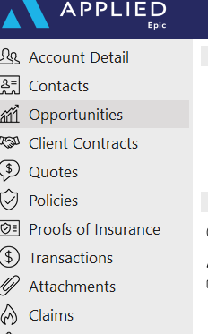

1. To create a new opportunity, select the **+** to start.

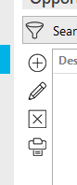

1. Complete sections of the **Opportunity Detail.** Remember **RED** sections are required fields
   1. Select whether the Opportunity is New or Renewal
   2. Type brief description of what business you are trying to obtain
   3. Enter target close date (salespeople will know what this means)

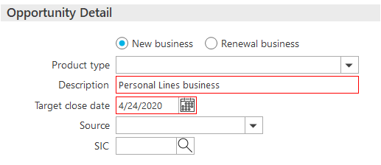

1. Add department to **Structure** section.

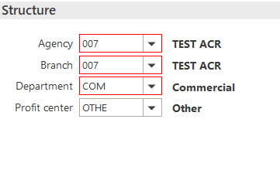

1. Complete **Estimated Value** section.
   1. Make sure you fill in estimated **Revenue** since this is what pulls to your **Dashboard**, but other information may be entered

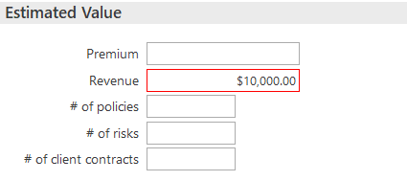

1. Choose your **Sales Team** and the **Owner** of the **Opportunity**. The Owner could be you as the salesperson, or it could be the producer if you are entering this information on behalf of the salesperson.

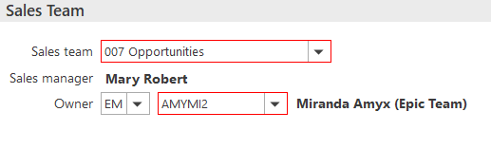

1. Complete **Stage Details** to show what stage you are in your Opportunity.
   1. Choose your Stage Group if you have one created for your team. If not, you can use **Default Group**
   2. The **Stage** identifies the opportunity’s position in the sales pipeline*.* It also updates the percent of probability for winning the Opportunity.

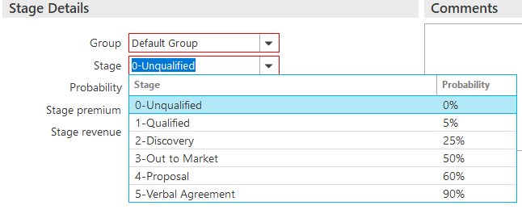

1. Use the **Comments** section to add any other information pertaining to this Opportunity. Click **Detail** when done.

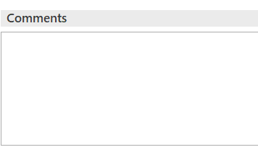

1. An automatic AOP activity will be created and closed out Successful stating you added an opportunity
2. More information sections will appear on your left Navigation Panel.

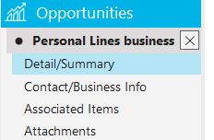

1. In the **Detail/Summary** section, there is a **Categories** tab. You can add **Agency Defined Categories** for your Opportunity if desired.
   1. Add Category but selecting the **+**

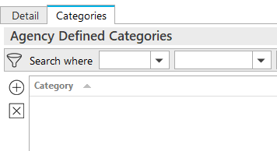

1. Under **Contact/Business Info**, you will addthe nameof the person at the client you are contacting about this Opportunity.
   1. You will use the **+** button to add their information.

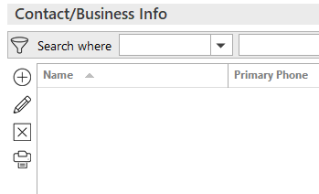

1. Under **Associated Items**, you can associate this Opportunity to a current **Marketing Submission,** **Policy**, or **Service**.
   1. You will use the **+** button to add this information.

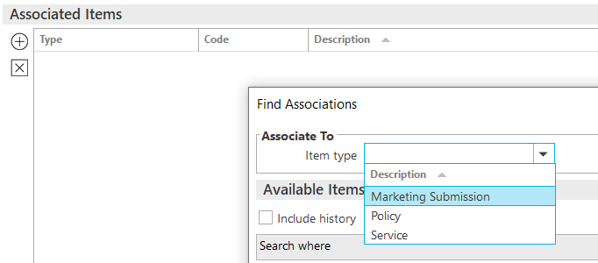

1. **Attachments** is where you will attach documentation about this Opportunity by using the **+** button.

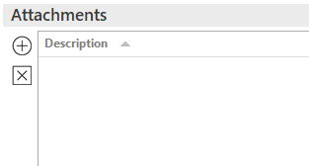

**Updating the Opportunity**

|  |
| --- |
| **TIP:** As you are working on your Opportunity, you will want to update the Stage, add documents, and maybe update Comments. |

1. From your **Home** screen, your created Opportunities will show in the **Opportunities** section. You can view by **30 Days, 60 Days, 90 Days**… From this section, you can click on the blue link, and it will take you to the **Opportunities Detail** or **Right Click** and update~~d~~ *the* information from there.
   1. **Add Activity** – Add an F9 activity
   2. **Change Stage** – Updated your stage
   3. **Change Stage Group** – Amend your Stage Group
   4. **Close** – Close your Opportunity either Won or Loss
   5. **Renew** – Renew your Opportunity

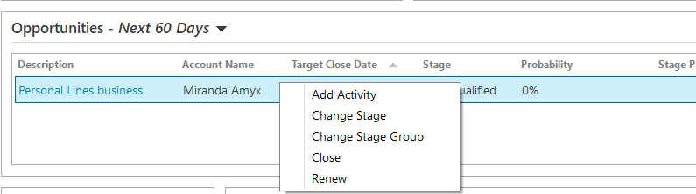

1. As you work through your Opportunities, update the Stage to keep the Dashboard updated.
   1. Each time you select to **Change Stage**, it will automatically update to the next **Stage** in your **Group.**

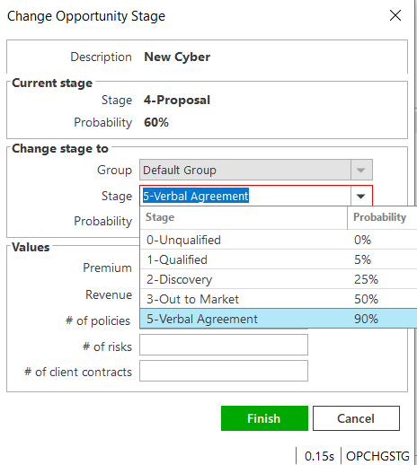

1. Once an **Opportunity** is complete, you can **Right Click** on Opportunity, then **Close**.



1. Once you have selected **Close**, you will choose **Lost** or **Won**. If **Opportunity** is lost, you will have to give a **Reason** for the loss. Select **Finish**.

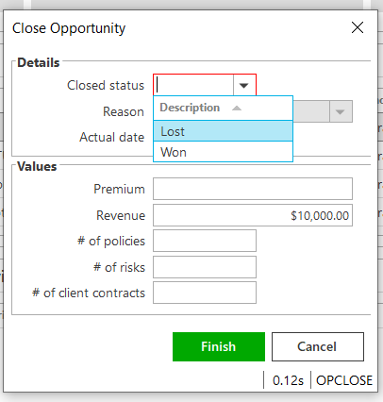

1. An **Automatic Activity** will appear. Select which code applies, add notes, and then **Finish** out Activity.

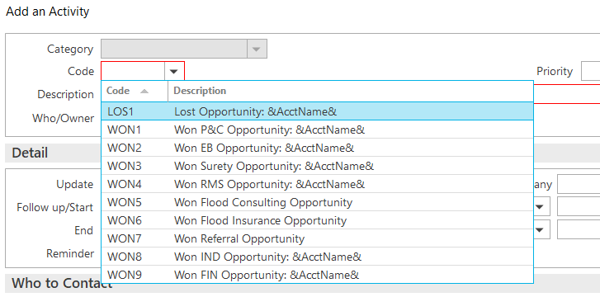

**Working through the Dashboard**

Your Home screen will show your own personal **Dashboard**. As a team manager, you will have the opportunity to look at each team members Dashboard

|  |
| --- |
| **TIP:** Double clicking on each graph will take you into more detail about that information. Dates and value can also be changed at the more detail view.  **TIP:** Graphs default to Revenue. |

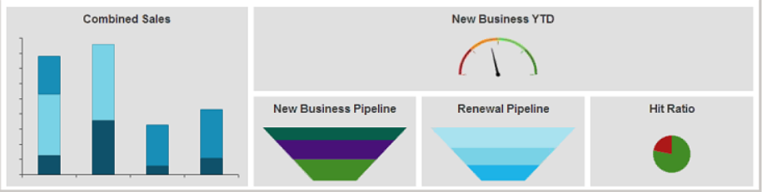

* **Combined Sales**
  + This shows up to 150 Days of new & renewal **Opportunities** and expiring policies you have.
* **New Business YTD**
  + Shows you your sales goal that was set and where you are with that sales goal.
* **New Business Pipeline**
  + This will show you what new business opportunities and where you are in the different sales stages. You may change your target date if needed.
* **Renewal Pipeline**
  + Shows your upcoming renewals and renewal **Opportunities.**
* **Hit Ratio**
  + This section will give you the Opportunities you have won and/or lost

## JA.12 Creating a Proposal or Summary in Epic

### General Information

|  |
| --- |
| Epic has been configured with templates to allow users to generate Platform branded Proposal and Summary that can be used to present to clients when marketing coverage for new or renewal business. **The Summary template is accessed using On Demand>Proposal – Do not use On Demand>Summary of Insurance.**    **The following are highlights and pointers to consider:**   * The same proposal group works from either the Current/Future lines or the Marketed lines (at the carrier response stage) * Each line of business is configured to pull the following four (4) areas from the Epic policy details into the Line of Business page on the Proposal:   + Additional Coverages   + Forms & Endorsements   + Remarks (only when the Print on form is checked)   + Additional Interest * When using the Summary Group, users will have to associate the Line of business to both the Premium Summary pages and the Detail pages for each selected policy. This will ensure that the policies will appear on the premium summary page as well as the policy detail pages.      * Remember to enable Macros when the Word document generates as this is how the data merges into the document. * The overall formatting of each page of the Proposal and Summary templates has been designed to meet the legal specifications of Acrisure and to meet general needs of most of the users. The word document will need to be reviewed carefully as some data may need to be manually updated. Tables and data fields with no information should be updated or deleted and spacing should be adjusted to provide a professional look and feel. |

### How to Generate a Proposal

|  |
| --- |
| 1. Within the Client Account navigate to the Policies tab.  2. Click on a policy (or package header)   * 1. If creating a proposal for Marketed, change the view from Current/Renew to Marketed and then select the Submission.   3. On the Option Bar/Menu (top navy bar) click On Demand>Proposal.  **Refer to the screen shot below and the corresponding numbers with the following steps:**    See Notes  1. Add/Remove the policies that will need to be included in the proposal.   * 1. Click on the **Add** Badge Follow outline button and choose from either:   2. the available current/renewed policies, if generating from the current/renew policies view   3. the available lines being in the marketing submission, if generating from the marketing area   * You do not need to reposition the LOBs on the top half of the proposal box.  2. Pick the Proposal Group. The SE Platform has the following options and each one has preselected pages within the group. Choose the option that best suits your needs.   * 1. 1. Acrisure Standard Proposal   2. 1. CL Acrisure Summary of Insurance   3. 1. PL Acrisure Summary of Insurance   3. The Proposal Templates/Proposal Documents box will display all the preselected pages available based on the selected Proposal Group. This list must be reviewed, and pages deleted or rearranged based on guidelines determined by your leadership.   * 1. You must have a cover page and it must be in the top position.   2. **IMPORTANT : Associate a Line of Business to the Location Summary page to pull premises data.**   4. Individual Contacts are from the Account Contacts tab and will default with the Primary contact. added here will pull through to the Authorized Persons page.  **Notes:**  1. Before pressing Finish, you can add/move/delete pages, using the buttons on the left.  2. If you have multiple LOB of the same type, extras will drop to the bottom of the list. Be sure to reorder them before pressing Finish.  3. The premium summary page must appear after all the LOBs. Note: after merging, it can be moved.  4. LOBs without an associated Line will be suppressed by default. Uncheck the box next to Suppress blank templates to bring in the page even if there is not a LOB connected yet (e.g. you want to offer Cyber but it is not included on your account yet). |

## JA.13 Import/Export Risks

|  |  |
| --- | --- |
| Export Template to Import Data for the following Risks on certain Policy Types: | |
| * Locations * Scheduled Equipment * Named Insureds | * Vehicles * Drivers |

Export Risks

|  |
| --- |
| 1. Select/Highlight appropriate policy 2. Click **Actions** > **Export Risks**      1. Select Export Type      1. Select Mapping File Type      1. Check “Disable Delivery Options” 2. Check “Send as Blank Template”      1. Click **Continue** 2. Click Export, Click Yes 3. Click Attachments and locate mapping file |

#### Email Blank Template

|  |
| --- |
| 1. Uncheck ‘Disable Delivery Options’ 2. Remove Account Email Address; Enter Email Address to send template 3. Enter Subject      1. Click **Continue** 2. Click Export, Click Yes |

## Data on Exported Template

|  |
| --- |
| * **Template columns MUST remain AS IS – Do not delete or move ANY columns. The Import will fail if modified.** |

1. Copy and paste the data in each column. If there is no data for a particular column, leave it blank.
2. On Excel Template > Click File > Save As > Rename the Import File saving it to your Desktop

## Import Risk

|  |
| --- |
| * **Service Summary/Policy stage must be ‘In Process’ to Import Risks.** * If Service Summary/Policy is **NOT** ‘In Process’ stage, Click Actions > Endorse/Revise Existing Lines > Select CHGI (Internal Policy Change) Activity Code. Follow Import workflow below, after Import is Complete – Select Actions > Issue/Not Issue Endorsement and Select Issue. |

1. Select/Highlight appropriate policy
2. Click **Actions > Import Risks**
3. Click the **Add**  button to add the Import file

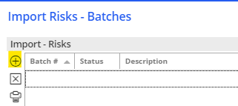

1. Select Risk Type 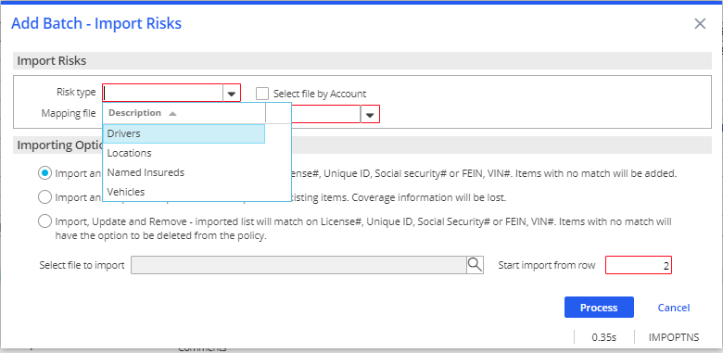
2. Select **SAME** Mapping File Type from Export
3. Select an Importing Option:

* Import & Update – Items with no match will be added.
* Import & Replace – Imported list will REPLACE ALL existing items. Coverage information will be lost.
* Import, Update & Remove – Items with no match will have the option to be deleted from the policy.

1. Select File to Import – Click the magnifying glass to locate the file you created in Step 2.
2. Start Import from Row **2**

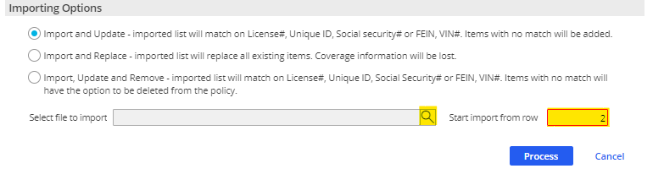

1. 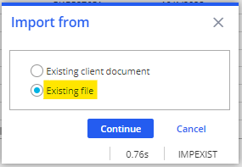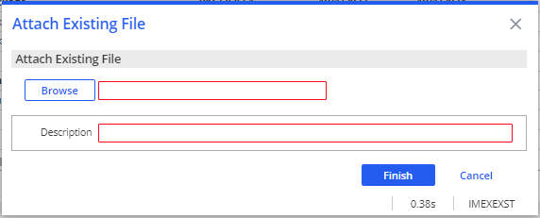Choose ‘Existing File’ if the file is located outside of Epic (i.e. Desktop); Click **Continue**
2. Click **Browse**, Choose selected file, Click **Open**, Click **Ok**
3. Update Description if needed
4. Click **Finish**
5. Click Process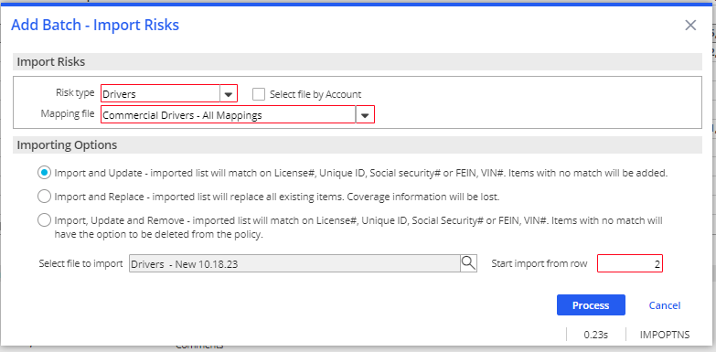
6. 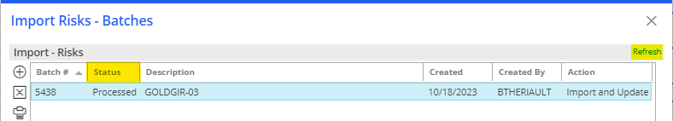Pay attention to the **STATUS**; Click Refresh in right corner.
7. Clicking Refresh > Status updates to **PROCESSED,** Click **Create**
8. Status updates to **CREATED,** Click **Preview**
9. Import Risks will display
10. Click **Import**
11. 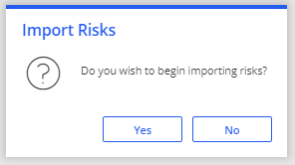Click Yes
12. Click Refresh
13. IF Import File disappears; the Import was Successful
14. Exit Import Risks – Batches by X in top right corner
15. Double Click on appropriate policy to view Imported Data

## Import Errors

|  |
| --- |
| * Epic will save a separate Excel file containing all the rows that failed. |

1. Locate the Error File in Attachments
2. Fix the issues from the Imported File
3. File > Save As and save the updated file to your Desktop
4. Proceed the Import Workflow

## JA.14 Adding Multi-Carrier Schedule to a Policy

|  |
| --- |
| 1. Verify Policy has been added to the clients account 2. Right click on Policy > **Activate/Inactivate Multi-Carrier Schedule**      1. Double click on policy 2. Under **Servicing/Billing** select **Multi -Carrier Schedule** 3. Select the + to add your first carrier  * Select the Policy radio button * Double check that you have the correct carrier * Fill in the Participation % * Fill in the Policy number * Double check the Percent of Commission      1. Follow the bullets points of **Step 5** for the other carriers 2. Make sure the total of your **Participation % equals 100%**      1. Little **X** out of the policy on the **Navigation Panel**. 2. From the Policy Scree, when you have the policy Highlighted, you can see the **Multi-Carrier Schedule** link below to view your schedule. |

## JA. 15 Statement of Values

**Step 1: Add Location 0 to the ACORD 125**

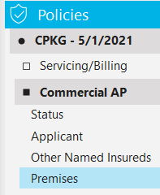

1. From the Client’s account, click the Policies area
2. Highlight the Commercial Property Policy **(CP1/CP2)**

*\*\* If CP1/CP2 is not in In Process Stage, go to* ***Actions > Endorse/Revise existing line*** *and do an internal endorsement* ***(CHGI)*** *to update.*

1. Double click the CP1/CP2 policy
2. From the Navigation Panel, click the Commercial AP and select Premises
3. In the Premises area, click the plus sign to add a new location

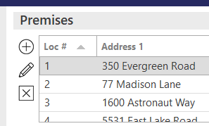

1. In the popup box, check the box for Blanket and in the address field, type **“BLANKET”**

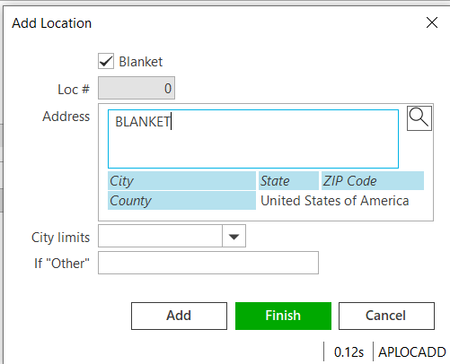

1. Click **Finish**
2. 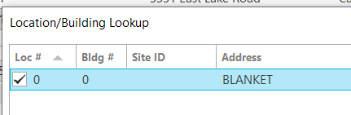In the left Navigation Panel, double click the Property line
3. Click Premises in the Navigation Panel
4. Click the plus sign under Premises to add the Location 0
5. Check the box and Click **Finish**

**Step 2: Update Subjects of Insurance**

1. From the Navigation Panel, click **Subjects** under the Property line
2. Enter all data for each location, i.e. Subject of Insurance, Description, Amount, Valuation, etc.
3. Be sure to add a Cause of Loss and update the Coinsurance %, otherwise, the values for each will show as $0 on the SOV.

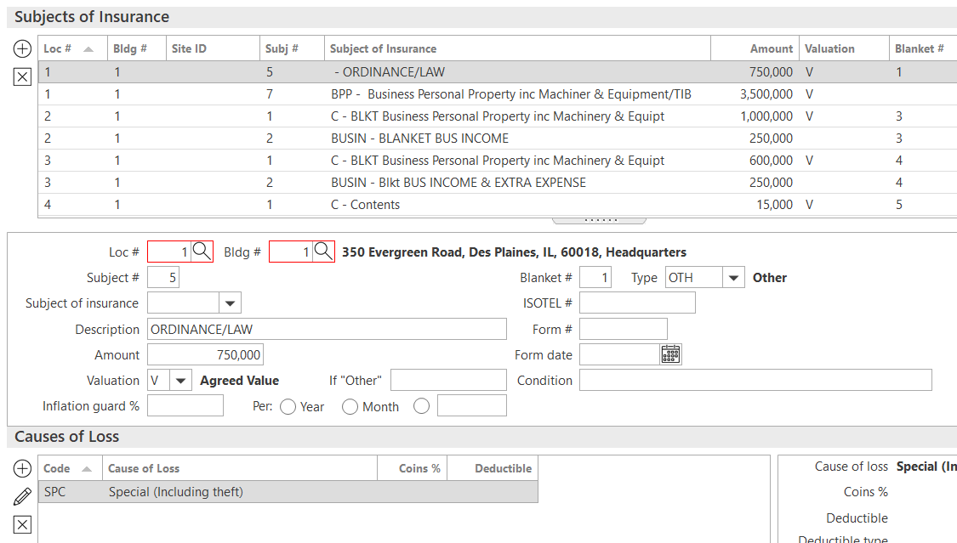

1. Repeat for each location; Highlight the location and fill in the details for the highlighted location at the bottom.

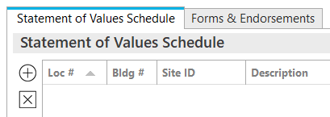**Step 3: Prepare Statement of Values**

1. Click Statement of Values in the Navigation Panel
2. Click the plus sign under the Statement of Values Schedule tab
3. At the top, under the Statement of Values – ACORD 139 section, fill in all relevant information, i.e. Headquarters address, other coverages like earthquake and flood, coinsurance percent, applicable cause of loss and total value. ***NOTE: You will need to manually total the property values and enter the total in the Total Value Field***

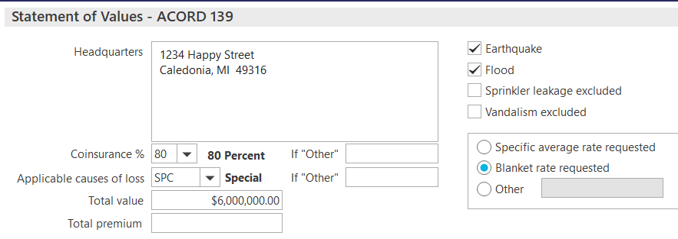

1. Select all locations to be included in the Statement, check the box to include all property premises if applicable, then click **Finish**

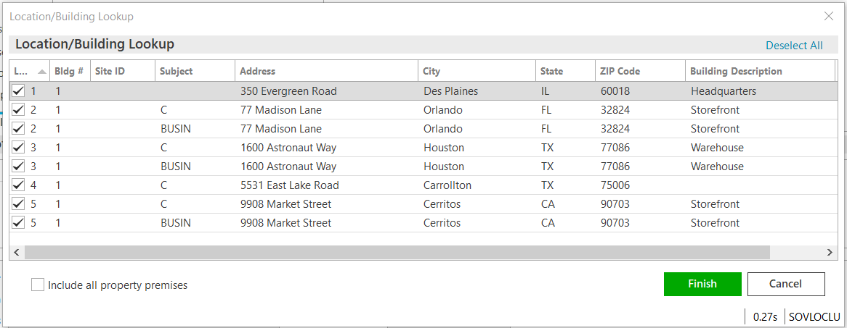

**Step 4: Print Statement of Values**

1. Click the **Print** button from the top blue options bar and select **Statement of Values**

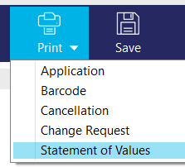

1. Click the Distribution tab to select the distribution options (Print, Email, Fax) and enter all details
2. If Desired Click to Download & Print to view the document before distributing
3. Click **Finish**

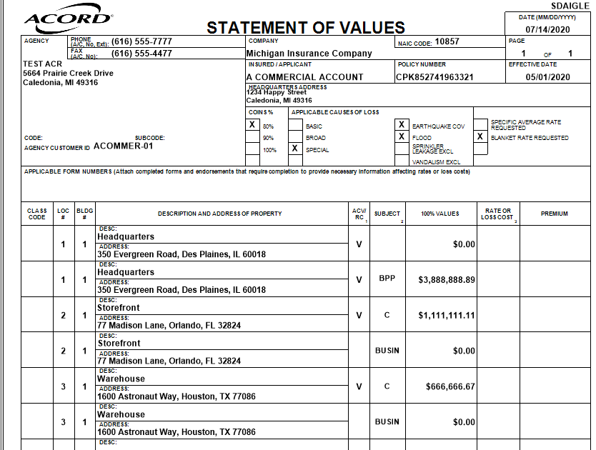

## JA. 16 Agency Bill- Revenue Sharing Workflow

### Acrisure Agency Partner with Carrier Relationship

1. Add Policy/Edit Existing Policy Premium Payable
2. Click the Billing Tab
   1. In the “Send Invoice To” section, change Type from Client to Broker
   2. In the Account field, click the magnifying glass to search for the Agency Partner name (who has the Client relationship)
   3. Enter Lookup Code > Contains ACR (All Acrisure AP Broker Lookup Codes begin with ACR)
   4. Scroll the list to find the Agency Partner
   5. Click once to highlight it, then click **Finish**



* The AP’s name (with the Client relationship) and address will appear
* Make sure the Bill Broker Net box is checked
* Set the Invoice Delivery Method to Mail



1. Click the Servicing Tab
   1. Add Policy Producer
   2. Add Policy Servicer
2. Click the PR/BR Commissions Tab

* Double-click the BREC (Client relationship)
* Change Type to the % symbol (Percentage of Premium)
* Enter the Agency Partner’s (with the Client relationship) Commission agreement
* Change the Production Credit % to 0
* Order # should be 0



1. Click **Finish**
2. While still in the **PR/BR** tab, click the **Add**  button
3. Enter PPAY for the Producer who is receiving commission on this policy

* Enter the Producer Code
* Change Type to ! (Net of Agency’s Commission)
* Percent = Enter the Producer’s commission rate
* Production Credit = 100%
* Order # = 1
* Click **Finish**



**NOTE:** If no PPAY (producer) is receiving commission on the policy, enter HOUSE as the PPAY at 0% commission and 100% production credit.

### Acrisure Agency Partner with Client Relationship

Add Policy/Edit Existing Policy Premium Payable with Broker

Select Line Tab

* Agency Bill
* Status = NEW
* Issuing company = Writing Company
* Premium Payable = Change from CA to BR (Broker); Code = AP with the Carrier relationship
* Line Commission % = Carrier rate minus whatever percentage the AP with the Carrier relationship keeps

*\*****Example****:* ***Carrier Commission rate = 20%****. The AP with Client relationship and Acrisure AP with the Carrier relationship split this commission 50/50.*

*AP with the Client relationship enters 10% as the commission rate in the Policy Line Commission area. (50% of the carrier commission)*

* Estimated Premium = Actual Premium amount (excluding taxes and/or fees)



Select **Pr/Br Commission** Tab

Click the **Add**  button (Pr/Br tab)

• Enter PPAY Code (producer receiving commission)

• Type = @ (Percent of Commission)

• Percent = the producer commission rate

• Production Credit = 100%



Click the Servicing Tab

* + - Enter Policy Producer
    - Enter Policy Servicer

1. Enter Application detail as needed

## JA. 17 Direct Bill- Revenue Sharing Workflow

### Acrisure Agency Partner with Carrier Relationship

1. Add Policy/Edit Existing Pr/Br Commission
2. Click the PR/BR Commission Tab
   * Click the **Add**  button
   * Change **Pr/Br** to **BPAY**
   * Enter the Agency Partner code (AP with **Client** Relationship)

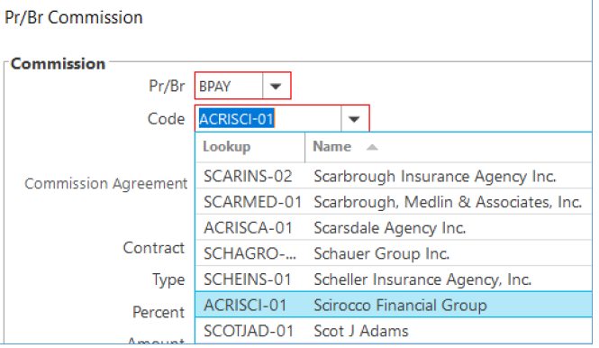

* + Change Type to @ (Percentage of Commission)
  + Enter the commission rate

(**Example:** If AP with the **Carrier** relationship is splitting the carrier commission 50/50 with the AP with the **Client** relationship, enter 50%)

* + Change the Production Credit % to 0
  + Order # should be 0

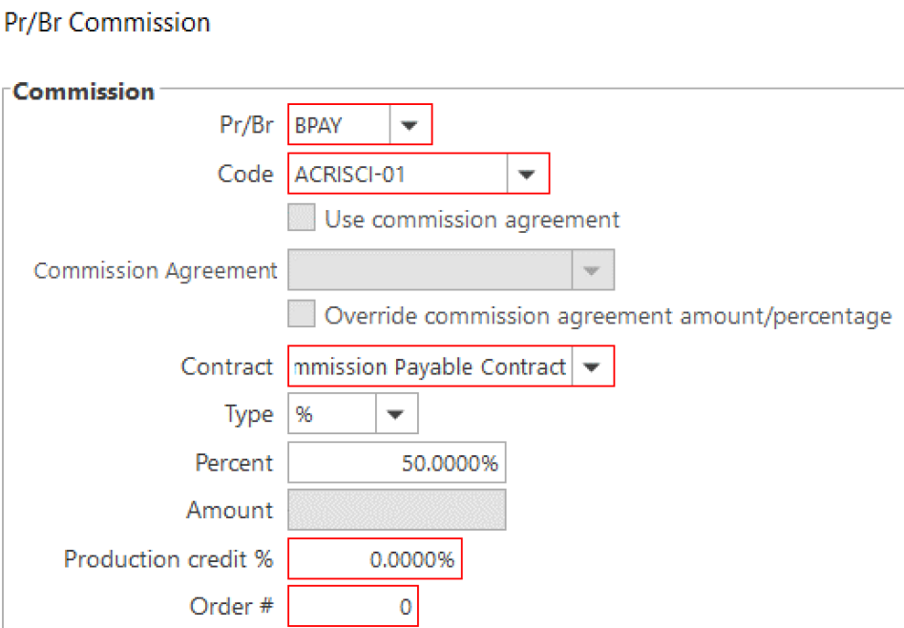

* + Click **Finish**

1. While still in the PR/BR tab, click the **Add**  button
2. Enter PPAY for the Producer receiving commission

* Enter the Producer Code
* Change Type to ! (Agency Net Commission)
* Percent = Enter the Producer’s commission rate
* Production Credit = 100%
* Order # 1

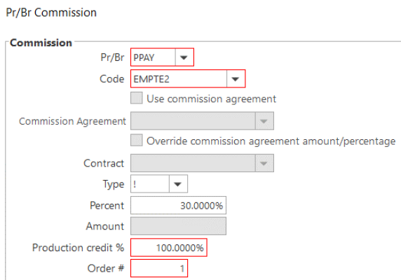

* Click **Finish**

1. Click the Servicing Tab

* Enter Policy Producer
* Enter Policy Servicer

1. Enter application detail as needed

### Acrisure Agency Partner with Client Relationship

Add Policy/Edit Existing Policy Issuing Company/Premium Payable

1. Select Line Tab

* Agency Bill
* Status = NEW
* Issuing company = Writing Company
* Premium Payable = Change from CA to BR (Broker); Code = AP with the Carrier relationship
* Line Commission % = Carrier rate minus whatever percentage the AP with the Carrier relationship
* Line Commission % = the split AP with the **Client** relationship is receiving from the AP with the **Carrier** relationship

*\*****Example:*** *Acrisure Agency Partner with the Carrier Relationship and the AP with the Client Relationship are splitting the carrier commission 50/50. Enter 50% in the Line Commission % field.*

* Estimated Premium = total dollar amount of the **commission** on policy

*\*****Example: Carrier is paying 20% commission on $10,000 premium. Total amount of “Premium” to enter = $2,000.***

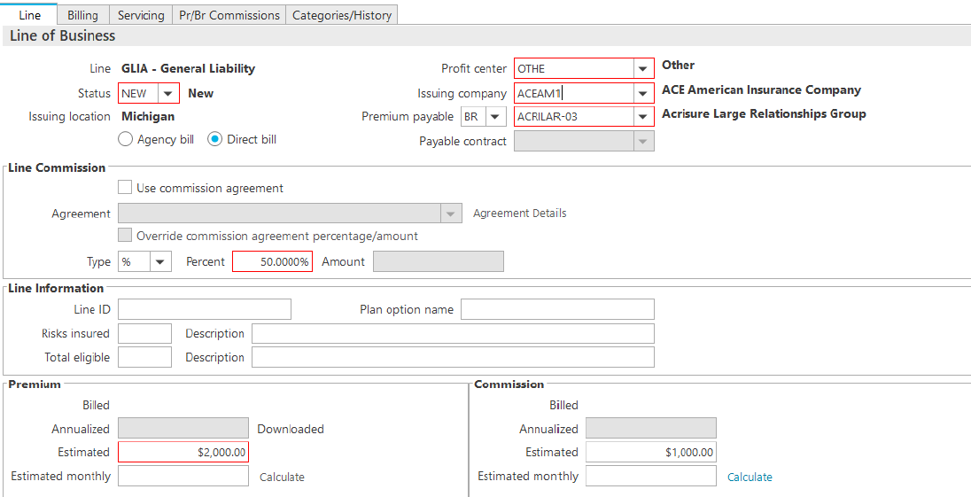

* Click **Detail**

1. On Pr/Br Tab
2. Click the **Add**  button

* Enter PPAY Code
* Type = @ (Percentage of Commission)
* Percent = the producer commission rate
* Production Credit = 100%

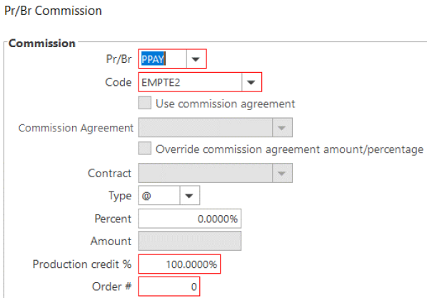

1. Click the Servicing Tab

* Enter Producer
* Enter Servicer

1. Enter application detail as needed

JA. 18 Pr/Br Commissions

|  |
| --- |
| * Pr/Br Commission Tab for Producer / Broker Commission is a **REQUIRED** field in Epic  New Policies  * + - 1. When adding New Policies the Pr/Br Commission Tab will automatically open   **Pr/Br** tab **(REQUIRED):**   1. Click the **Add** Badge Follow outlinebutton. 2. If a **Producer** is getting paid commission on a policy, select the **Producer** from the drop-down menuand click **‘Use Commission Agreement’**. By clicking the box Commission Agreement will automatically fill in **%** of commission.   **DO NOT AMEND COMMISSION % UNLESS APPROVED BY LEADERSHIP**   * + - * + **If ‘Use Commission Agreement’ box is not checked an ADC – Agency Defined Category of ‘Commission Agreement Exception’ must be added.**      1. Each policy requires at least one **PPAY** (Note: PPAYs are Employees; BPAYs are outside Brokers). **If there is **no** Producer involved select **House**. 2. Verify **Production Credit** is 100% unless splitting with other Producers. (Note: This is not commission related but gives the Producer credit for booking the business written. **BPAYs** never receive Production Credit). **If House Code – Production Credit will be 100%.**  Renewal/Rewrite Policies **Actions** > **Renew** for Renewal with same carrier or Rewrite to a different carrier the Pr/Br Commission will default to the same Producer as prior term and update commission to Renewal Status.  Verify Producer, Check ‘Use Commission Agreement’, Verify Commission Agreement    Agency Defined Category (ADC)   * If different commission was agreed from Leadership, an ADC must be added to the **Policy**.   + - 1. Double Click on **Policy**       2. Select **Servicing/Billing > Line**       3. Select **Categories/History** Tab  1. Click **Add** Badge Follow outlinebutton 2. Click check box for **Comp Agreement – Non-Standard Commission Agreement** 3. Click **Finish** |

## JA. 19 Referral Workflow (Real Estate, Cyber, PEO, Payroll, etc)

|  |
| --- |
| * Referrals and related correspondence will be documented with Activities in the Epic system * Whenever a Referral is given to the Real Estate or Cyber division at Acrisure, or any outside carrier or vendor where we get a share of commission or referral fee, a policy need to be set up to receive the renewal commission. |

#### Manual Activity and Policy Types

|  |  |  |  |  |  |  |  |  |  |  |  |  |  |  |  |  |  |  |  |  |  |  |  |  |  |  |  |  |  |  |  |  |  |  |  |  |
| --- | --- | --- | --- | --- | --- | --- | --- | --- | --- | --- | --- | --- | --- | --- | --- | --- | --- | --- | --- | --- | --- | --- | --- | --- | --- | --- | --- | --- | --- | --- | --- | --- | --- | --- | --- | --- |
| * **Manual Activity with the Corresponding Code:**  |  |  | | --- | --- | | **Manual Activity Code** | **Description** | | **GREF** | Non-Insurance Referral |  * **Policy Type and Description:**  |  |  | | --- | --- | | **Policy Code** | **Description** | | **R401** | 401K Referral | | **RACS** | Acrisure Cyber Services | | **RODP** | On Demand Pay Referral | | **RPA2** | Payroll Referral | | **RPE0** | PEO | | **RPE1** | PEO Benefits Package | | **RPED** | PEO Dental | | **REPM** | PEO Medical | | **RPEU** | PEO Voluntary | | **RPEV** | PEO Vision | | **RPEW** | PEO Workers Compensation | | **RPRP** | Portable Retirement Plan Referral | | **RSLO** | SMB Loan Referral | | **RSUB** | Subscription/Membership | | **RTIT** | Acrisure Title Referral | |

Add Monoline Policy

|  |
| --- |
| 1. Go to **Policies** in the left Navigation Panel within the client account. 2. Click the plus (+) button to **Add** a Policy * 1. **Type**: Select from the R-type PEO policies   2. **Policy #**: Enter the policy # from the carrier   3. **Effective/Expiration Dates**: Enter the dates to match the policy term   4. **Source**: Select applicable   5. **Agency/Branch**: Select applicable   6. **Department:** Will default to OTH Non-Insurance Products   7. **Line:** Will default based on the policy type   8. **Status:** Select applicable   9. **Issuing Location:** Will default based on the primary location   10. **Bill Mode:** Select applicable agency or direct bill   11. **Profit Center:**       1. Select **PEO: PEO – AcriSource** when coverage has been placed with our AcriSource team       2. A screenshot of a computer           Description automatically generatedSelect **OTH: Non-Insurance Products** when coverage has been placed directly with a PEO   12. **Issuing Company:** Select the applicable insuring carrier   13. **Premium Payable:** Use the dropdown to change to BR and select the broker that coverage has been placed with   14. **Line Commission:** Enter the accurate commission percentage   15. **Premium:** Enter premium   16. **Commission:** Use the blue hyperlink to calculate commission  1. Click **Detail** 2. Select the **APOL** activity code   A screenshot of a computer  Description automatically generated   * 1. Add applicable notes   2. Status will default to Open; amend to **Closed** > **Successful** if policy documents have been received and no follow up is needed   3. Click **Finish**  1. Go to the **Servicing/Billing > Pr/Br Commissions** tab   A screenshot of a computer  Description automatically generated   1. Click the plus (+) button to add a PPAY 2. Use the dropdown to select the appropriate producer who wrote the business or House 3. Use the defaulted commission agreement 4. Click **Finish** 5. Go to the **Servicing/Billing > Servicing** tab and use the dropdown to select the policy servicer in the **Non-Insurance Product Sales** field   A screenshot of a computer  Description automatically generated   1. Add application detail as needed 2. Click the **X** in the left Navigation Panel to close the policyA screenshot of a computer     Description automatically generated 3. **In Process Policy**    * 1. Select No, leave “In Process” if further details need to be entered      2. Select the **Yes, perform action** radio button if all details have been entered         + Use the dropdown to select **Issue/Not Issue Policy** if all policy documents have been received         + Use the dropdown to select **Update State to Submitted** if policy docs are pending   A screenshot of a computer  Description automatically generated   1. Click **Finish** |

Add a Package Policy

|  |  |
| --- | --- |
| 1. Go to **Policies** in the left Navigation Panel within the client account. 2. Click the plus (+) button to **Add** a Policy   A screenshot of a computer  Description automatically generated   1. **Line:** Select from the R-type PEO policies 2. **Status:** Select applicable 3. **Issuing Location:** Will default based on the primary location 4. **Bill Mode:** Select applicable agency or direct bill 5. **Profit Center:**    * 1. Select **PEO: PEO – AcriSource** when coverage has been placed with our AcriSource team      2. A screenshot of a computer          Description automatically generatedSelect **OTH: Non-Insurance Products** when coverage has been placed directly with a PEO 6. **Issuing Company:** Select the applicable insuring carrier 7. **Premium Payable:** Use the dropdown to change to BR and select the broker that coverage has been placed with 8. **Line Commission:** Enter the percentage 9. **Premium:** Enter premium 10. **Commission:** Use the blue hyperlink to calculate commission 11. Click **Detail** 12. Use the dropdown to select the **APOL** activity code   A screenshot of a computer  Description automatically generated   * 1. Add applicable notes   2. Status will default to Open; amend to Closed > Successful if policy documents have been received and no follow up is needed   3. Click **Finish**  1. Go to the **Servicing/Billing > Pr/Br Commissions** tab   A screenshot of a computer  Description automatically generated   1. Click the plus (+) button to add a PPAY 2. Use the dropdown to select the appropriate producer who wrote the business or House 3. Use the defaulted commission agreement 4. Click **Finish** 5. Go to the **Servicing/Billing > Servicing** tab and use the dropdown to select the policy servicer in the **Non-Insurance Product Sales** field   A screenshot of a computer  Description automatically generated   1. Return to the **Servicing/Billing > Line** screen to add additional lines to the package 2. Click the plus (+) button to **Add** a Line   A screenshot of a computer  Description automatically generated   * 1. **Line:** Select from the R-type PEO policies   2. **Line Commission:** Enter the percentage   3. **Premium:** Enter premium   4. **Commission:** Use the blue hyperlink to calculate commission   5. To add additional lines, click **Add** and repeat steps a-d   6. Once all lines have been added to the package, click **Finish**  |  | | --- | | If there is no breakdown of premium by line, enter all estimated premium and commission under one line of business. |  1. Add application detail as needed 2. Click the **X** in the left Navigation Panel to close the policy detail   A screenshot of a computer  Description automatically generated   1. **In Process Policy**    * 1. Select No, leave “In Process” if further details need to be entered      2. Select the **Yes, perform action** radio button if all details have been entered         + Use the dropdown to select **Issue/Not Issue Policy** if all policy documents have been received         + Use the dropdown to select **Update State to Submitted** if policy docs are pending      3. Click **Finish**   A screenshot of a computer  Description automatically generated |

Add a PEO Admin Fee

|  |
| --- |
| 1. Go to **Policies** in the left Navigation Panel within the client account. 2. Click the plus (+) button to **Add** a Policy   A screenshot of a computer  Description automatically generated   1. **Type**: Select the RPEO policy type 2. **Policy #**: Enter a member number or the word Fee 3. **Effective/Expiration Dates**: Enter the dates to match the policy term of the other policies 4. **Source**: Select applicable 5. **Agency/Branch**: Select applicable 6. **Department:** Will default to OTH Non-Insurance Products 7. **Line:** Will default based on the policy type 8. **Status:** Select applicable 9. **Issuing Location:** Will default based on the primary location 10. **Bill Mode:** Select applicable agency or direct bill 11. **Profit Center:**     1. Select **PEO: PEO – AcriSource** when coverage has been placed with our AcriSource team     2. A screenshot of a computer         Description automatically generatedSelect **OTH: Non-Insurance Products** when coverage has been placed directly with a PEO 12. **Issuing Company:** Select **SERVIC** for SERVICE ONLY 13. **Premium Payable:** Use the dropdown to change to BR and select the broker that coverage has been placed through 14. **Line Commission:** Enter the accurate commission percentage 15. **Premium:** Enter the fee 16. **Commission:** Use the blue hyperlink to calculate commission 17. Click **Detail** 18. Select the **APOL** activity code   A screenshot of a computer  Description automatically generated   * 1. Add applicable notes   2. Amend Status to **Closed > Successful**   3. Click **Finish**  1. Go to the **Servicing/Billing > Pr/Br Commissions** tab   A screenshot of a computer  Description automatically generated   1. Click the plus (+) button to add a **PPAY** 2. Use the dropdown to select the appropriate producer who wrote the business or House 3. Use the defaulted commission agreement 4. Click **Finish** 5. Go to the **Servicing/Billing > Servicing** tab and use the dropdown to select the policy servicer in the **Non-Insurance Product Sales** field   A screenshot of a computer  Description automatically generated   1. Click the **X** in the left Navigation Panel to close the policy 2. Select the **Yes, perform action** radio button 3. Use the dropdown to select **Issue/Not Issue Policy** 4. Click **Finish**   A screenshot of a computer  Description automatically generated |